# Market overview and performance 2022–23

Victoria generated a total of 14.5 million tonnes of material in 2022–23, with 9.9 million tonnes recovered for reprocessing.

This resulted in a Victorian recovery rate of 69% (Figure 3). (For clarity, the soils component in this figure has been split out from other materials in the aggregate/masonry/soils section of this chart.)

Figure 3: Materials generated, recovered for processing, and disposed of in 2022–23 (tonnes) (Recycling Victoria 2024b)

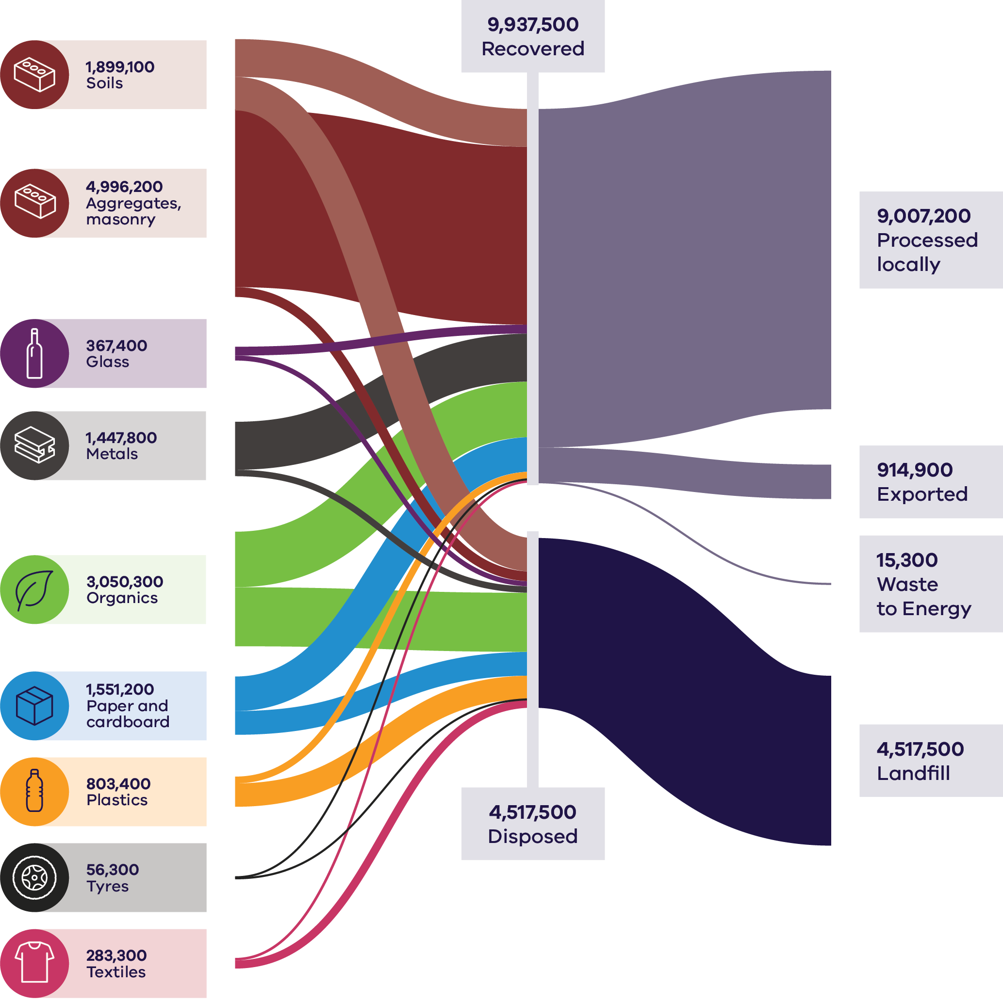

Table 2: Materials generated, recovered for processing, and disposed of in 2022–23 (tonnes) (Recycling Victoria 2024b)

| Materials (Tonnes) | Generated | Recovered | Disposed |
| --- | --- | --- | --- |
| **Soils** | 1899100 | 1005400 | 893700 |
| **Aggregates, masonry** | 4996200 | 4733800 | 262400 |
| **Glass** | 367400 | 233900 | 133500 |
| **Metals** | 1447800 | 1277900 | 169900 |
| **Organics** | 3050300 | 1478600 | 1571700 |
| **Paper and cardboard** | 1551200 | 918200 | 633000 |
| **Plastic** | 803400 | 181100 | 622300 |
| **Tyres** | 56300 | 41900 | 14400 |
| **Textiles** | 283300 | 66800 | 216500 |

| Totals (tonnes) |  |
| --- | --- |
| Recovered – Processed locally | 9007200 |
| Recovered – Exported | 914900 |
| Recovered – Waste to Energy | 15300 |
| Disposed – Landfill | 4517500 |

## Market overview

The value of the Victorian waste, recycling and resource recovery sector has been estimated at over $4.4 billion (ABS 2020). This value will continue to grow as Victoria transitions to a stronger circular economy.

Victoria remains the fastest growing state in the country with the population expected to reach 10.3 million by 2051 (DTP 2023). This growth will place greater pressure on the environment including through higher levels of waste generation.

Despite increasing population, Victoria’s recovery rate has been relatively consistent (69–70%) since 2016–17. There is still a need for improvement to transition to a circular economy and meet Victoria’s target to divert 80% of non-hazardous waste from landfill by 2030. Victoria needs to continue efforts to develop a reliable and robust circular economy market to avoid valuable material and embodied energy being lost to landfill.

Analysis of trends in resource recovery between 2020–21 and 2022–23 shows a mix of steady performance in the C&D sector, a positive trend in household MSW recovery and challenges in maintaining or improving recovery rates of specific material streams in the C&I sector. Increased focus on waste management systems for businesses, such as through improved separation and collection of materials, could further improve recovery rates.

A key opportunity for C&I to achieve significant gains in overall circularity is in food organics. While households are benefiting from the rollout of kerbside FOGO services, businesses such as those in food manufacturing and hospitality would benefit from improved investment and systems of waste separation and collection.

Key barriers to circularity include the following:

* **Contamination** – high processing costs associated with sorting, decontaminating and cleaning material streams.
* **Limited end markets** – weak local demand for reusing, reprocessing or recycling some material streams.
* **Product design** – products are not designed for circularity or end-of-life. Complex product designs, the use of mixed materials, and the difficulty of disassembling products hinder effective recycling.

**Competition with international jurisdictions** – Victorian recyclers and re-manufacturers compete with international jurisdictions that have lower costs and stronger manufacturing bases.

Competition with virgin materials – cheaper virgin materials, particularly those derived from fossil fuels, often undermine the competitiveness of recycled alternatives.

Recent government policy has been introduced to support a stronger and more reliable and transparent waste and recycling sector by measures such as:

* improving the way waste is collected through a new standardised 4 stream household waste and recycling system, which reduces contamination and increases the value and opportunity of the materials collected
* implementing a product stewardship scheme for the recovery of recyclable containers through Victoria’s Container Deposit Scheme (CDS Vic) to incentivise increased participation in the collection and deposit of containers, reducing contamination and increasing the value and opportunity of the materials collected
* increasing waste levies to incentivise circular economy opportunities and making them more cost effective when compared to disposal
* regulation and planning to ensure that collection and recycling services remain reliable and transparent
* driving investment through long term recycling infrastructure planning, outlining where improved capacity and capability are required to meet Victoria’s needs

new government procurement policies for major transport projects to optimise the use of recycled and reused Victorian material within allowable limits under existing specifications.

Victoria has the conditions to support further investment in the waste, resource recovery and recycling sector, including continuing strong government policy to enable and encourage growth, strong domestic demand and facilitating a collaborative research and development environment to support innovation.

Commodity values of recycled material evolve with markets. Commodity values for recycled materials are influenced by multiple factors including:

* international and domestic market demand
* virgin material alternatives
* landfill gate fees and waste levies

product stewardship arrangements (CDS Vic, e-waste)

A material’s commodity value (the price the market is willing to pay) relative to its processing costs and the virgin material alternative, provides insight into the commercial incentives for circularity. Strong commodity values can justify higher processing costs, enabling more complex recycling processes. For example, metals have high commodity values due to strong market demand, which helps overcome transport and processing costs, resulting in higher recovery rates.

Some materials such as aggregates, masonry and soil, have relatively low commodity values but still enjoy high rates of recovery, due to simpler and more cost-efficient processing requirements, and with strong financial incentive for the otherwise high costs associated with disposal fees.

Recycled plastics, on the other hand, are costly to recover and process and are lightweight; therefore, cannot commercially compete with virgin fossil-fuel derived plastics which are priced attractively low. However, the price of virgin plastics does not reflect the environmental and social harms of extracting finite natural resources, distorting the true economic comparison between virgin and recycled plastics.

In 2022–23 Victoria recovered and circulated an estimated $1.8 billion worth of materials back into the economy. However, material with potential value of $1.3 billion was lost to landfill, indicating more can be done to support markets in capturing this potential value (Figure 4).

Figure 4: Realised market value, Potential market value, and Commodity value for 2022–23

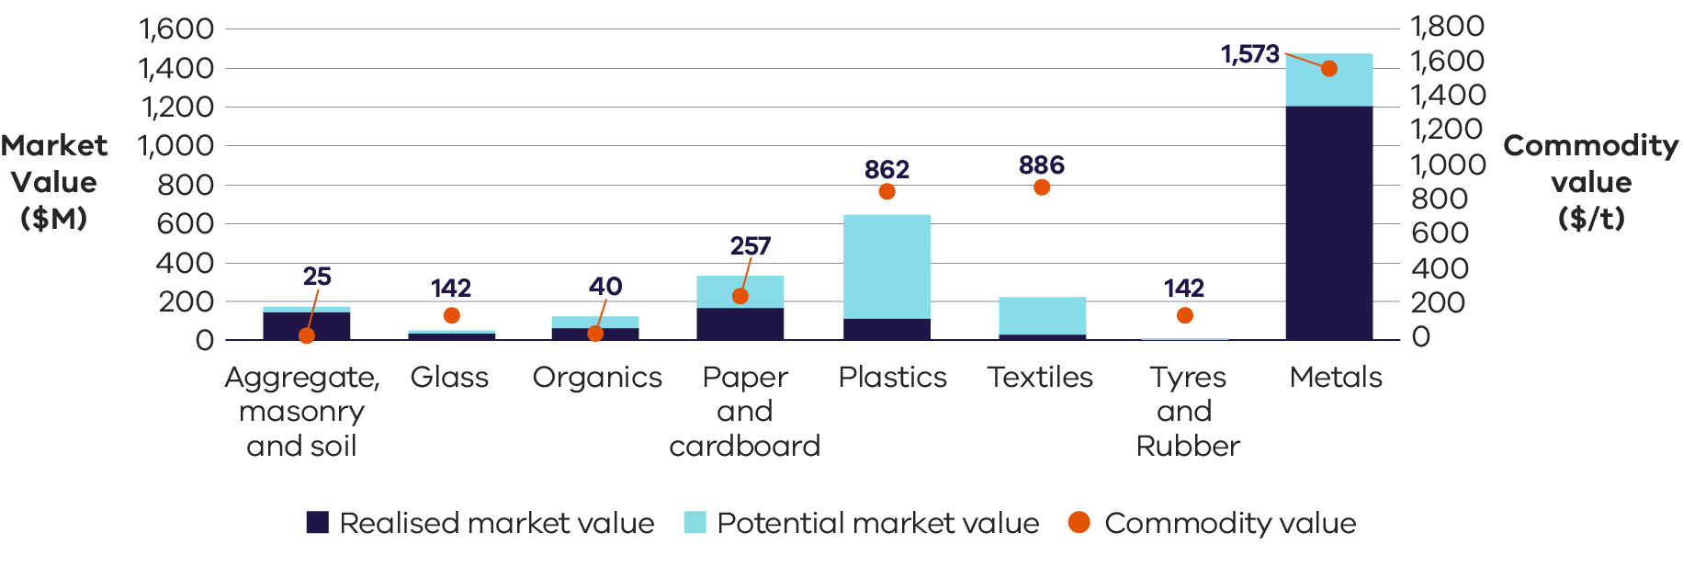

## Performance by activity

### Material generation

In 2022–23 Victoria’s generation of waste materials totalled 14.5 million tonnes. The C&I sector represents the second largest contributor, accounting for just under one third of total material generation by weight. The largest material stream contributors to this are:

* aggregates, masonry and soils
* organics
* paper and cardboard
* metals.

Table 3: Comparison of material generation, recovery and disposal between financial years (Recycling Victoria 2024b)

| Source sector | Total generation (tonnes) | | | | Recovered (tonnes) | | | | Disposed (tonnes) | | | | Recovery rate (%) | | | |
| --- | --- | --- | --- | --- | --- | --- | --- | --- | --- | --- | --- | --- | --- | --- | --- | --- |
| **FY** | **20–21** | **21–22** | **22–23** |  | **20–21** | **21–22** | **22–23** |  | **20–21** | **21–22** | **22–23** |  | **20–21** | **21–22** | **22–23** |  |
| MSW | 3.3 | 3.5 | 3.6 | **↑** | 1.6 | 2.0 | 2.0 | ↑ | 1.7 | 1.5 | 1.6 | ↓ | 49% | 57% | 56% | ↑ |
| C&I | 4.9 | 4.3 | 4.2 | **↓** | 2.9 | 2.3 | 2.3 | ↓ | 2.0 | 2.0 | 1.9 | ↓ | 60% | 54% | 54% | ↓ |
| C&D | 7.7 | 6.6 | 6.7 | **↓** | 6.6 | 5.6 | 5.6 | ↓ | 1.1 | 1.1 | 1.0 | ↓ | 86% | 84% | 84% | ↓ |
| **Total** | **15.8** | **14.4** | **14.5** | **↓** | **11.1** | **9.9** | **9.9** | **↓** | **4.7** | **4.5** | **4.5** | **↓** | **70%** | **69%** | **69%** | **↓** |

**Note:** the arrows in 2022–23 represent the change compared to the 2020–21 financial year.

Total material generation in 2022–23 decreased by over 1 million tonnes in the last 2 years since 2020–21. This decline is likely driven by a reduction in material generation within the C&D sector, possibly reflecting the sector’s improvements of in-situ material re-use which occurs before it is classified as waste.

The C&D sector remains the largest contributor to material generation by weight across the 3 sectors, accounting for nearly 50% of the total tonnes. This is largely due to the significant relative weight of materials such as aggregates, masonry and soils generated by this sector.

The key trends in C&D material generation over the past 3 financial years show:

* a 1 million tonne decrease in material generation from 2020–21 to 2021–22, likely caused by efficiencies in material use, as well as reduced sector activity

a subsequent increase of approximately 100,000 tonnes from 2021–22 to 2022–23, likely reflecting a return to sector activity, particularly linked to transport infrastructure projects.

Material generation trends for C&I over the recent years show:

* a 600,000 tonne decrease from 2020–21 to 2021–22, possibly influenced by COVID-19 which disrupted typical waste generation patterns as workplaces shifted to home-based activity

a smaller subsequent drop of 100,000 tonnes from 2021–22 to 2022–23.

MSW accounted for the remaining 25% of material generation by weight. The observed increase in MSW generation is possibly attributed to post COVID-19 population growth and the shift toward remote working.

Over the next 30 years total material generation is projected to increase by about 93%, increasing the state-wide generation to an estimated 28 million tonnes by 2053 (Recycling Victoria 2024b). The largest contributor to material generation, C&D, is projected to grow and contribute 55% of the total material generation in 2053. The C&I and MSW sectors are expected to decrease contribution to 26% and 18% respectively (Recycling Victoria 2024b).

### Material generation per capita and Gross State Product

Gross State Product (GSP) is an aggregate measure which details the total economic production of a state economy and is the state equivalent to the national Gross Domestic Product (GDP).

The amount of waste material generated by the 3 source sectors is shown compared with population (Figure 5). The flattening of population growth in 2020–21 and 2021–22 correspond to COVID-19 impacts, when there was reduced domestic population in Victoria. The source sector show that C&D waste generation has fallen by about 1 Mt since 2021, while C&I generation has risen to a peak of just under 5 Mt before falling to around 4.3 Mt. Generation of MSW fell to just over 3 Mt in 2020–21, noting that the amount generated increased as population began to rise again.

Figure 5: Material waste generation by source compared with Victorian population

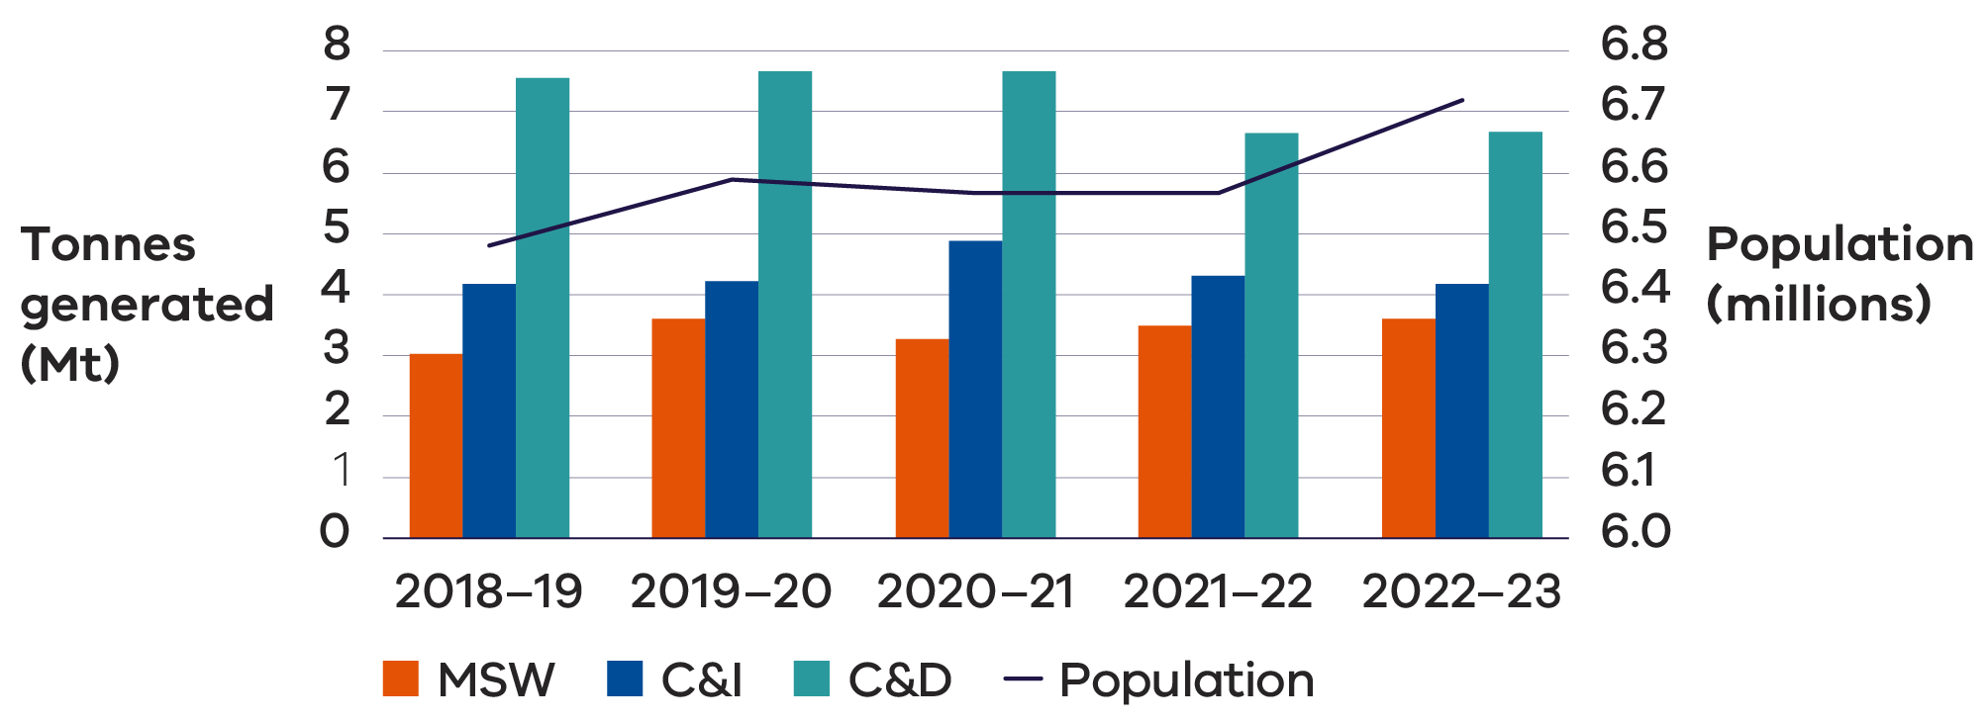

Generally, as a country’s GDP (or GSP in Victoria’s case) increases, so too does its consumption, which can lead to higher levels of waste generation. This relationship can be attributed to several factors:

* Increased consumption – higher GDP (or GSP) typically indicates greater wealth, leading to increased consumption of goods and services, which can generate more waste.
* Industrial activity – countries with higher GDP often have more industrial activity, which can produce significant amounts of waste.

Urbanisation – economic growth frequently drives urbanisation, resulting in concentrated waste generation in cities.

There are cases where GDP (or GSP) trends do not directly correlate with consumption, often due to improved waste management practices and technologies, introduction of price signals or economic incentives to encourage circularity of materials, recycling and waste reduction initiatives, and public policies. Figure 6 illustrates the relationship between waste generation and GSP in recent years.

Figure 6: Waste generation by source compared with Victorian GSP

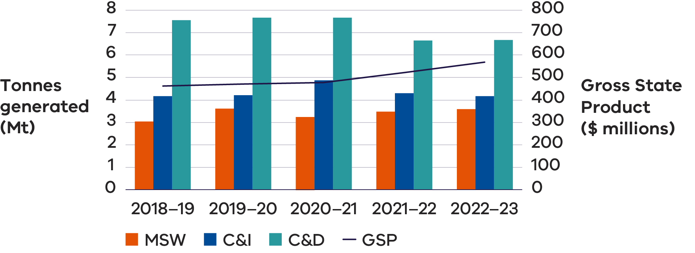

Waste generation has not followed the same trends as GSP growth in Victoria in the last few years. This is possibly attributed to:

* 1 million tonne decrease in material generation from C&D from 2020–21 to 2021–22, driven by efficiencies in material use and reduced infrastructure sector activity

600,000 tonne decrease from 2020–21 to 2021–22 in C&I waste, largely influenced by COVID-19 impact, which disrupted typical waste generation patterns as workplaces shifted to home-based activity and a smaller subsequent drop of 100,000 tonnes from 2021–22 to 2022–23.

### Material reuse and repair

Community leadership and state government funding has supported continued progress in the development of new repair and reuse projects. These programs include repairing and sharing of toys, clothes, nursery items and establishing repair cafes.

Many schools have established second-hand uniform and textbook shops run by volunteers associated with the schools. These allow families more affordable access to school essentials. There are also a number of online platforms and market places that enable people to sell and buy second hand goods privately.

Charitable recycling enterprises are widespread with nearly 650 shops and outlets throughout Victoria, enabling customers to purchase goods including clothes and household items. This network enables people to support not-for-profit organisations and provides environmental benefits by extending the life of unwanted clothing and household goods and contributing to emissions reduction.

# Right to repair

One development in the European market that may have implications for other jurisdictions is the adoption of “right to repair’ rules in April 2024 (European Parliament 2024). The European Commission (2020) calculates premature disposal of consumer goods produces 261 million tons of CO2-equivalent emissions, consumes 30 million tonnes of resources, and generates 35 million tonnes of waste in the EU each year.

Under the new “right to repair” rules, manufacturers have obligations to repair goods, inform consumers about their rights to repair and provide timely and cost-effective repair services. If the item to be repaired is under warranty, the repair triggers an extra year on the warranty.

The list of household goods that are considered repairable include washing machines, vacuum cleaners and smartphones. Consumers may also borrow a device while theirs is being repaired or, if it cannot be fixed, opt for a refurbished unit as an alternative.

Similar programs and policies are emerging in the United States, where right to repair legislation has passed in the last year in California, Colorado, Minnesota and New York (The White House, 2023). California’s new law requires manufacturers to make the parts, tools and documentation needed to diagnose, maintain and repair consumer electronic devices and appliances available to independent repair shops and consumers at fair and reasonable price.

Laws and economic incentives are useful to enable consumers and businesses to support these emerging circular economy opportunities.

Much of Victoria’s material reuse and repair is unrecorded. To support improved information, Charitable Reuse Australia developed the National Reuse Measurement Guidelines, published in October 2024 (Allen et al. 2024). The intent of the guidelines is to provide an overarching reporting framework with organisational level data on environmental, social and economic impacts to be collected from individual reuse organisations and annually provided to Charitable Reuse Australia, who will collate, harmonise, interpret and report on the data.

## Case Study: Repair cafes

The repair cafe movement started in the Netherlands in 2009 and has since grown to a network in over 3000 locations around the world, including in Victoria. There are numerous other organisations providing equivalent services to their community, but with different brands or names. Repair cafes are not repair services as such and are not there to do house calls to repair large appliances or furniture. Volunteer fixers and menders offer their time and skills to help make possible repairs free of charge. People visiting the repair cafe bring broken or damaged items from home – toasters, lamps, hair dryers, clothes, bikes, toys, crockery – anything that is broken is welcome. This helps reduce waste and save money and resources. The volunteers offer their time and skills to members of the community, providing a teaching experience by showing how to do the repairs and encouraging visitors to the café to acquire new skills by using the equipment under supervision.

There is a strong economic case for encouraging the repair of goods. Australian economist Richard Denniss wrote in his book Curing Affluenza: How to Buy Less Stuff and Save the World, that a community that repairs its goods “would employ more people, per dollar spent, than a community that instinctively disposes of them” (Wilson 2019). It would create more high skill jobs and reduce the cost of living.

Victorian Government Circular Economy Communities Fund, has provided almost $5.4 million for social enterprises, including repair cafes. A network of repair cafes exists across Victoria. Different locations measure success in different ways – the number of visitors, the number of items fixed, and the mass of material getting an extended life rather than being destined for landfill.

### Material recovery

Below are the recovery rates per material in Victoria for 2022–23. Acknowledging the limitations of understanding circularity by using resource recovery rates across material streams, they do serve as a good measure in determining which streams are performing better than others in the Victorian market.

Figure 7: Resource recovery rates for key materials in Victoria 2022–23 (Recycling Victoria 1014b)

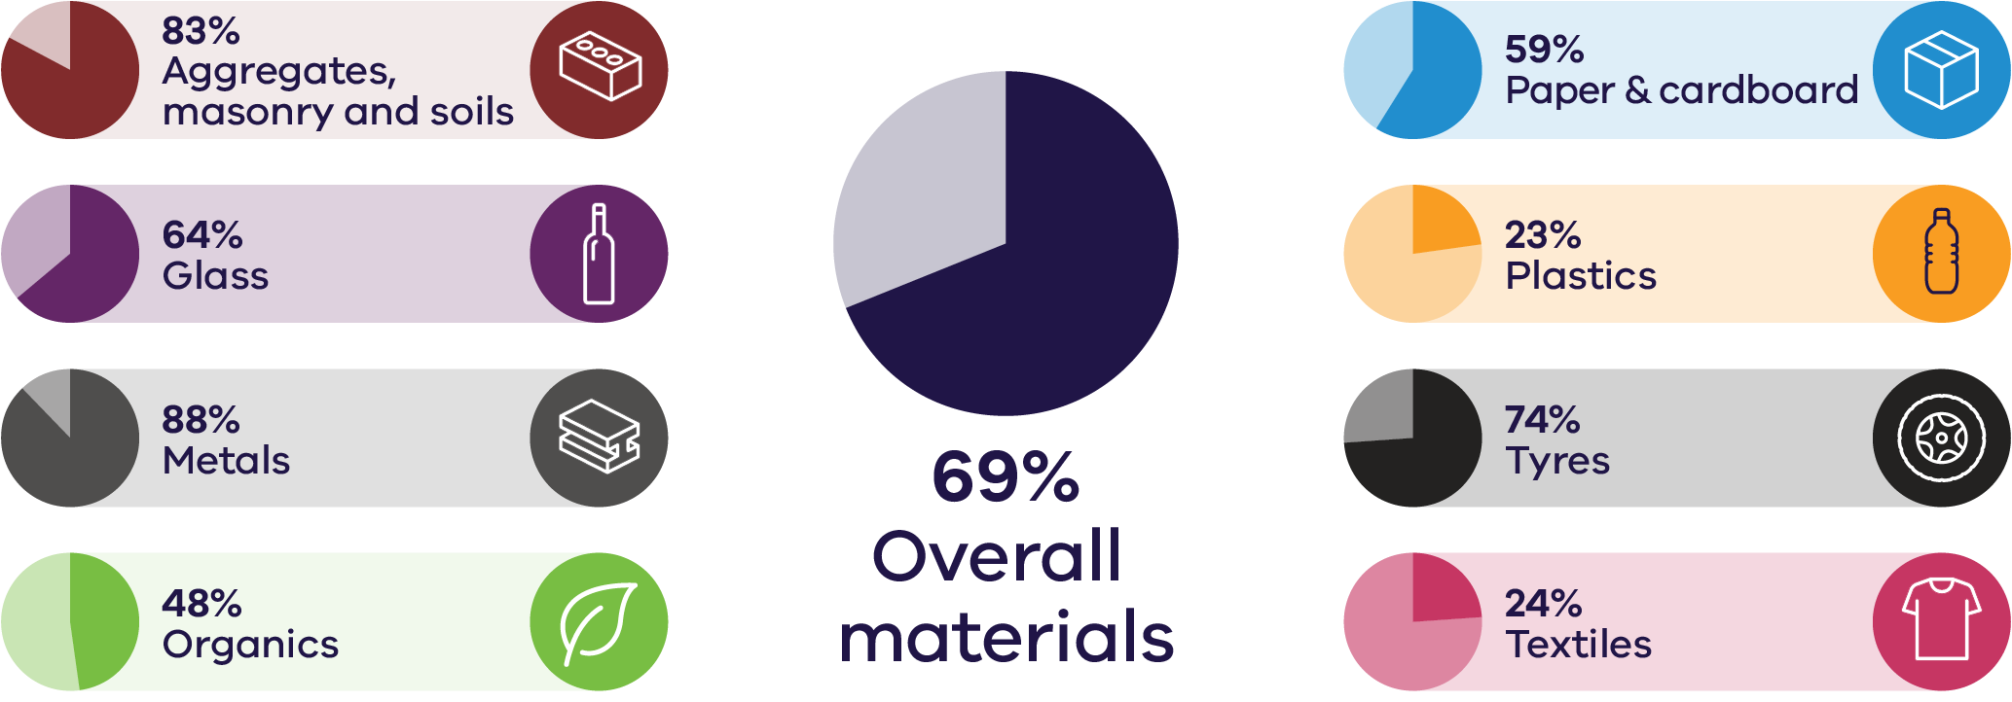

Across recent years, metals, and aggregates, masonry and soils, have had the highest recovery rates within Victoria, with textiles, plastics and organics having the lowest recovery rates.

Table 4: Comparison of the overall recovery rates for the eight key material streams (Recycling Victoria 2024b)

| Material | 2020–21 | 2021–22 | 2022–23 |
| --- | --- | --- | --- |
| Aggregate, masonry and soils | 85% | 83% | 83% |
| Glass | 71% | 63% | 64% |
| Metals | 89% | 89% | 88% |
| Organics | 50% | 47% | 48% |
| Paper and cardboard | 57% | 60% | 59% |
| Plastic | 18% | 23% | 23% |
| Tyres and rubber | 86% | 76% | 74% |
| Textiles | 23% | 21% | 24% |

The recovery rate data indicates a mix of steady performance in the C&D sector, a positive trend in MSW recovery, and challenges in maintaining or improving recovery in the C&I sector and specific material streams. Increased focus on improving waste management strategies for materials like plastics, textiles and organics could further improve recovery rates across all sectors.

The C&D sector continues to report the highest recovery rate among the 3 sectors at 84%. This strong performance is primarily driven by effective recovery in metals, glass and aggregates, masonry, and soils.

The MSW sector has a recovery rate of 56%, showing an increase compared to 2020–21. This improvement is likely a result of the continuing rollout of additional kerbside collection services, specifically FOGO. The changes are also linked to post COVID-19 behavioural shifts, with more people working from home, leading to increased waste being captured by household collection services.

The C&I sector has a recovery rate of 54%, with a small decrease recorded compared to the 2020–21 financial year.

Table 5: Recovery rate for the eight key material streams across the 3 sectors for 2020–21, 2021–22 and 2022–23 (Recycling Victoria 2024b)

|  |  |  |  |  |  |  |  |  |  |
| --- | --- | --- | --- | --- | --- | --- | --- | --- | --- |
| Material | MSW | | | C&I | | | C&D | | |
|  | **2020-21** | **2021-22** | **2022-23** | **2020-21** | **2021-22** | **2022-23** | **2020-21** | **2021-22** | **2022-23** |
| Aggregate, masonry and soils | 13% | 38% | 21% | 11% | 36% | 41% | 89% | 87% | 87% |
| Glass | 69% | 66% | 66% | 75% | 58% | 59% | – | 67% | 67% |
| Metals | 79% | 87% | 85% | 92% | 91% | 91% | 72% | 77% | 76% |
| Organics | 52% | 60% | 60% | 53% | 35% | 36% | – | 12% | 12% |
| Paper and cardboard | 45% | 53% | 52% | 63% | 64% | 64% | 56% | – | – |
| Plastic | 21% | 24% | 31% | 15% | 23% | 12% | 14% | 13% | 16% |
| Tyres and rubber | 57% | 61% | 53% | 88% | 79% | 77% | – | – | – |
| Textiles | 37% | 42% | 44% | 11% | – | 1% | – | – | – |
| **Total** | **49%** | **57%** | **56%** | **60%** | **54%** | **54%** | **86%** | **84%** | **84%** |

**Note:** values indicate that no material was reported as recovered for that material in that year. This is likely due to variations in reporting or the material not being present in those recovery streams for the source sector.

### Residual management

The C&I sector was the largest contributor to total waste material disposed across the 3 sectors in 2022–23, accounting for just over 40%. MSW was the next highest contributor accounting for just over 35% of total disposed material. The C&D sector was the lowest contributor accounting for almost 25% of all waste.

In 2022–23, the waste levy and other economic incentives played a crucial role in reducing waste sent to landfill and promoting higher recovery rates. By imposing a fee on landfilling, the waste levy provided a financial disincentive for businesses and individuals to dispose of waste in landfills, encouraging them to explore alternative waste management options such as recycling, reuse or composting. In 2022–23, the amount payable for each tonne of municipal or industrial waste was $110.79 ($/tonne) in the Melbourne metropolitan area. In rural areas it is $62.95($/tonne) for municipal waste and $116.76 for ($/tonne) industrial waste (EPA n.d.).

### Case Study: Waste levy

The Victorian Waste Levy incentivises waste reduction and resource recovery in Victoria’s waste management through the following means:

**Economic incentives** – The waste levy amount has increased over time, from around $2 a tonne in 1992, under $20 a tonne in 2009–10, to $63.28 a tonne in 2017–18 and $129.27 in 2023–24. A further increase in the waste levy to $167.9 from 1 July 2025, announced in the 2024–25 Victorian Budget (EPA n.d.), will bring the levy more in line with neighbouring jurisdictions and increase waste disposal costs, encouraging businesses and consumers to reduce waste and seek recycling or recovery options.

**Investment in infrastructure** – Revenues from the waste levy are used to promote recycling facilities and technology, enhancing recovery capabilities and efficiency. In 2022–23 $53.1M of public and private investment was leveraged to support investment in the waste management and recovery sector.

**Cost of alternatives** – When the cost of waste disposal rises, the relative cost of recycling and recovery processes becomes more commercially attractive, leading to higher recovery rates. This is underpinned with Environment Protection Authority Victoria (EPA) compliance activities to ensure waste is not diverted and dumped illegally, with $44 million allocated in 2024–25.

**Awareness and education** – Increased waste levies provide a price signal that shifts consumer and business behaviour toward more sustainable and relatively lower cost products with better recyclability. Victoria’s waste levy contributes to the Sustainability Fund which funds activities which promote greater community awareness of recycling. For example, in 2022–23 the $26.6 million Victorian Government Household Education and Behaviour Change Program aligned statewide and local government level communications to educate Victorians to better manage and reduce their household waste.