Can I? Can’t I? Vehicle use on Victorian public land

Photo : Riding a trail-bike on a muddy road within a Victorian Forest.

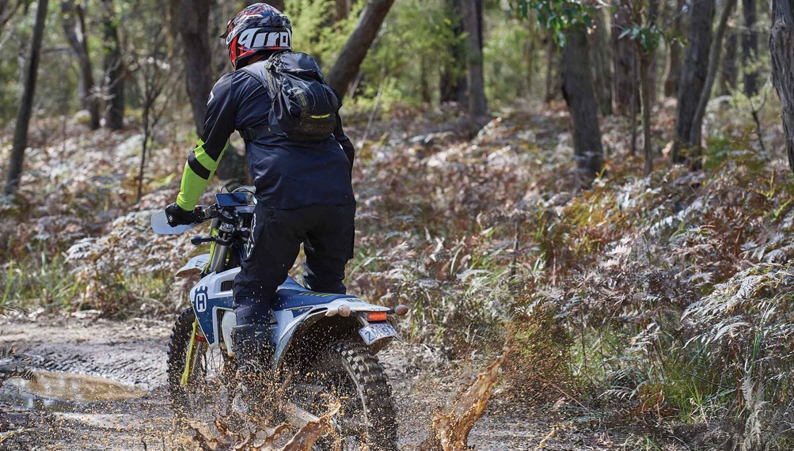

# Help protect our forests and parks.

Riding or driving off-road or on closed roads and tracks can:

* disturb wildlife habitat and plants
* damage seasonal roads and tracks
* risks the safety of you and others

# Penalties apply for breaking the rules.

Things to remember:

* drivers and riders must be licensed and vehicles registered
* registration plates must be fixed and visible on trail bikes at all times
* only use open roads and tracks
* do not ride on single tracks
* reduce speed and noise when around others or in high visitation areas (i.e. picnic areas and campgrounds).

# Common questions and answers

**Who can ride or drive on public land?**

The same road rules apply on public land roads and tracks as on all other public roads in Victoria. Make sure you have a licence and your vehicle is registered.

Mount registration plates on trail bikes so they are clearly visible. You must carry your licence with you while riding.

## Can children ride trail bikes on public land?

No. Riding anywhere on public land in Victoria requires a motorcycle licence or learner permit.

To apply for a licence or permit, you must be a Victorian resident over the age of 18.

## Can I ride an e-bike on public land?

Yes. Higher-powered e-bikes with an output greater than 250 watts are classified as motorcycles so the same motor vehicle rules apply.

This means you must be licenced and your e-bike registered. Higher-powered e-bikes must stay on open roads and tracks on public land.

## Where can I ride or drive?

You can head out on any of the 40,000km of public roads and tracks through our forests,   
parks and reserves.

Stay on formed roads and vehicle tracks that are open to the public. Do not ride on informal single tracks, natural terrain or in streams.

It is your responsibility to look on the FFMVic or Parks Victoria websites if you’re unsure if you can legally travel on a certain road or track.

### Why?

Driving or riding off-road can cause erosion, damage native vegetation, spread disease and weeds, and destroy wildlife habitat. Illegal off-road use also risks your safety as riders and drivers as well as other bush users.

## When can I ride or drive?

Some roads are temporarily closed from autumn to spring but also at other times if necessary to prevent serious road damage. It is an offence to travel on them once they   
are closed. You can check the FFMVic or Parks Victoria websites for seasonal and permanent road closures.

### Why?

Some sections of Victoria’s road network would rapidly deteriorate if they were used   
during the wetter months. If these tracks are damaged, it could result in longer closures for repair works and limit important access for emergency service vehicles during bushfires   
or other emergencies.

## What do I do if I find a track unsafe for use?

Land managers monitor tracks throughout the year to ensure they are fit for use. If you find a track that is unsafe, we encourage you to notify DEECA on **136 186** or Parks Victoria on **131 963**.

### Why?

It is important to assess the conditions yourself while riding as roads can quickly become unsafe due to changing weather conditions.

## Can a person be fined for not following the rules?

Authorised Officers from the Conservation Regulator, FFMVic and Parks Victoria will issue infringement notices if they identify illegal vehicle use.

Authorised Officers conduct frequent patrols on public land and in some areas utilise surveillance technology.

## How can I report illegal vehicle use on public land?

Your assistance helps us to better protect our forests, parks and reserves.

If you witness illegal vehicle use on public land, report it by phone: **136 186**.

## Some key tools to help you locate open, public roads throughout the year:

* More to Explore App
* Vic Traffic App
* Department of Energy, Environment and Climate Action: [deeca.vic.gov.au](http://deeca.vic.gov.au/)
* Conservation Regulator: [conservationregulator.vic.gov.au](http://conservationregulator.vic.gov.au/)
* Parks Victoria: [parks.vic.gov.au](http://parks.vic.gov.au/)
* Forest Fire Management Victoria: [ffm.vic.gov.au](http://ffm.vic.gov.au/)
* MapshareVic:[mapshare.vic.gov.au/mapsharevic](http://mapshare.vic.gov.au/mapsharevic/)

# If you see something, say something.

**Please call 136 186 to report suspected illegal activity.**

# Publication information

## Acknowledgements

We acknowledge and respect Victorian Traditional Owners as the original custodians of Victoria’s land and waters, their unique ability to care for Country and deep spiritual connection to it.

We honour Elders past and present whose knowledge and wisdom has ensured the continuation of culture and traditional practices.

DEECA is committed to genuinely partnering with Victorian Traditional Owners and Victoria’s Aboriginal community to progress their aspirations.

## Copyright

© The State of Victoria Department of Energy, Environment and Climate Action, 2023.

## Creative Commons

This work is licensed under a Creative Commons Attribution 4.0 International licence, visit the [Creative Commons website](http://creativecommons.org/licenses/by/4.0/) (<http://creativecommons.org/licenses/by/4.0/>).

You are free to re-use the work under that licence, on the condition that you credit the State of Victoria as author. The licence does not apply to any images, photographs or branding, including the Victorian Coat of Arms, and the Victorian Government and Department logos.

**ISBN** 978-1-76136-257-6 **(Print)**

**ISBN** 978-1-76136-258-3 **(pdf/online/MS word)**

## Disclaimer

This publication may be of assistance to you but the State of Victoria and its employees do not guarantee that the publication is without flaw of any kind or is wholly appropriate for your particular purposes and therefore disclaims all liability for any error, loss or other consequence which may arise from you relying on any information in this publication.

## Accessibility

To receive this document in an alternative format, phone the Customer Service Centre on 136 186, email [customer.service@delwp.vic.gov.au](mailto:customer.service@delwp.vic.gov.au), or contact National Relay Service on 133 677. Available at DEECA website ([www.deeca.vic.gov.au](http://www.deeca.vic.gov.au/)).

**End of document.**