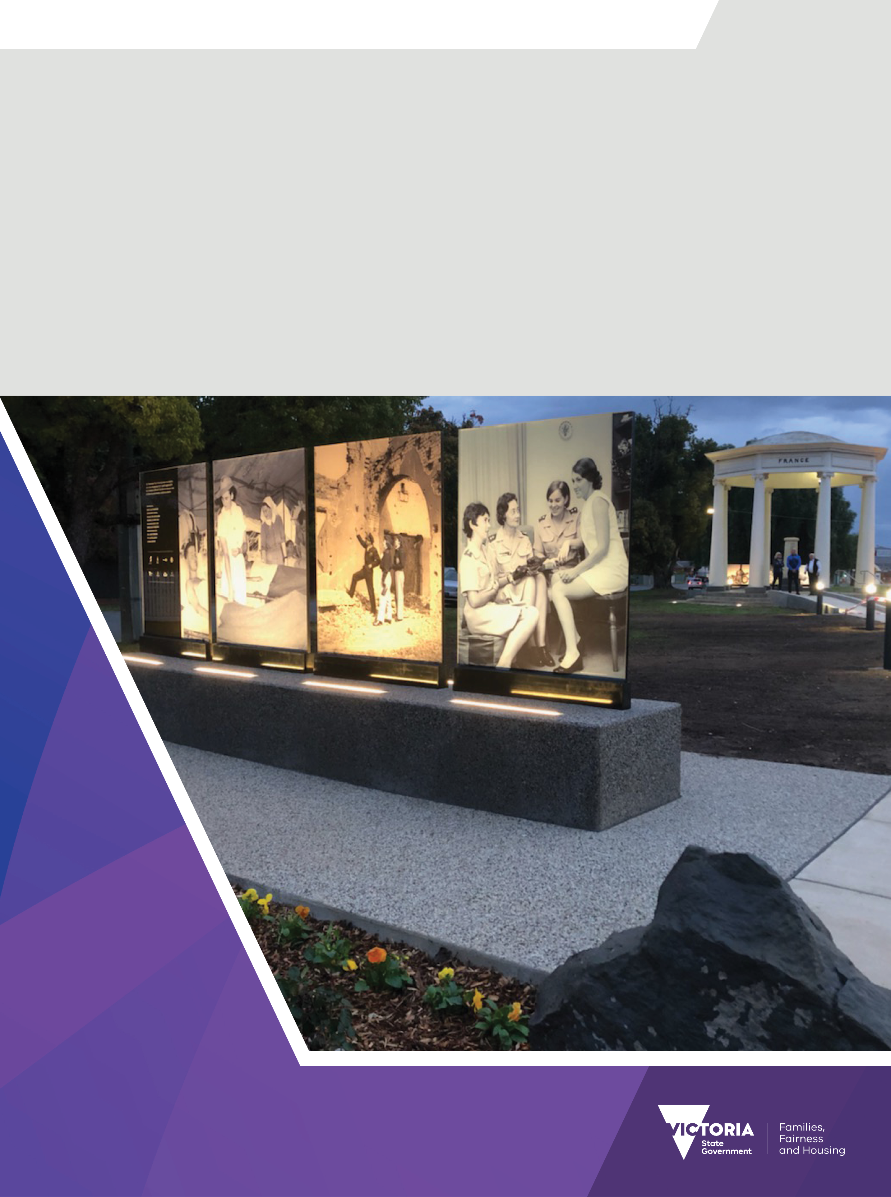Victoria Remembers 2025–26

Program guidelines

OFFICIAL

We acknowledge the Traditional Owners of Country throughout Victoria and pay respects to their Elders past and present. We acknowledge that Aboriginal self-determination is a human right and recognise the hard work of many generations of Aboriginal people.

We are committed to safe and inclusive workplaces, policies, and services for people from LGBTIQA+ communities and their families.

To receive this document in another format, phone the Grants information hotline on 1300 366 356, or email the Veterans Grants team [veteransgrants@dffh.vic.gov.au](mailto:veteransgrants@dffh.vic.gov.au)

**If you need help with communication**

Contact us through the National Relay Service (NRS). For more information:

* visit [National Relay Service](https://www.accesshub.gov.au/about-the-nrs) (https://www.accesshub.gov.au/about-the-nrs) to choose your preferred access point, or
* call the NRS Helpdesk on 1800 555 660.

Authorised and published by the Victorian Government, 1 Treasury Place, Melbourne.

© State of Victoria, Australia, Department of Families, Fairness and Housing, July 2025.

[](https://creativecommons.org/licenses/by/4.0/)

With the exception of any images, photographs or branding (including, but not limited to the Victorian Coat of Arms, the Victorian Government logo or the Department of Families, Fairness and Housing logo), this work, *Victoria Remembers 2025-26 program guidelines*, is licensed under a Creative Commons Attribution 4.0 licence.

The terms and conditions of this licence, including disclaimer of warranties and limitation of liability are available at [Creative Commons Attribution 4.0 International Public License](https://creativecommons.org/licenses/by/4.0/) https://creativecommons.org/licenses/by/4.0/.

You are free to re-use the work under that licence, on the condition that you credit the State of Victoria, Australia (Department of Families, Fairness and Housing) as the author, indicate if any changes have been made to the work and comply with the other licence terms.

This document may contain images of deceased Aboriginal and Torres Strait Islander peoples.

In this document, ‘Aboriginal’ refers to both Aboriginal and Torres Strait Islander people. ‘Indigenous’ or ‘Koori/Koorie’ is retained when part of the title of a report, program or quotation.

ISBN 978-1-76130-841-3 (pdf/online/MS word)

Available at [Victoria Remembers Grant Program](https://www.vic.gov.au/victoria-remembers-grant-program) https://www.vic.gov.au/victoria-remembers-grant-program

(2506380)

# Message from the Minister for Veterans

The Victorian Government is proud to honour the contributions of our veterans. I am pleased to announce the opening of the Victoria Remembers Grant Program for 2025-26.

This longstanding program honours our veteran community. It is about commemorating our significant wartime and peacekeeping history.

Funding supports projects that reflect and preserve the diverse experiences of Victoria’s veterans. It also helps support the families that continue to uplift them.

This year's program also continues to prioritise public education projects. It does so by funding initiatives that build our understanding of the sacrifices made by those people who served our country.

Supporting initiatives such as exhibitions, memorials and educational programs is one small way we can honour our veterans and remember their legacy for generations to come.

I look forward to seeing the diverse range of applications received through this year’s program.



The Hon. Natalie Suleyman MP

Minister for Veterans

Contents

Message from the Minister for Veterans 3

Program overview 5

About Veterans portfolio grants 5

About the Victoria Remembers Grant Program 5

Program objectives 6

Funding priorities 6

Available funding in 2025–26 6

How to apply 7

Eligibility criteria 7

Eligibility overview 7

Organisation eligibility 8

Ineligible organisations 10

Auspice arrangements 10

Eligible activities and costs 10

Ineligible activities and costs 11

Other eligibility criteria – mandatory documents 12

Assessment process 13

Merit assessment 13

Notification of application outcomes 14

Conditions of funding 14

Funding agreements 14

Payment of grant funds and reporting requirements 15

Funding acknowledgement 15

Legal responsibilities 15

Funded events 16

More information and help 16

Access online grant resources 16

Subscribe to our newsletter 16

# Program overview

## About Veterans portfolio grants

The Victorian Government offers grants to support and commemorate veterans and to preserve   
war heritage.

Our grants programs support veteran communities to:

* honour, commemorate and educate Victorians about veterans’ service and sacrifice
* provide welfare and wellbeing-related activities to the ex-service community
* improve veteran community infrastructure
* restore:
  + community war memorials
  + honour rolls
  + avenues of honour.

For more information visit [Grants to support and commemorate veterans](https://www.vic.gov.au/grants-support-and-commemorate-veterans)[1].

## About the Victoria Remembers Grant Program

Victoria Remembers provides grants of up to $30,000 (excluding GST) for projects honouring or commemorating veterans’ service. This includes projects that educate Victorians about veterans’ contributions.

The Office for Veterans in the Department of Families, Fairness and Housing (DFFH) works with the [Victorian Veterans Council](https://www.victorianveteranscouncil.org.au/)[2] to award Victoria Remembers grants in one round each year.

Applicants in this year’s program can apply for commemorative services and projects that run between 1 January to 15 December 2026.

You must submit your application via the [Grants Gateway](https://grantsgateway.dffh.vic.gov.au/)[3] no later than 5:00 pm on Monday 15 September 2025.

**Direct submissions and late applications are not accepted**.

We will notify successful applicants by November 2025.

For more information visit [Grants to support and commemorate veterans](https://www.vic.gov.au/grants-support-and-commemorate-veterans)[4].

# Program objectives

Projects should honour and commemorate the service and sacrifice of veterans or educate Victorians about veterans’ contributions.

## Funding priorities

We prioritise projects that:

* honour, commemorate, or educate about veterans’ service in effective ways
* target veterans who are:
  + women
  + First Nations
  + LGBTIQA+
  + from culturally and linguistically diverse backgrounds (CALD)
  + veterans with disability
  + veterans who have experienced negative impact of service to their mental health
* focus on post-1990 Australian Defence Force operations
* create and expand collaborative partnerships.

Projects should:

* be completed within 12 months of the signed agreement date
* include in-kind contributions, particularly from organisations with multiple or commercial revenue streams. We may look at higher contributions more favourably.

Be aware that:

* You cannot apply for funding if your project has already started or will start before the anticipated announcement date of November 2025.
* Success of previous funding is **not** indicative of future funding through this program.
* Incomplete or incorrect applications are not considered.

Organisations that receive revenue from electronic gaming **are ineligible** to apply.

## Available funding in 2025–26

### Funding available

Organisations can submit more than one application.

* The total value of Victoria Remembers applications in this round must **not** exceed $30,000 (excluding GST).
* Previously funded applicants are **not** guaranteed to receive funding in this or future grant rounds. They are not guaranteed to receive the same amount of funding.

### Activity period

This grant round supports activities that take place between 1 January 2026 and 31 December 2026. Please note:

* You need to complete your project within 12 months of the project approval date.
* You cannot apply for funding if your project starts before 1 January 2026.

# How to apply

Key dates and timelines

| Applications open | Submit application | Applications close |
| --- | --- | --- |
| 28 July 2025 | 28 July – 15 September 2025 | 5:00 pm, 15 September 2025 |
| * Read the guidelines at [Victoria Remembers](https://www.vic.gov.au/victoria-remembers-grant-program)[5]. * Make sure you meet the eligibility criteria. * Seek an auspice arrangement if required. * Access [online grant resources](https://www.vic.gov.au/applying-reporting-veterans-grants)[6]. * Start early to allow time to get necessary:   + information   + quotes   + documents. * Download a PDF copy of your application to review and prepare your responses. * Contact us if you have any questions. * Phone the grants information hotline on 1300 366 356. * Email the Veterans Grants team: [veteransgrants@dffh.vic.gov.au](mailto:veteransgrants@dffh.vic.gov.au) | * Register or log in to the [Grants Gateway](https://grantsgateway.dffh.vic.gov.au/)[7]. * You must be authorised by the organisation to submit the applications. * Save your application as a draft and resume it later. * Upload and submit **all** mandatory and supporting documents with your application. * Submit the application by the due date and time. * You will receive acknowledgement of submission via email. * Note the application number for reference when contacting us about your application. | * We do **not** consider late or incomplete applications. * We assess your application within 2 months of the closing date. |

# Eligibility criteria

## Eligibility overview

To be eligible to apply for funding through Victoria Remembers:

* Your application must be submitted by an eligible organisation. (Refer to the ‘Organisation eligibility’ section.)
* Your organisation must **not** have outstanding reports from previous or current grants funded via the Department of Families, Fairness and Housing (the department)
* you must be seeking funding for an eligible activity (refer to the ‘Eligible activities and costs’ section).

## Organisation eligibility

To be eligible for this program, your organisation must have a valid Australian Business Number (ABN).

If you do not have an ABN, you must provide written advice from the Australian Taxation Office that no withholding tax is required from the grant payment.

Your organisation must also be:

* a company incorporated under the *Corporations Act 2001* and registered as not-for-profit through the Australian Charities and Not-for-profits Commission (ACNC), or
* an organisation incorporated under the *Associations Incorporation Reform Act 2012, Corporations Act* *2001* (Cth) or equivalent state legislation.

If your organisation is unincorporated, you can arrange for an incorporated organisation to act as an auspice on your behalf. Refer to the ‘Auspice applications’ section.

Or, unincorporated organisations are eligible if they are:

* a government entity, for example a local council
* a social enterprise with a clearly stated purpose or mission that specifically relates to the welfare and wellbeing of veterans. Social enterprises must attach their constitution with their application.

A social enterprise is an organisation that has an economic, social, cultural or environmental mission consistent with a public or community benefit; and operates by one of the following impact models:

* employment-generating – creates employment and training opportunities for marginalised people
* community need – delivers accessible products and services to meet community needs that are not met by the market
* profit redistribution – donates at least 50% of profits or revenue to charity.

Social enterprises must submit their constitution and proof of their social enterprise impact model.

Besides all the above, to be eligible, your organisation must:

* show that your main activity is providing welfare or wellbeing services or supports to the ex-service community in Victoria
* be financially solvent
* be based in Australia. **Note**: funded projects must be delivered in Victoria.

How to check your Australian Business Number (ABN)

* To check your ABN, visit the [Australian Business Register (ABR)](https://abr.business.gov.au/)[8]

How to check your organisation type:

* For incorporated associations, co-operatives or organisations incorporated through other means go to [Consumer Affairs Victoria](https://www.consumer.vic.gov.au/)[9]
* For a Company Limited by Guarantee go to [ASIC Connect Online](https://connectonline.asic.gov.au/RegistrySearch/)[10]
* For registered charities go to [Australian Charities and Not-for-profits Commission (ACNC)](https://www.acnc.gov.au/charity/charities)[11]
* For Aboriginal corporations go to [Office of the Registrar of Indigenous Corporations (ORIC)](https://www.oric.gov.au/)[12].

### Figure 1: Organisation eligibility chart

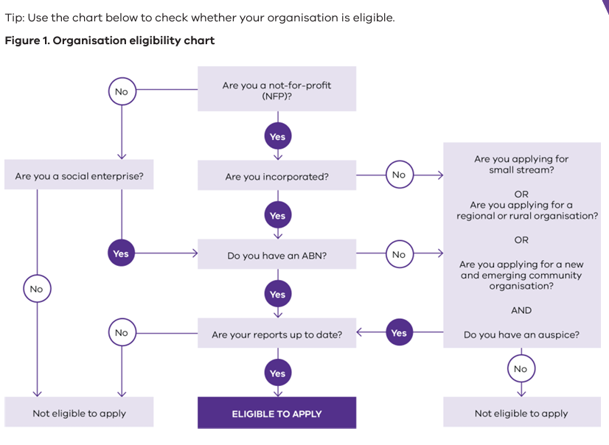

To check if your organisation is up to date on reporting requirements, please view your current grants in the [DFFH Grants Gateway](https://grantsgateway.dffh.vic.gov.au)[13].

Any report which is showing as red is overdue. These reports must be completed before you submit your application to this grant program to avoid disappointment.

Or, email the Veterans Grants team [veteransgrants@dffh.vic.gov.au](mailto:veteransgrants@dffh.vic.gov.au) to check whether your organisation is up to date with grant reporting requirements.

## Ineligible organisations

Organisations that **cannot** apply include:

* state and federal government departments
* individuals and sole traders
* public companies limited by shares – unless the foundational document can prove not-for-profit status
* commercial enterprises
* organisations that have failed to comply with the terms and conditions of previously awarded grants from any Department of Families, Fairness and Housing grant program
* groups whose projects are the responsibility of another Victorian government department
* hospitals and health service organisations.

Funding for this grant comes from the [Community Support Fund](https://www.dtf.vic.gov.au/funds-programs-and-policies/community-support-fund)[14]. This means organisations that receive revenue from electronic gaming **are not eligible** to apply.

## Auspice arrangements

If your organisation is not incorporated or does not have an ABN, you may consider partnering with another organisation that meets these eligibility criteria who will accept legal responsibility for the grant. This is known as an auspice arrangement.

If the application is successful, your organisation will deliver the activity, but the auspice organisation will be responsible for:

* signing the grant funding agreement with the department
* ensuring the legal and financial requirements of the grant and funding agreement are met
* receiving and distributing grant funds under the funding agreement
* ensuring all project activities are completed
* submitting reports and financial acquittals on behalf of your organisation.

If you want to propose an auspice arrangement the application must include:

* a letter of support from the auspice organisation. This is a mandatory document for all applications with auspice arrangements.
* a memorandum of understanding outlining roles and responsibilities between the 2 organisations

Please note:

* The auspice organisation must formally agree to support your application before you submit.
* The department may decide to communicate with the auspice organisation (instead of, or in addition to, the grant recipient). It may do this in relation to any aspect of the funding agreement.

## Eligible activities and costs

From 1 January 2025, organisations that are not registered for GST can use grant funds to cover the cost of GST from goods and services bought with the department’s grant funds. These organisations should provide **GST inclusive** costs in their grant application and acquittal report. GST registered organisations should continue to show GST exclusive costs in their application and all reporting.

More information, including what this means for your grant application, is available from the [Grants Gateway](https://grantsgateway.dffh.vic.gov.au/s/help-guides-and-documents)[15].

Examples of projects we might fund include:

New war memorials:

* for districts without an adequate existing memorial
* that commemorate the service or sacrifice of veterans in a specific battle or campaign relevant to a local area, and which does not already exist in Victoria
* in honour of individuals awarded the Victoria Cross
* creative or modern interpretation of a memorial

Commemorative events:

* that commemorate major or significant anniversaries, for example every 5th or 10th year anniversary. Lower priority may be given to other anniversaries.
* that honour or commemorate service and sacrifice of Victorian veterans
* that are of local or regional significance
* encourage school students or children to attend

Public education projects:

* applications for digital publications that include evidence of diverse and broad distribution channels
* that educate Victorians about the service and sacrifice of veterans
* that use digital forms of storytelling, for example websites, podcasts, short films. These may be given a higher priority.

Preservation of wartime heritage

* that preserves war heritage for future generations
* for expert assessment or materials to conserve objects of demonstrated historical significance
* that increase public access to heritage by creating displays.

Please note: Memorabilia displays should be publicly accessible.

## Ineligible activities and costs

Ineligible projects include:

* repair and restoration of existing war memorials. The Restoring Community Memorials and Avenues of Honour Program is for these projects.
* capital works, maintenance or repairs to buildings and office equipment – the Capital Works Grants Program is for these projects
* projects located outside Victoria or on Defence land
* buying or restoring:
  + weapons
  + decommissioned military assets and armoured vehicles
* ongoing staffing, administrative, office or equipment costs, for example:
  + IT equipment
  + musical instruments
  + sporting equipment
  + white goods
  + coffee machines
* landscape beautification and cosmetic improvements
* university research projects
* administrative, advertising or office equipment purchasing costs, for example:
  + computers
  + printers
  + white goods
* buying vehicles, for example:
  + cars
  + buses
* veterans’ reunions and conferences
* personal memoirs, unit or ship histories
* functions and event catering
* interstate and overseas travel
* printing costs
* publishing of books.

Also, Victoria Remembers does not support activities that:

* are funded primarily under another state, federal, local government program
* are within the responsibility of another state, federal, local government program
* have already started or been completed, including any activities undertaken before notification of the application outcome
* are private sector projects undertaken because of a Victorian Government contract.

Please note:

* If you are unsure about whether a cost can be supported under Victoria Remembers, please contact the Veterans Grants team before submitting your application. Refer to the ‘More information and help’ section.
* You may be offered a smaller funding amount than you applied for. We may ask for a revised project plan and budget.

## Other eligibility criteria – mandatory documents

You need to submit the following mandatory documents with your application:

* evidence that your organisation is one of the following:
  + ex-service organisation
  + local government authority
  + not-for-profit organisation
  + educational institute
* annual statement:
  + evidence of your organisation’s financial information over a 12-month period. We need this to make sure your organisation is viable and financially responsible.
* evidence that any project income from other sources is approved and available before submitting your application
* auspice applications must provide the signed Accepting an Auspice Arrangement form from the auspice organisation. You can download this form from the [Victoria Remembers Grant](https://www.vic.gov.au/victoria-remembers-grant-program)[16] page on the Victorian Government website. You also need letters of support from other organisations, agencies or partners involved in your project.

Please note:

* You can attach documents to your online application. Check carefully to make sure all attachments are uploaded before you submit your application.
* If you have trouble uploading documents online, you can email them to the Veterans Grants team [veteransgrants@dffh.vic.gov.au](mailto:veteransgrants@dffh.vic.gov.au). Make sure you include your application number with the email. You must submit all documents before the due date.
* You **do not need** to provide letters of support from government officials or representatives. For example, your local Member of Parliament or councillor. We do **not** consider these in the assessment process.

# Assessment process

All applications to the Victoria Remembers Grant Program undergo the following assessment process:

* **Eligibility assessment** – all applications undergo an eligibility assessment against the eligibility criteria. The eligibility assessment determines whether the application should proceed to the merit assessment stage.
* **Merit assessment** – eligible applications are assessed against the assessment criteria, based on responses you provide on the application form.
* **Assessment panel** – all applications are reviewed by a panel, which includes representatives from the Victorian Veterans Council.
* **Ministerial approval** – the Minister for Veterans makes the final decision based on the recommendations from the assessment panel.
* **Application outcome** – all applicants are notified of the outcome of their application by email.

**All decisions are final**. This includes decisions about any aspect of the:

* funding application
* eligibility or assessment process, including:
  + any decision to offer or award a grant under the Anzac Day Proceeds Fund
  + any decision to withdraw the offer or cancel the grant funding agreement.

## Merit assessment

Eligible applications are assessed on merit. We use the following assessment criteria.

We will ask ‘what, why, how and who’ to determine the benefits the project provides to veterans and the wider Victorian community.

* **What is the project?**
  + Describe the project and how it will educate Victorians or commemorate veterans’ service.
  + How is your organisation making a difference for veterans and their families?
* **Why is there a need for the project?**
  + Who will benefit from your project?
  + Is your project addressing a priority cohort?
  + Why is your project necessary?
  + What will happen if the project is not funded?
  + If your project is education based, who and how many people will it reach?
  + If your project is to honour and commemorate veterans’ service, how will it achieve this?
* **How have you planned for the project and what steps will you take to deliver it?**
  + When do you expect the project to start?
  + How will the project be delivered?
  + How will you promote the project? For example, how will you promote your new memorial or education program?
  + Does the project require any approvals permits or other permissions?
* **How will you manage the project?**
  + Will staff or volunteers manage the project?
  + Do you have the capacity to complete the project in 12 months?
  + Do you need to consult with others to deliver this project?

# Notification of application outcomes

We give you written notification of the outcome of your application.

If you are successful, we tell you about any specific conditions attached to the grant. We publish details about your project, including its name, description and grant amount, on the [Victoria Remembers](https://www.vic.gov.au/victoria-remembers-grant-program)[17] website.

If you are unsuccessful, you may ask us for feedback about your application.

# Conditions of funding

## Funding agreements

If successful, you must enter a legally binding Victorian Common Funding Agreement (VCFA) with the department. You must enter into this agreement by the milestone date set in the Activity Deliverables and Payments Table of your VCFA. If you do not accept the agreement during this time, the grant may be withdrawn.

The VCFA outlines:

* the grant’s terms and conditions, including use of funds
* key deliverables and due dates
* reporting requirements.

If you need to request a variation to the VCFA or ask for a reporting extension, email the Veterans Grants team [veteransgrants@dffh.vic.gov.au](mailto:veteransgrants@dffh.vic.gov.au).

## Payment of grant funds and reporting requirements

If you are successful in receiving funding, your organisation will need to submit a final report and financial acquittal. You may also need to provide progress reports for complex or high-value projects.

Milestone payments are made via electronic funds transfer (EFT) once deliverables are met, in line with the VCFA.

You must use all funds during the activity period, as outlined in the VCFA. You must return any unspent funds to the department.

### Goods and services tax (GST)

* GST is paid if the grant is funding a good or service, and if the recipient organisation is registered for GST.
* GST is **not** paid if the recipient organisation is not registered for GST.
* GST is **not** paid if the recipient organisation is a government entity (e.g., school, local council).
* GST is **not** paid if the grant is **not**funding a good and/or service.

The Australian Taxation Office (ATO) considers grants and sponsorships as taxable income. The ATO can help with information on tax, including GST. Call 13 28 66 or [visit the ATO](https://www.ato.gov.au/)[18].

## Funding acknowledgement

Successful applicants must acknowledge that funding for the project came from the Victorian Government and the Victorian Veterans Council (VVC).

The VCFA sets out guidelines around promotion. These include a requirement that all activities must acknowledge support from Victorian Government and VVC. You must include the appropriate logos on any activity-related publications and websites, media releases and promotional materials, project hardware and formal event invitations.

You must formally invite the Victorian Government and the VVC to attend any official events related to the project (for example, a project launch or exhibition). We will send you the acknowledgement requirements if your project is funded.

## Legal responsibilities

If you apply for a grant, you must make sure the project activity follows relevant:

* legislation
* regulations
* by-laws
* codes.

It must also meet the requirements of any:

* Commonwealth
* state
* territory
* local authority.

It is your responsibility to know the laws and protocols that regulate your work.

## Funded events

Events funded by the department must be respectful and open to all Victorian communities to attend.

Please make sure that your event is inclusive and consider an Acknowledgement of Country or Welcome to Country, the accessibility of your event and its environmental impact.

# More information and help

* Phone the Grants information hotline on 1300 366 356.
* Email the Veterans Grants team at [veteransgrants@dffh.vic.gov.au](mailto:veteransgrants@dffh.vic.gov.au) with your query. You can also request a call back (during business hours).

**If you need an interpreter** please email the Veterans Grants team at [veteransgrants@dffh.vic.gov.au](mailto:veteransgrants@dffh.vic.gov.au) to request a call back, advising us of your preferred language.

**If you need help with communication,** contact us through the National Relay Service (NRS). For more information:

* visit [National Relay Service](https://www.accesshub.gov.au/about-the-nrs)[19] to choose your preferred access point, or
* call the NRS Helpdesk on 1800 555 660.

## Access online grant resources

[Visit the Applying and reporting veterans grants](https://www.vic.gov.au/applying-reporting-veterans-grants)[20] website for resources on:

* how to write a grant application
* how to access the department’s Grants Gateway
* common grants words and terms
* in-kind contributions
* auspice arrangements and how to know if you need one.

## Subscribe to our newsletter

For updates on upcoming grant rounds, [subscribe to the Veterans Grants email newsletter](https://www.vic.gov.au/veterans-subscriptions)[21].

1. https://www.vic.gov.au/grants-support-and-commemorate-veterans
2. https://www.victorianveteranscouncil.org.au/
3. https://grantsgateway.dffh.vic.gov.au/ to complete an application
4. https://www.vic.gov.au/grants-support-and-commemorate-veterans
5. https://www.vic.gov.au/victoria-remembers-grant-program
6. https://www.vic.gov.au/applying-reporting-veterans-grants
7. https://grantsgateway.dffh.vic.gov.au/
8. https://abr.business.gov.au/
9. https://www.consumer.vic.gov.au/
10. https://connectonline.asic.gov.au/RegistrySearch/
11. https://www.acnc.gov.au/charity/charities
12. https://www.oric.gov.au/
13. https://grantsgateway.dffh.vic.gov.au
14. https://www.dtf.vic.gov.au/funds-programs-and-policies/community-support-fund
15. https://grantsgateway.dffh.vic.gov.au/s/help-guides-and-documents
16. https://www.vic.gov.au/victoria-remembers-grant-program
17. https://www.vic.gov.au/victoria-remembers-grant-program
18. https://www.ato.gov.au
19. https://www.accesshub.gov.au/about-the-nrs
20. https://www.vic.gov.au/applying-reporting-veterans-grants
21. https://www.vic.gov.au/veterans-subscriptions