Ride for tomorrow

Safe and legal trail bike riding

Table of Contents

Introduction 2

Before you go 2

Choose the right bike 2

Protect yourself 6

Licence and registration 8

When you’re there 10

Where to ride 10

Visitor areas 10

Share the forest 11

Safe riding tips 12

TAC coverage 12

Publication information 14

# Introduction

Trail bike riding is a popular, fun and adventurous way to enjoy the Victorian outdoors, and riders have access to a range of roads, tracks, and experiences across public and private land.

This booklet contains information to help riders develop safe riding practices to protect themselves, others and the environment.

# Before you go

## Choose the right bike

It’s important to choose a bike that is safe, legal and suits your experience and activity.

**Trail bikes:** reliable, easy-to-ride and can be used on both public land tracks and sealed roads.

Image 1: A trail bike

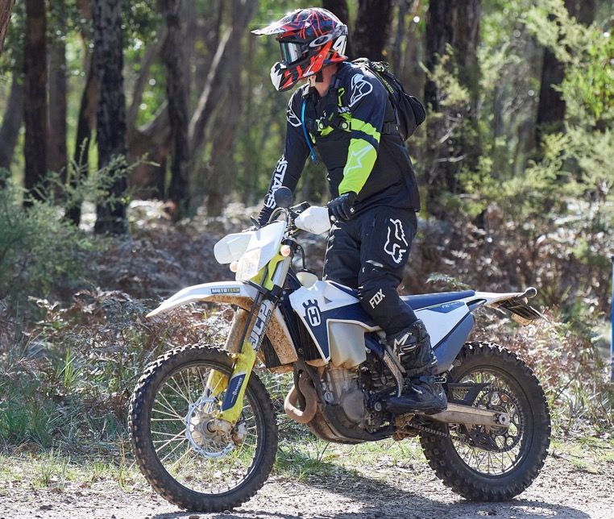

**Enduro bikes:** lightweight, high-performance vehicles mainly for endurance riding events on private land, but also great for trail riding.

Image 2: An enduro bike

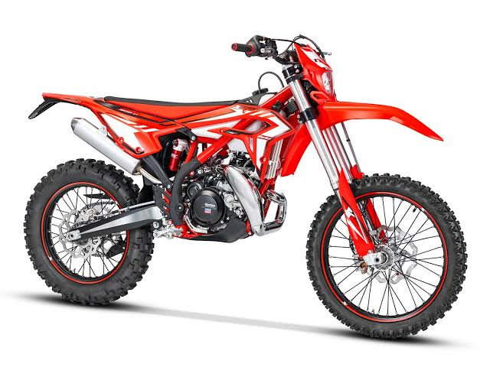

**Motocross bikes:** best for high-speed competition riding on an enclosed, man-made course, not sealed roads or public land tracks.

Image 3: A motocross bike

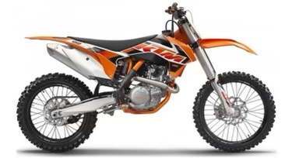

**Dual-sport and adventure bikes** have big engines, large fuel tanks and can comfortably carry you and your multi-day supplies, making them great for long-distance dirt road touring rides.

Image 4: A dual-sport/adventure bike

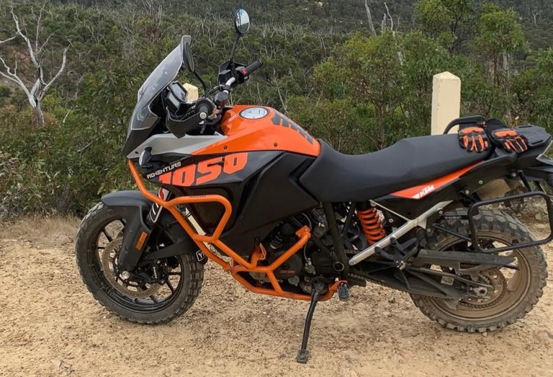

**Trial bikes:** light, responsive vehicles, best for slow, technical riding around natural and man-made obstacle courses on private land.

Image 5: A trial bike

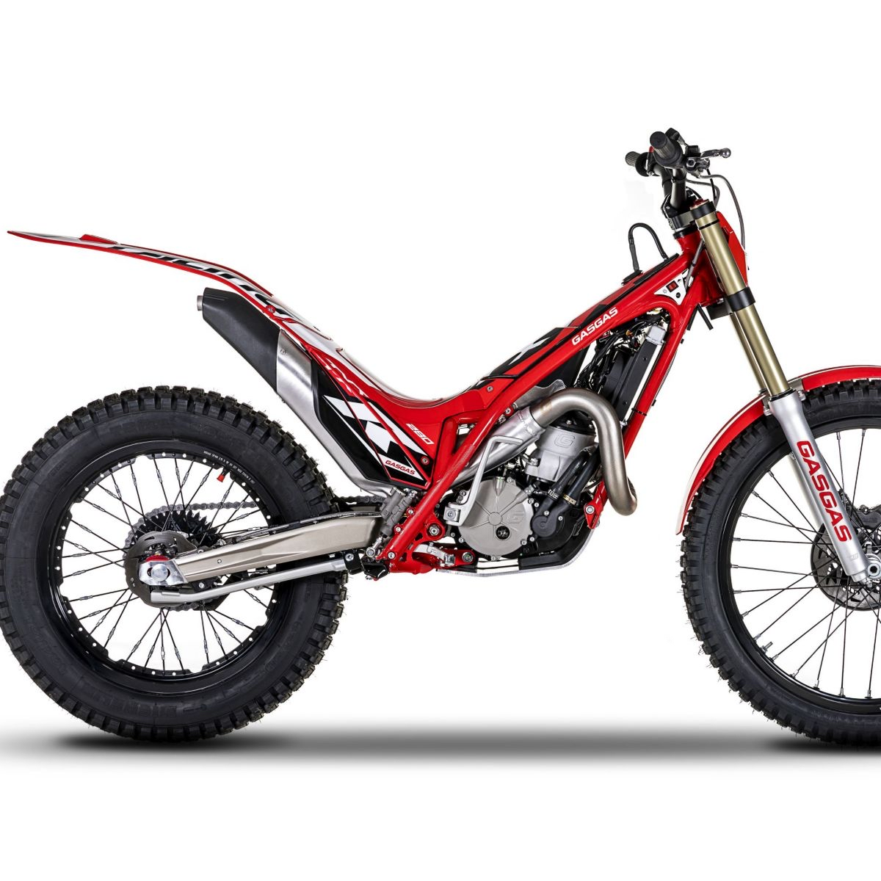

**Minibikes:** small, lightweight bikes for use by riders under 12 yrs on private property or motorcycle club tracks only.

Image 6: A minibike

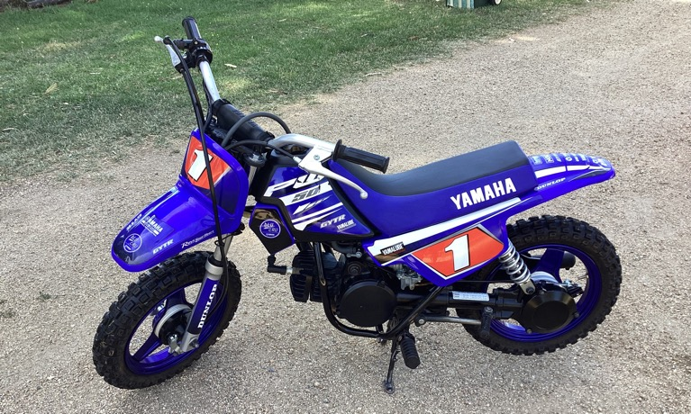

**Quad bikes:** for use on private land only. It is also possible to get conditional registration for limited public road use.

Image 7: A quad bike

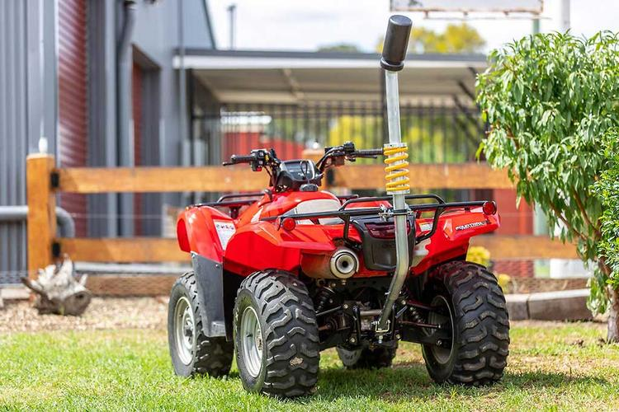

### Not sure which bike is right for you?

Visit your local motorcycle dealer for advice.

## Protect yourself

Trail bike riders all hit the dirt sooner or later but wearing the right protective gear when it happens can reduce the severity of your injury.

**Remember:**

* No amount of protective equipment is a safety substitute for riding responsibly, under control, and within your ability.

Even if it’s a short ride, always wear your personal protective equipment.

### Need advice about protective equipment?

Visit your local motorcycle dealership to ensure correct fit, comfort, and performance.

Motocap independently tests and rates motorcycle clothing. The results are available at [www.motocap.com.au](https://www.motocap.com.au/)

Protective equipment includes:

* **Goggles** protect eyes from dust, twigs, stones, and bugs. Goggles approved to Australian Standard 1609-1981 are best. Regular sunglasses aren’t enough.
* **Helmets** are compulsory when riding on public land and all motorcycle club tracks. To give your head the best protection available, you must wear a helmet approved to AS/NZS 1698:2006 or ECE 22.05 (or any later version of that standard).
* **Clothing** needs to cover your body and should be heavy duty, abrasion resistant, and able to be worn with body armour.
* **Gloves** protect hands and give a better grip on controls.
* **Body armour** is crucial in an accident. The best impact protection is approved by European Standards – marked CE or EN 1621-1 (limb protection) and 1621-2 (back protectors).
* **Boots** designed for dirt bike riding protect your lower legs, ankles and feet, which are easily injured.

Image 8: Essential motorcycle protective equipment

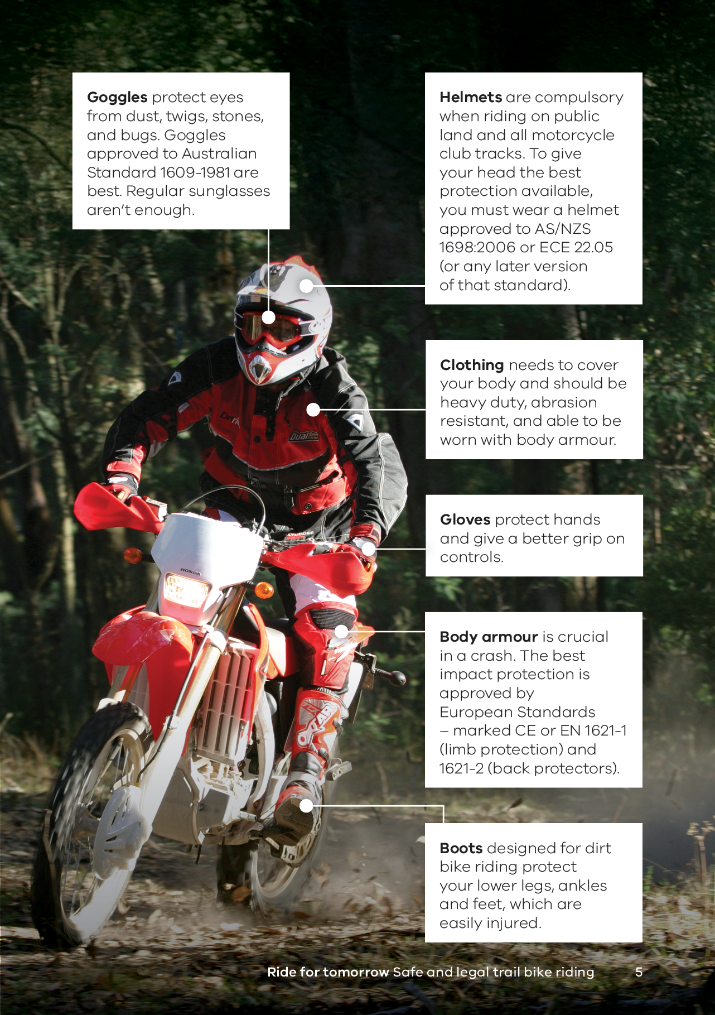

## Licence and registration

**To ride your bike on public land, you must have the correct licence and registration.**

### Licences

* To hold a Victorian motorcycle licence or learner permit, you must be 18 years or older and live in Victoria. A car licence does not authorise you to ride a motorcycle.
* All riders must only ride bikes they are approved and competent to use. Riders with a Motorcycle Learner Permit or restricted motorcycle licence holder can only ride bikes under the Learner Approved Motorcycle Scheme (LAMS).
* Both experienced and beginner riders should undertake accredited motorcycle training to develop their skills and riding awareness.

### Registration

* Full registration allows you to use your motorcycle on any open public road, but unregistered motorcycles can only be used on private property.
* Recreational registration is a cheaper alternative to full registration but has restrictions on where you can ride. Recreation registered motorcycles are permitted on formed, open roads on public land, but not on freeways, arterial roads or any roads within built up areas (defined by speed zones under 100km/h).
* Registering your motorcycle has other benefits, including making it easier to identify if it goes missing and providing coverage if you are injured in a crash (see page 13).
* You can also register for a Motorcycle Crash Card at <https://transport.vic.gov.au/road-rules-and-safety/motorcycles/motorcycle-safety-levy/motorcycle-crash-card> - Transport Victoria. The card provides emergency service personnel with personal information that can assist first responders.

**Remember:**

* Always carry your licence with you when riding.
* You can get your digital driver licence on your phone through the myVicRoads or Service Victoria app, or carry your plastic licence.
* Mount your registration plate on the back of your motorbike so it's clearly visible.

Riding a motorcycle on public land without a licence or registration is a serious offence and carries heavy penalties. Also, if you have an crash you may not be covered by the TAC.

For more information about motorcycle licences and rules go to:   
<http://www.transport.vic.gov.au/registration-and-licensing/licences/motorcycle-licence>

[](http://www.transport.vic.gov.au/registration-and-licensing/licences/motorcycle-licence)

For more information about ongoing motorcycle registration go to: [www.vicroads.vic.gov.au/registration](http://www.vicroads.vic.gov.au/registration)

[](http://www.vicroads.vic.gov.au/registration)

# When you’re there

## Where to ride

Licensed riders on registered motorcycles have access to around 40,000km of public roads and tracks in Victoria’s forests, parks, and reserves. Many of these roads are for 4WD and offer an adventurous ride!

Vehicles must stick to open, formed roads while on public land. It’s a serious offence for trail bike riders to go off-road, including creating or using illegal single trails, or riding on roads closed to the public.

Unlicenced riders and riders with unregistered bikes are limited to private land and motorcycle club venues.

### Why not join a motorcycle club?

Clubs offer friendship, training, and a supervised place to ride.

## Visitor areas

Trail bike visitor and unloading areas are available in many forests, parks and reserves. They often have facilities like parking areas, toilets, picnic tables, and information boards. In some cases, suggested riding routes are signposted for riders not familiar with the area.

More information on trail bike routes, unloading areas, and road closures is available on the *More to Explore* App



## Share the forest

**Forests and parks are for everyone, and trail bike riders must share these areas with other visitors and the native wildlife that lives there.**

### Protect non-riders

* Keep speed and noise down near residential areas and recreation areas, like campsites and picnic spots.
* When approaching hikers or mountain bikers, slow down and let them pass before continuing to ride.
* When approaching horse riders, stop, turn off engines, and remove helmets. Horses frighten easily!
* Obey road rules and watch out for cars and other trail bikes. Stick to the left and be careful on corners.

### Protect the environment

* Stay on formed roads and public vehicle tracks. Riding in streams, on natural terrain or illegal single trails can cause erosion, damage native vegetation, and destroy wildlife habitat.
* Look out for native wildlife and avoid disturbing, touching or feeding them.

Wash vehicles and equipment before each ride to limit the spread of weeds and disease.

**It’s your responsibility to look out for the bush and other forest users while riding.**

## Safe riding tips

* **Ride smart:** stick to your skill level and control your speed.
* **Check conditions:** monitor weather forecasts and plan ahead to avoid days of high bushfire risk or storm events.
* **Don’t go alone:** always ride with a friend or let someone know where you’re going and when you’ll be back.
* **Be prepared:** take a map, plenty of food and water, first aid supplies and communication tools like a radio and a Personal Locator Beacon (PLB).
* **Be aware:** ride new tracks slowly until you are familiar with them or stop and walk the most challenging sections. This helps you navigate any blind corners, steep drop-offs, or trees that have fallen across tracks.
* **Stay on-road:** Don’t ride on mountain bike tracks or walking paths – these networks are unsafe for motorbikes and put other visitors at risk. Never use or create illegal single trails as they’re not built or maintained to any standard and not officially mapped, making it harder for emergency services to locate and assist you in an in a crash or an emergency.
* **Follow Victorian Road Rules**: All riders must follow Victoria Road Rules when riding on public roads and drink and drug driving offences apply on private land.

## TAC coverage

In Victoria, the Transport Accident Commission (TAC) promotes road safety and provides support for people injured in road crashes.

The TAC is funded from vehicle registration fees and covers the reasonable cost of medical treatment and support services.

It is a ‘no fault’ scheme so benefits will be paid to an injured person regardless of who caused the crash. However, if someone else was at fault and you are seriously injured, you may also be able to seek compensation.

**Remember:**

* TAC coverage from registration is the best value personal injury insurance riders can have.
* Recreational and Full Registration offer the same benefits.
* TAC does not cover damage to vehicles.

TAC may not cover injuries at motorsport or club events.

### More information

More information is available from TAC at [www.tac.vic.gov.au](http://www.tac.vic.gov.au/)



# Publication information

## Acknowledgements

We acknowledge and respect Victorian Traditional Owners as the original custodians of Victoria’s land and waters, their unique ability to care for Country and deep spiritual connection to it.

We honour Elders past and present whose knowledge and wisdom has ensured the continuation of culture and traditional practices.

DEECA is committed to genuinely partnering with Victorian Traditional Owners and Victoria’s Aboriginal community to progress their aspirations.

## Copyright

© The State of Victoria Department of Energy, Environment and Climate Action, June 2025.

## Creative Commons

This work is licensed under a Creative Commons Attribution 4.0 International licence, visit the [Creative Commons website](http://creativecommons.org/licenses/by/4.0/) (<http://creativecommons.org/licenses/by/4.0/>).

You are free to re-use the work under that licence, on the condition that you credit the State of Victoria as author. The licence does not apply to any images, photographs or branding, including the Victorian Coat of Arms, and the Victorian Government and Department logos.

**ISBN** 978-1-76176-026-6 **(print)**   
**ISBN** 978-1-76176-027-3 **(pdf/online/MS word)**

## Disclaimer

This publication may be of assistance to you but the State of Victoria and its employees do not guarantee that the publication is without flaw of any kind or is wholly appropriate for your particular purposes and therefore disclaims all liability for any error, loss or other consequence which may arise from you relying on any information in this publication.

[conservationregulator.vic.gov.au](http://conservationregulator.vic.gov.au/)

## Accessibility

To receive this document in an alternative format, phone the Customer Service Centre on 136 186, email [customer.service@delwp.vic.gov.au](mailto:customer.service@delwp.vic.gov.au), or contact National Relay Service on 133 677. Available at DEECA website ([www.deeca.vic.gov.au](http://www.deeca.vic.gov.au/)).

**End of document.**