# Whole of Victorian Government Social Media Operational Guidelines

Prepared by Department of Premier and Cabinet (2025)

### Why are these guidelines important?

Social media provides unique opportunities for Victorian Government departments and agencies to engage with Victorians. Departments and agencies can build a profile and generate a social media following by opening up a two-way conversation with the public. These interactions can help increase the reach of your social media posts but there are risks, including being sued for defamation. This is particularly important in the context of the recent High Court case of *Fairfax Media Publications Pty Ltd v Voller* where the Court held that an entity that operates social media accounts can be considered the publisher of third-party comments[1] and could be liable in defamation for such comments.

These guidelines help provide a best practice guide for Victorian Government departments and agencies to meet the standards set out in the Social Media Operational Policy.

These guidelines do not cover the use of social media for personal or workplace communications (Microsoft Teams), or department or agency-specific social media policies. For guidance on personal use, refer to the [[Code of Conduct for Victorian Public Sector Employees](https://vpsc.vic.gov.au/ethics-behaviours-culture/codes-of-conduct/code-of-conduct-for-victorian-public-sector-employees/)](https://vpsc.vic.gov.au/resources/code-of-conduct-for-employees/).

These guidelines focus on social media moderation. For more information on general social media operation, read your entity’s social media documents and visit the [Use social media](https://www.vic.gov.au/use-social-media) guide and [Social media branding – digital guide](https://www.vic.gov.au/social-media-branding-digital-guide).

### What is covered in this document?

The guidelines in this document cover:

* Social media strategy
  + Risks and mitigation
  + Identifying potentially defamatory content
  + Social media audit
  + Record keeping
* Community guidelines
* Moderation guide
  + Moderation
  + Moderation tools
* Complaint handling policy
  + Complaints
* Moderation staffing levels
* Support for staff

### Social media strategy

Managing social media requires planning, resources, and good governance. There is a time commitment, responsibility for creating content, defamation risk assessment and mitigation, listening to what is happening and responding when needed and managing communities and stakeholders should any conversation turn negative.

When developing your social media strategy, consider the following:

* Do you have the **resources** (time, people, budget) to manage, monitor and moderate?
* Have **authorisations**, **roles** and **responsibilities** been defined?
* Do you have a **clear workflow** with assigned roles? This can include authorised administrators, content generation, content approval and escalation, reporting and administration.
* Do you understand your **audience**?
* What will spark **conversation**? (Positive and negative)
* How are you prepared to deal with the conversation if it turns **negative?**
* How will user **feedback** be processed and acted upon? Is there an agreed process for escalation?
* How will you **respond** so users know you are listening to them?
* Do you have a **clear structure and strategy** for each of your social media platforms, including standards for tone, copy, images, and videos?
* Have you considered a risk assessment and or issues management guide to plan for any **risks** that may affect your channels?
* Will you have training and ongoing support to enable a psychologically and culturally **safe work environment** for content moderators?
* Have you considered what **evidence** you may need to retain from your record’s comment sections to meet public sector record keeping obligations?

If the social media account is used for paid advertising, moderation of the account is up to departments and agencies to determine roles and responsibilities with regards to comment moderation.

Please note, that depending on the target audience and budgeted reach, paid social media campaigns may have greater impacts to consider. This can include factors such as the social media content reaching a new audience – a majority of which have not previously interacted with the department/VG content. You should consider appropriate moderation staffing levels accordingly.

DPC recommends against setting up a ‘ghost’ profile (a regular profile with comments shut off), unless for a specific purpose, such as a short-term advertising campaign. Ghost profiles can damage the reputation of your organisation by making you seem faceless or disengaged.

### Risks and mitigation

Risk mitigation involves identifying known risks, issues or potential opponents to your planned messages and campaigns, and how you plan to react to these risks or respond to them. This can be in the form of prepared responses to likely questions or documenting agreed processes to handle posts, comments or replies that are abusive or threatening, or negative sentiment about a project or issue. A Risks and Mitigation Action template is available in Appendix A.

It’s important to plan how to reduce the likelihood of such risks occurring. Identifying campaigns or messages that are more likely to give rise to potentially defamatory comments can help determine whether comments on posts should be either pre-moderated or as a last resort - disabled. Creating a plan for community management and moderation can help reduce defamation risk before posting by considering:

* whether the nature of the material is particularly controversial
* whether the material refers to a specific individual, or is likely to facilitate and encourage comments regarding a specific individual
* whether the comments are likely to relate to persons associated with the agency, or more likely to relate to third parties
* the approach that a department or agency might wish to take if one of its employees is named in the comment section of the department or agency’s post;
* whether third-party comments are likely to be critical, as opposed to positive.

These factors can then inform the response set out in ‘moderation tools’ below.

### Identifying potentially defamatory content

To quickly identify potentially defamatory comments that may require further action, moderators should ask themselves the following questions:

* **Does the post or comment identify an individual?**

An element of the cause of action for defamation is that the material identifies an individual. Moderators should assess whether any living person, small company or not-for-profit can be identified, as all have the ability to sue for defamation.

An individual can be identified by name, by photograph or by indirect identification.

Indirect identification can be difficult to determine. At least one person must be able to identify the individual from information in the comment due to their knowledge of extrinsic facts. For example, an individual may be identified by a pseudonym or a nickname. Note that comments about a group or could also identify an individual. Examples include comments that refer to a ‘sporting team’ which could identify the captain of that team, or ‘senior management’ that could defame each individual senior manager.

* **Is the comment potentially defamatory?**

Another element of the cause of action is whether the comment is defamatory. Moderators need to consider whether the comment impacts the individual’s reputation. Material will be defamatory if one of the following is satisfied:

* + The comment tends to lower the individual in view of the ordinary reasonable person. Ask yourself: Do I think less of this individual because of the statements made in the comment?
  + The comment causes the individual to be shunned and avoided. For example, a statement that someone has Covid-19 may not cause others to think less of the individual but may cause others to avoid the individual. Ask yourself: Would I avoid the individual because of the statements made in the comment?
  + The comment exposes the individual to hatred, contempt or ridicule. For example, there is an explicit photo posted of an individual in a certain state without their consentwhich exposes that individual to more than a trivial degree of ridicule or to hatred or contempt. Ask yourself: Would I hate or ridicule this individual, or hold them in contempt, because of statements made or pictures/photos/videos in the comment?

Moderators should assume that any comment made on a post was facilitated and encouraged by the post and should assume that all comments should be removed if the comment identifies an individual and is likely to be defamatory about that individual.

To support your team in the event of any complaints being made about a potentially defamatory comment or post, you should ensure that you have an adequate record of any actions required such as hiding or blocking, as well as the justifications for actions and a record of the original post/ comments. For more information, visit Record Keeping.

### Social Media Audit

Social Media accounts tend to change over time with audiences moving to the next best platform. We recommend completing an annual audit of your accounts to ensure they are meeting their aims. This would be in addition to regular reports and analysis. Sometimes it isn’t always best to have an account for each platform – you should consider where your audience really is and if you are reaching them.

When setting up an audit consider evaluating the following:

* Engagement
* Reach
* Account goals i.e. business and user needs
* Time spent managing the account
* Targeted audience vs. audience reached
* Any issues and risks that have been identified
* Paid campaign performance Vs organic engagement
* Click through traffic
* Whether current record keeping practices are adequate

### Record Keeping

When posting on an official government social media account, messages (posts, comments and direct messages) created or received by a public officer should be managed as a public record in accordance with the *Public Records Act 1973*. You should be recording every all records as required by your department, including any contextual metadata. It is a statutory requirement. However, every government entity has varied requirements for how long each record should be kept and the recording method. [Visit the Public Record Office Victoria’s guide](https://prov.vic.gov.au/recordkeeping-government/a-z-topics/social-media-records) for more information on how to comply with your social media record keeping obligations: https://prov.vic.gov.au/recordkeeping-government/a-z-topics/social-media-records

You can capture social media records manually by screenshotting messages, download inbox data from social media scheduling software (linking original posts and assets to the comments) or by utilising a records management software. Agencies should seek only to capture personal information when it is necessary to the agency’s activities or functions and de-identify information that is no longer needed for any purpose. For more information on the privacy requirements for record keeping, please visit [PROV’s guide on privacy requirements](https://prov.vic.gov.au/recordkeeping-government/a-z-topics/privacy-and-recordkeeping-obligations).

*As part of their obligations, Social Media teams should – at a minimum – be recording the following information:*

* *Date and time the message was sent or received.*
* ***For messages sent from your account****: the name of the public officer that sent the message, who authorised the message, and to whom it was sent*
* ***For messages sent to your account****: The public officer (if different from who sent the original message) and account name that received the message, the person to whom it was sent, and the name used by the person who posted the message (no need to determine the sender’s actual identity)*
* *The purpose (context) of the message.*
* *The name of the social media application that the message was published on.*

An example is available in Appendix B.

Records will need to be retained in line with a relevant retention and disposal authority, and be disposed of lawfully in accordance with a disposal instrument authorised by the Keeper of Public Records. See your agency’s records / information management team for information on how your agency manages records.

### Community guidelines

Community management plays a significant role in managing risk.

All social media accounts must have **community guidelines**. This sets out what is and is not allowed in the comments of your social media account (see Appendix C).

### Moderation guide

Effective monitoring and moderation can remove the risk of a conversation with a member of the public getting out of hand, discourage spam, trolls and social media users who post comments with the intention of simply causing arguments or stirring up controversy.

Having moderation guidelines can help with identifying content that requires a response and the type of response required. Typical reactions to comments include:

**Respond** Reply with an approved response

**Ignore** The comment does not need a reply

**Hide** Conceals the post from the community (commenter and their followers can still view it)

**Refer** Hide, then seek advice on the required action from your team or manager

**Delete** Delete the post so it can no longer be viewed

**Ban** Block the user and record the justification (ensure that you follow your moderation guide, and don’t block users simply for critiques))

Please note, not all options are available on all platforms.

Ensure there is always at least one person available within your stated hours of moderation to listen to what is happening and respond when needed. A moderation guide template is available in Appendix D or develop your own to suit your communication needs and have these checked by your department’s legal team before proceeding.

When moderating in a team it is good practice to inform other team members on posts/ comments of interest and mitigatory actions.

When creating a moderation guide and the associated responses, consider the following:

**Transparency**  Disclose information and be as open as possible

**Sourcing** Provide as much information as possible e.g., links, forms, videos etc.

**Timeliness**  Don’t rush to respond but also ensure a response is given within 24 hours, if not sooner (you may consider providing a holding statement e.g., ’thanks for your question, it’s been passed on to the relevant area. We’ll get back to you soon.’

**Tone**  Make sure the tone is appropriate to your social media account: it should be professional, warm, and courteous

**Signposting**  If appropriate, signpost or redirect comments to offline options or alternative online options

**Feedback**  If appropriate, acknowledge that a record of the comment or feedback will be kept for future reference

**Respect** Acknowledge comments/opinions from the community (even if contrary to the department or agency)

**Adherence to** [WoVG standards](https://www.vic.gov.au/digital-guides) – ensure that:

* members of the public receive timely responses to genuine queries and requests for information
* queries and responses can be tracked, and responses are managed in accordance with relevant legislation: the *Public Records Act 1973* (Vic), the *Public Administration Act 2004*, the *Privacy and Data Protection Act 2014* (Vic), the *Public Administration (Public Sector Communication) Regulations 2018* (Vic), the *Freedom of Information Act 1982* (Vic), and the *Charter of Human Rights and Responsibilities Act 2006* ((Vic).

### Moderation tools

Consider utilising each social media platforms moderation tools, including:

**Profanity filters**

* Profanity filters use algorithms to censor offensive words, swearing, and other forms of bad language.

**Filtering out specific words (and emojis)**

* Facebook has the option to cut out specific words not covered under its profanity filter.
* You can choose up to 1,000 keywords, phrases, or emojis to block from your page, which will automatically hide variations of the word too.

**Limiting who can comment on your posts**

* By adjusting the commenting audience, you can limit who can comment in the first place. This function works on organic but not paid posts.
* The drawback is that comments bring more attention to your post, as your post is then more likely to appear in the news feed of people who follow the commenter.

While a safe option requiring the least effort, you should consider the risk of limiting the Victorian community’s ability for open engagement with government entities.

**Turn off comments**

* If you think a post is likely to invite harmful comments or contains particularly sensitive information or material, it might be worth disabling or limiting the comments on the post. Using this function frequently may limit your following and interactivity as it takes away the opportunity for engagement and dialogue. We recommend for you to only use this option when absolutely required.
* Turning off comments can result in low content rank meaning fewer people will see your post. Always aim to moderate comments rather than turn comments off.
* However, you might consider turning off comments particularly when moderators are not rostered.
* Note comments may be turned off on social media paid advertising.

**Increasing moderation**

* For posts that attract particularly potentially defamatory comments, increase moderation efforts for a period. This may include turning off comments for a period, for instance outside of work hours.

**Publishing comments after moderation**

* If the platform allows it, publish comments by third parties (made in ‘real time’) only after a moderator has approved them. This is not available on social media paid advertising.

**Hide Replies**

* Tweet authors have the option to [hide replies](https://help.twitter.com/en/using-twitter/mentions-and-replies) to their tweets. When a tweet author hides a reply, the author of the reply will not be notified.

**Decide not to publish the post**

* If the post is expected to draw large amounts of backlash and your team does not have the resourcing to adequately monitor and moderate responses, consider not publishing the post.

### Direct messaging

If your pages have direct messaging turned on, you should consider setting out monitoring strategies in your community guidelines and moderation guide. For example, planning potential actions required when a member of the public messages the page and their contact details are needed for additional support to an inquiry.

### Complaint handling policy

Official social media accounts need to have an approved complaints handling process with a publicly accessible version. . The process will need to include steps that individuals (including small not for profits and companies) can take to make a complaint about an alleged defamatory comment against them and to seek its removal.

If you receive a complaint in which an individual is claiming they’ve been defamed on your social media platform, the best way to manage the risk is to capture the comment/post, remove the comment/post, followed by a quick apology for any hurt or distress caused by the comment/post. You should notify and confer with your legal team about the drafting of any apology.

A full and prompt apology and retraction in connection with a defamatory matter does not constitute an admission of fault or liability and may be relevant to mitigation of damages.

### Moderation staffing levels

Content moderators can be exposed to secondary traumatic stress (brought on by continued and prolonged exposure to abusive, threatening, distressing or disturbing images and information).

To help ensure moderators are safe at work, teams must place importance on proactive support. This section places emphasis on providing sufficient staffing levels to handle demand and support moderators with downtime away from moderating.

Please note that this does not supersede the requirements outlined in your Enterprise Agreement.

It is up to each entity to identify moderation staffing levels based on the comments and possible exposure to secondary traumatic stress.

For example, a staff member moderating for 4 days in a row being exposed to abusive, threatening, distressing or disturbing content may need a period of at least 48 hours away from moderation.

Each entity must also regularly review appropriate staffing levels to deal with the level of messages, comments, replies and mentions per week. This may include support during peak periods and when advertising is running.

Entities with significant levels of messages, comments, mentions and replies could consider engaging customer service or contact centre teams within that entity if they have capability in social media management.

As outlined in the Whole of Government Social Media Moderation Policy, a Victorian Government entity should conduct its own assessment as to whether it requires a specific policy due to an increased likelihood of defamatory comments occurring on its social media posts. A tailored policy could subsequently be developed, which considers among other things, the entity’s resources which would include its staffing levels.

### Support for staff

It is important to manage the health and well-being of staff when moderating. Moderators can be impacted by the continual, and at times negative, nature of social media including the comment sections. To help ensure moderators are safe at work, teams should consider a holistic proactive approach to mental health and wellbeing.

The following practices should be implemented into your moderation work:

* Moderators should be allowed the opportunity to opt out of specific topics that they know or expect will be disturbing to them.
* Built-in breaks – it is good practice to require moderators to take breaks every two hours to prevent prolonged exposure to the content in their workflow. It will also encourage them to interact socially with co-workers which is a known preventative measure for mental health and wellbeing.
* Utilise managers for regular debriefing after exposure to disturbing content.
* Encourage moderators to utilise the available EAP Support services.
* Increase competencies of managers and team leaders in identifying signs of vicarious trauma and stress outcomes.
* Train moderation staff in self-identifying signs of vicarious trauma and stress outcomes.

### Appendix A – Risks and Mitigation Actions Template

The basic template below can be used to document risks and suggested actions.

Please note that most of the identified risks will require records, including any justifications for the mitigation action, to be captured.

|  |  |
| --- | --- |
| Risk | Mitigation action |
| Account is not monitored 24/7 | Communicate in user guidelines or moderation policy that responses may only be provided during business hours. |
| Post is allegedly defamatory, or a complaint is received from someone who feels they have been defamed in the comments | Capture and then remove the offending post immediately followed by an apology (notify and consult with legal in drafting). |
| Question about a program or campaign | Respond with a prepared response (FAQ) or draft a new response for approval following the departmental approval process. |
| Responses critical of the department or a project | Acknowledge the comments/opinions from the community (even if contrary to the department or agency) or respond with a prepared response. |
| Posts, comments, or replies are abusive, defamatory or threatening | Capture and then remove or report posts per community guidelines. Ensure thorough record of incident is captured (including reasoning for removal).  Apply filters to block/hide trigger words. Consider whether further action should be taken in line with social media operational guidelines. |
| Comments or replies to a post are derogatory, defamatory, racist, sexist, homophobic or against community guidelines (breach of guidelines) | Capture then remove (hide or delete) the comment and if possible, send a private message to the author with a warning their comment is against the guidelines. If a breach occurs a second time (or is severe in nature) the commenter can be blocked/removed. |
| Negative comments about ministers | If there is a low defamation risk, consider keeping the comment and replying as necessary. Note: official social media accounts are apolitical. |
| Users are communicating with you and not getting a response, they are losing interest or getting frustrated. | Manage expectations with a holding reply or apologise for the delay in getting accurate information to answer their question.  Update the communication plans or FAQs to address emerging topics. |
| Lack of community interest / high level of apathy | Have a content strategy and include regular monitoring and analytics to help determine what content is engaging for your audience. |

### Appendix B – Records keeping example

#### Record keeping program

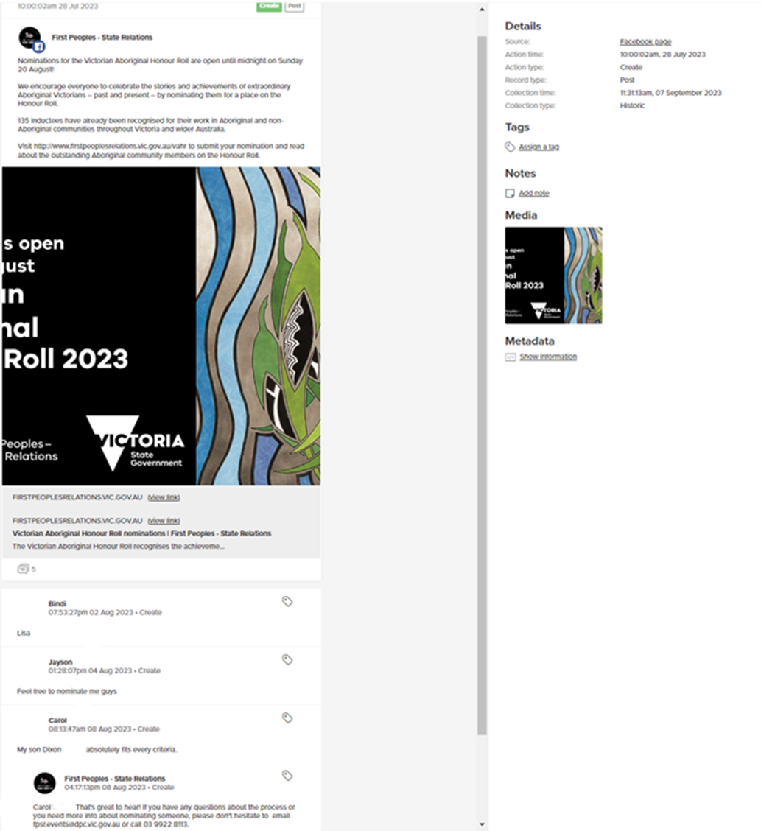

### Record keeping manual screenshot

Pictured is a screenshot of the original post and comments. The record will provide the following information for record keeping purposes:

* date it was sent or received
* the name used by the person who posted the message and the response was sent to (no need to determine the sender’s actual identity)
* the purpose of the message

As it is not provided in the screenshot, the following information will be required to be stored in a document:

* time it was sent or received
* the name of the public officer that sent the message, who authorised the social media message
* The name of the social media application that the message was published on

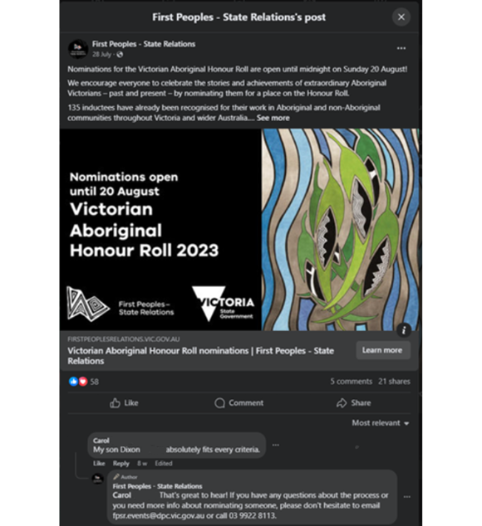

### Appendix C – Example - Community Guidelines

#### Sample Guidelines - Comprehensive

We value the comments and contributions we receive on social media.

While we encourage people to join the conversation, we will not tolerate disrespectful, offensive, crude, hateful or irrelevant comments or comments that make another person feel unsafe.

Please keep all comments and discussion respectful and courteous. We may remove or report posts, comments, or links that we consider:

* discriminatory, potentially defamatory, false, or misleading, racist, off-topic, inflammatory, repetitive, offensive or otherwise inappropriate
* disrespectful toward another person
* to make another person feel unsafe
* commercial content, advertisements, or spam
* campaigning for a product, service, cause or initiative
* infringement of the privacy, intellectual property or legal rights of others
* any other material we consider to be inappropriate.

We retain the right to block a user whose posts or comments include any of the above.

The views, opinions, and information expressed in user-generated comments remain with the authors and do not necessarily reflect those of the Victorian Government.

If you have any questions relating to these guidelines, please contact us.

### Sample Guidelines – Condensed

With our social media channels, the Victorian Government will:

* endeavour to remove any inappropriate, offensive, or defamatory comments
* leave what you share that relates to the subjects covered on this page
* endeavour to respond to comments that ask questions in a timely manner.

Aside from our posts, comments posted to this page do not represent the opinions of the Victorian Government.

Responses may only be provided during business hours.

### Sample Guidelines - Facebook group or general forum

<The primary purpose of this page/group is to <insert purpose>.

This Page/Group is not a promotional vehicle.  Any blatant advertising (as deemed by the administrators) will be removed from the group and the member will be warned.  If advertising from the member continues to occur, the member will be notified and removed from the group.

We encourage sharing useful information, but we ask that all members respect copyright and fair use principles. Always give people proper credit for their work and content.

Unacceptable behaviour is your responsibility.

Please be responsible for what you write.

We have the right to remove anyone who:

* Blatantly advertises within the group
* Spams the platform or its members
* Is obtrusive and/or disruptive
* Uses inappropriate language such as swearing
* Is derogatory or defamatory, discriminatory or makes socially unacceptable, inflammatory comments
* Attempts to engage in overt political or religious debates and arguments

If a comment breaches the above guidelines, it will be removed, and the commenter will be sent a private message with a warning their comment is against the guidelines. If a breach occurs a second time (or is severe in nature) the commenter will be blocked/removed.

### Appendix D – Sample Moderation Guide

Please note these are only examples. A government entity should conduct its own assessment as to whether it requires a specific moderation workflow due to an increased likelihood of defamatory comments occurring on its social media posts. A tailored policy could subsequently be developed, which considers the entity’s objectives, resources, and nature of its social media posts.

### DEECA Moderation Guide Example (next page)

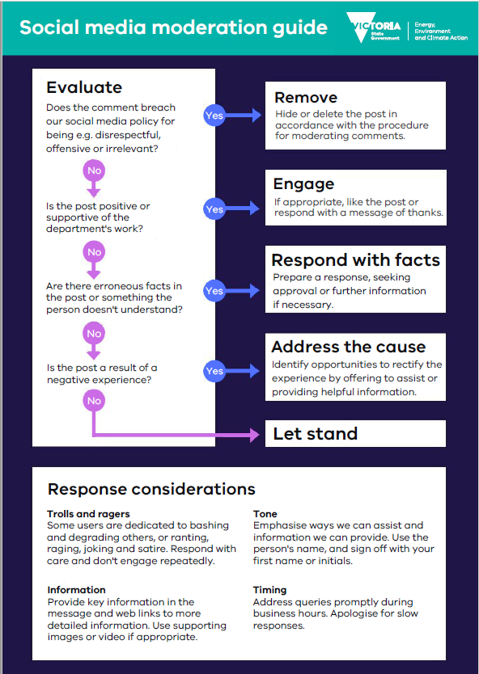

### Department of Health Moderation Framework Example

|  |  |
| --- | --- |
| Issue or query | Recommended action |
| General, answerable question | Use saved response  E.g: *“Hi there, You can find more information about [subject] at <link>. Kind regards, DH Social Media”*  If no saved response is found, but there is information that addresses the question on a DH web page, the above format can be considered for use. Also consider adding the response as a new saved response. |
| Questions that are complex and relating to an emerging theme of concern in the community that is not answered clearly on the site | Consider hiding (if on Facebook)  Save message in Sprout  Refer to team or senior  If a response is provided, unhide and respond as normal  In some cases, a placeholder response like:  *“Hi, thanks for your question. We’re finding information about it for you and we’ll get back to you when we can”*  May consider to get user to contact us via direct message (DM) |
| One person sending repetitive questions publicly on same subject across multiple posts (spamming) | Only provide one response.   Remind user of community guidelines if appropriate  Ignore subsequent comments.   Consider for ban if behaviour continues |
| One person sending repetitive contacts asking for more detailed explanation | After initial response is sent - ignore or hide |
| Requests for diagnosis or medical advice | Do not offer specific personalised health advice.  Respond with saved response on medical advice |
| Questions that are out of our scope and relate to a different organisation or department | Provide links to the correct department or org’s contact details |
| Questions with answers that are already addressed in post or link, and are clearly inflammatory in nature | Ignore, hide if causing negative conversation on public post |
| Specific complaints about a healthcare provider | Refer to Sprout asset library for saved response  Consider referral to team, however priority should be to direct complainant to best service to assist in the first instance. Generally, we would refer to the [“How to make a complaint about a health service provider”](https://www.health.vic.gov.au/participation-and-communication/how-to-make-a-complaint-about-a-health-service-provider) page.  Invite to PM if complaint requires escalation, requires more information or they are requesting a follow up. |

### Appendix E – About Us Section (Facebook)

#### Template

Welcome to the official Facebook page of the (insert entity).

Read our community guidelines before posting – (insert link to guidelines)

Our vision is to (insert vision statement)

(Information on entity responsibility/ role in program area)

(Information on the purpose of the account)

This page is monitored by (insert entity name) Monday to Friday, 9 am - 5 pm AEST.

To get in contact for general enquiries or any feedback/ complaints contact us here (insert contact details). (Link to entity’s privacy information)

#### Example – Victoria Police

Victoria Police administers various social media platforms to engage with members of the community and provide important safety and public interest information.

DO NOT USE SOCIAL MEDIA TO REQUEST POLICE ASSISTANCE.

In an emergency, call Triple Zero (000).

Find your nearest police station → https://www.police.vic.gov.au/location

To report non-urgent crimes and incidents, call the Police Assistance Line on 131 444 or visit → www.police.vic.gov.au/palolr

We encourage members of the community to engage with us on all official social networks.

However, in order to ensure our page is a welcoming and safe place for all members of our community we ask that you:

* + Be respectful of others and their opinions.
  + Do not harass, abuse or threaten other visitors to the page.
  + Do not post comments that are likely to offend others, particularly in reference to an individual’s race, age, gender, sexuality, political leaning, religion or disability.
  + Do not use obscene or offensive language.
  + Do not post defamatory comments.
  + Do not promote anything that may constitute spam, such as commercial interests, solicitations, advertisements or endorsements of any non-governmental agency.

To protect your personal privacy, do not include email addresses, phone numbers or home addresses in public posts or comments.

Any posts or comments that violate these terms will be deleted and you may even be banned from the page.

Comments on our page do not represent the opinions of Victoria Police.

Full terms: [www.police.vic.gov.au/social-media-terms-use](http://www.police.vic.gov.au/social-media-terms-use)

1. See F*airfax Media Publications Pty Ltd v Voller; Nationwide News Pty Limited v Voller; Australian News Channel Pty Ltd v Voller* [2021] HCA 27.