Guide to Footpath Trading Permits
Guide

    - Footpath trading – top tips to improve your processes, streamline requirements and reduce delays

Footpath trading is essential for supporting vibrant communities and prosperous local economies. However, councils must also manage key risks associated with footpath trading to ensure compliance and promote public safety. Based on what some councils are already doing, we’ve identified key changes to make it easier for businesses to get started, and easier for councils to manage growing permit volumes with less effort.
- Specify a clear ‘trading zone’ map –specify a ‘trading zone’ to clarify when a Footpath Trading Permit is required. Include zone measurements that are tailored to your council’s needs.
- Simplify fee structures – include flat application fees and standardised fees by space occupied or by number of furniture items or goods.
- Harmonise minimum footpath and kerbside clearances – align with the Disability Discrimination Act 1992 (Cth) to provide consistent, accessible trading across municipalities and public spaces.
- Publish a concise online guide – outline fees, timelines, required documents and a non-technical ‘how-to-apply’ document, plus a single contact channel for updates.
- Consider removing pre-permit inspections for low-risk situations – request a simple site plan instead and automate low-risk applications for same-day approval through automated council permit processes.
- Provide an online renewal declaration –provide an online renewal declaration at a reduced fee, with instant permit reissue, and publish expected processing times and key requirements.
- Develop clear compliance and enforcement measures tailored to your context – include specific measures in local laws to guide council action in event of non-compliance. Councils may also use inspection powers under the Local Government Act 1989 to manage risk and enforce compliance where appropriate.

    - Benefits to your council and local businesses

- Minimising touchpoints by automating low-risk applications – a single online form with a site-plan upload replaces the pre-permit inspection. Applied to the nearly 70 000 footpath-trading permits in Victoria each year, this saves approximately $3.9 million in staff time.
- Reducing staff time spent processing applications – automated permit approvals enable councils to process applications more quickly, streamlining turnaround times.
- Time and efficiency gains for councils – collapsing up to 26 fee categories into one flat application fee removes selection errors and cuts portal-build complexity, trimming roughly 15 minutes from every lodgement.
- Simpler applications for business – simpler applications with a standard trading-zone diagram, clearances aligned to the Disability Discrimination Act 1992 requirements and a ready-to-fill site-plan template mean businesses spend less time working out how to apply.
- Lower administrative burden through digital renewals – a two-click online declaration instantly reissues permits, eliminating manual invoicing, receipting and follow-up for both councils and traders.
- Faster approvals cut business costs – moving inspections to the post-approval compliance phase reduces turnaround from 30 days to under a week, meaning businesses spend less time waiting for approvals and can open sooner.

    - Three opportunities to streamline Footpath Trading Permit processes – high-level outline
Permitting solutions | Key features | How it works | Benefits to councils and businesses
- Standardised permit trigger | Defined trading zone specified in permit trigger. | - Applicants conduct trade only within the designated trading zone, setting out a standardised trigger  - Applicants must not conduct trade prior to obtaining a permit  - Applicants may also trade in their neighbour’s trading zone once consent has been obtained. | High – ensures consistency across councils, reduces confusion, and promotes effective public space management.
- Automatic permitting with model fee structures | Councils apply a model fee structure via automatic permitting. | - Councils set their own fees in line with a model fee structure, with different tiers based on categories associated with footpath trading  - A simple, flat rate is recommended for the application fee  - Applications must include a fee, and permits are active only after payment is received. | High – fees are proportionate to activity type and impact, simplifying processes for businesses across multiple locations.
- Harmonising minimum footpath and kerbside clearance requirements | Requirements align with accessibility provisions under the Disability Discrimination Act 1992. | - Specific zoning, minimum footpath and kerbside clearance measurements to establish trading zones  - Clear guidelines manage risks like blocked pedestrian access. | High – supports equitable access and reduces administrative burden without compromising safety
    - Model local law requirements and guidance
These model, risk-based local law requirements for administering Footpath Trading Permits give councils ready-made clauses and supporting guidance to adopt in their own policy guidance as relevant. The content has been co-designed with Victorian councils.
Better practice example – City of Greater Geelong, Neighbourhood Amenity Local Law 2024 (cl. 43 (1))
The requirement for a Footpath Trading Permit is outlined in a couple brief sentences. This concise approach ensures additional guidance – which may be subject to more frequent changes – is outlined in procedural documentation.
For example: Use of council land or a road for outdoor eating facilities – A Person must not, without a Permit, use a Footpath or any part of a Road or any Council Land for the purposes of an Outdoor Eating Facility.
Penalty: 20 Penalty Units – Any tables, chairs, umbrellas, or other equipment or infrastructure in an Outdoor Eating Facility used in contravention of this Local Law or of any conditions of a Permit may be removed by an Authorised Officer or a Delegated Officer and impounded.

Conditions

General
You must only trade in your trading zone, which is the area left over once you allow:
- 1.5m for pedestrians to walk in front of your building (if your footpath is between 2.5m and 3.5m) or 1.8m for pedestrians to walk in front of your building (if your footpath is more than 3.5m).
- 1m between your property and your neighbour's property (0.5m on each side of the property line) to allow for access between trading zones.
- 0.6m from the kerbside with standard parking, 0.7m from the kerbside adjacent to a loading zone, 1.5m from the kerbside adjacent to a disabled parking zone.
- 0.5m of clear space from street lights, tree pits, trees or plants, electricity poles, and meter boxes, 1m of clear space from traffic poles/lights, tram stops, bus stops, bicycle stands or racks, fire hydrants, public seating, litter bins, parking ticket machines or meters, telephone boxes or payphones, and service pits, and 2m of clear space from an intersection, corner, or pedestrian crossing.
You can trade in your neighbour’s trading zone as long as you have their consent.
You also need to:
- ensure items do not impair the vision of motorists or pedestrians.
- remove any litter and put it in a bin inside your premises.
- ensure full compliance with the Disability Discrimination Act 1992 requirements at all times.
Refer to the diagram below for an example trading zone map.

Tables and chairs
- Tables and chairs are removed from the footpath at the close of trade, if damaging weather is predicted, or in the event of a trading zone interruption (e.g. street event or service works on the footpath).
- Tables and chairs are kept clean.
- Those using your tables and chairs do not smoke.

A-frames/tear drop banners or flags
You may place either one A-frame sign or one tear drop banner/flag in your trading zone if:
- the A-frame sign is no higher than 1.2m and no wider than 0.9 m
- the tear drop banner or flag is not reliant on, or physically fixed or attached to any council infrastructure
- there is clear and unobstructed pedestrian access on the footpath
- the sign/tear drop banner or flag:
  - is secure and stable, adequately weighted down or secured appropriately against wind
  - does not present a hazard to pedestrians or other footpath or street users, including pedestrians with disability
  - is removed from the footpath at the close of trade each day, if damaging weather is predicted, or in the event of a trading zone interruption (e.g. street event or service works on the footpath).

Goods displays/stands
- No loose items are placed directly on the footpath.
- Goods are displayed on a stand or table.
- Stands or displays are not fixed to existing structures.
- Displays and goods are removed from the footpath at the close of trade each day or in the event of a trading zone interruption (e.g. street event or service works on the footpath.
- The display is no more than:
  - 1.5m high
  - 1.5m long
  - 0.8m deep.

Market umbrellas
- Umbrellas are only used in areas where there are no conflicts with existing structures or trees.
- Umbrellas are removed from the footpath at the close of trade each day, if damaging weather is predicted, or in the event of a trading zone interruption (e.g. street event or service works on the footpath).
- Umbrellas are secured at all times when displayed.
- There is at least 2.2m of clearance between the lowest point of the umbrella canopy and the natural ground level.

Portable wind barriers, canvas screens, removable screens
- Barriers or screens are removed from the footpath at the close of trade each day, or in the event of a trading zone interruption (e.g. street event or service works on the footpath).
- Barriers or screens are secured at all times.
- Barriers or screens are no more than 0.9m high.

Portable heaters
- Portable heaters are removed from the footpath at the close of trade each day, if damaging weather is predicted, or in the event of a trading zone interruption (e.g. street event or service works on the footpath).
- Portable heaters are covered as a specific term in your public liability insurance policy.
- Portable heaters are compliant with the current Australian standards for portable gas heaters. For more information contact Energy Safe Victoria.

Plants and planter boxes
- Portable plants and planter boxes are removed from the footpath at the close of trade each day, or in the event of a trading zone interruption (e.g. street event or service works on the footpath).
- Plants and planter boxes are maintained and attended to all year round.
- Plants and planter boxes are no more than:
  - 1.2m high (including the height of any plants)
  - 1.8m long.

Declaration by applicant
Applicants are required to make a standard declaration confirming that the information they have provided is true and complies with the conditions outlined in the model local law.
By lodging a footpath trading application with your council, you declare that:
- you understand you are participating in a pilot council program and you must operate your business in line with the conditions specified
- the council reserves the right to take enforcement action for non-compliance
- you will ensure that all supporting documents are kept up to date and a copy provided to the council when renewed or changed
- you have provided the council with a copy of your current certificate of currency for the insurance required.
- your business has all the permits and licences required to operate
- you agree to indemnify the council, its servants and agents from and against all actions, costs, claims charges, expenses, penalties, demands and damages which may be brought or made or claimed against them in connection with your participation in the pilot program, due to your breach of the terms and conditions of the pilot program or in connection with your negligent acts or omissions.
- This means that you are agreeing to compensate the council if a claim is brought against it by a third party, such as a member of the public, if they suffer (or claim to have suffered) loss or damage (including property damage, personal injury, and death) due to your acts or omissions. This will include any legal costs of the council associated with such a claim or action. This indemnity is binding, and the council will rely upon this indemnity if a claim is brought against it in connection with your participation in the pilot program.
- You agree to release the council, its servants, and agents in relation to all claims resulting in loss, damage, death, or injury, in connection with the pilot program.
- This means that you are agreeing that council will not be liable for any loss or damage you suffer because of your participation in the pilot program. You are agreeing that you cannot bring a claim against the council for loss or damage caused by your participating in the program. This is legally binding, and the council will rely upon this release if you do bring a claim.
- You understand and agree to comply with all of the conditions outlined above.

Example model fee structure
The table below outlines an example that can help councils simplify or update their fee structures.

Area | Suggested model structure
Application fee | Flat application fee (optional) – this may be the same rate for an initial application as upon renewal, it may be waived upon renewal, or it may be reduced upon renewal.
Tables, chairs, goods | Three options for councils include:  - flat fees for outdoor dining and goods, either:  - a single fee, or  - two separate fees (one for tables and chairs, one for goods)  - a per square metre rate for use of the footpath (a single rate or multiple rates based on location)  - a per table, per bench, per seat rate and a flat rate for goods.
All other items (A-frames, heaters etc.) | Flat rates (which can be set to $0 for councils who do not wish to charge).

Trading zone map with editable measurements and business information to include in your guidance
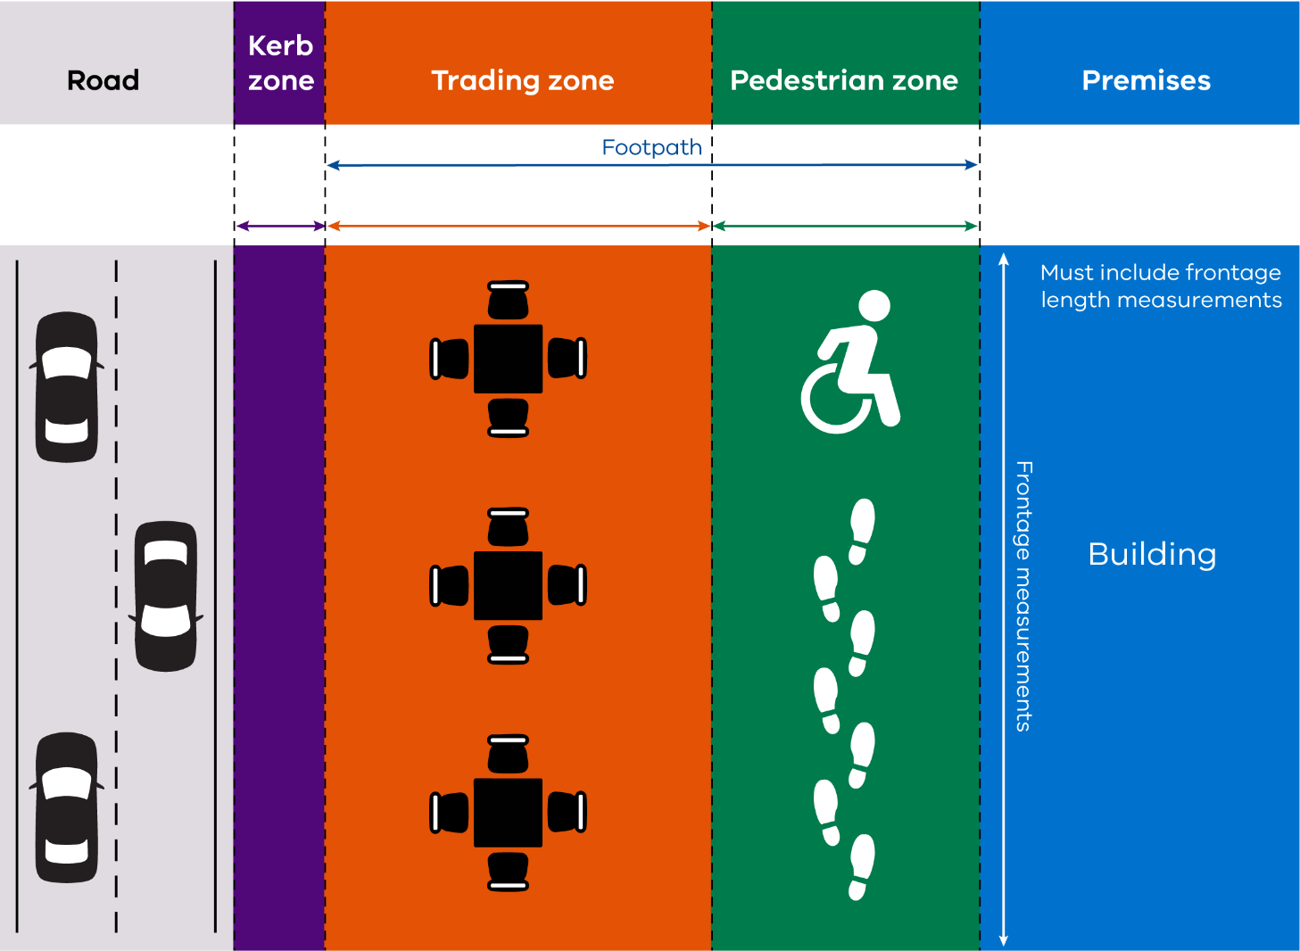
X.Xm
X.Xm
X.Xm
Business name, address and business hours
X.Xm
Source: Stonnington City Council Footpath Trading Guidelines

Australian Bureau of Statistics (ABS), Australian Industry, 2020-21 (Cat. no. 8155.0): 68 752 Footpath Trading Permit applications recorded for Victoria.
Efficiency saving: 68 752 permits × 1 hour × $56.74 average council administration wage (Victorian Government Standard Costing Guidelines, 2024) ≈ $3.9 million.

