Add and update Arrival users

Information for Service Provider Administrators and Service Administrators
A guide to support service provider administrators and service administrators to manage users in Arrival.
Service provider administrators and service administrators can add, update (and remove) users to Arrival as well as assign a role and service or multiple services within that provider.
This guide includes information on:
- Add a new user
- Additional roles
- Arrival user roles
- Resend access invitation to a new user
- Remove (Deactivate) a user
- Reactivate a user
- Update a user

Add a new user
- Login to Arrival. From the Welcome dashboard click the Users tile.
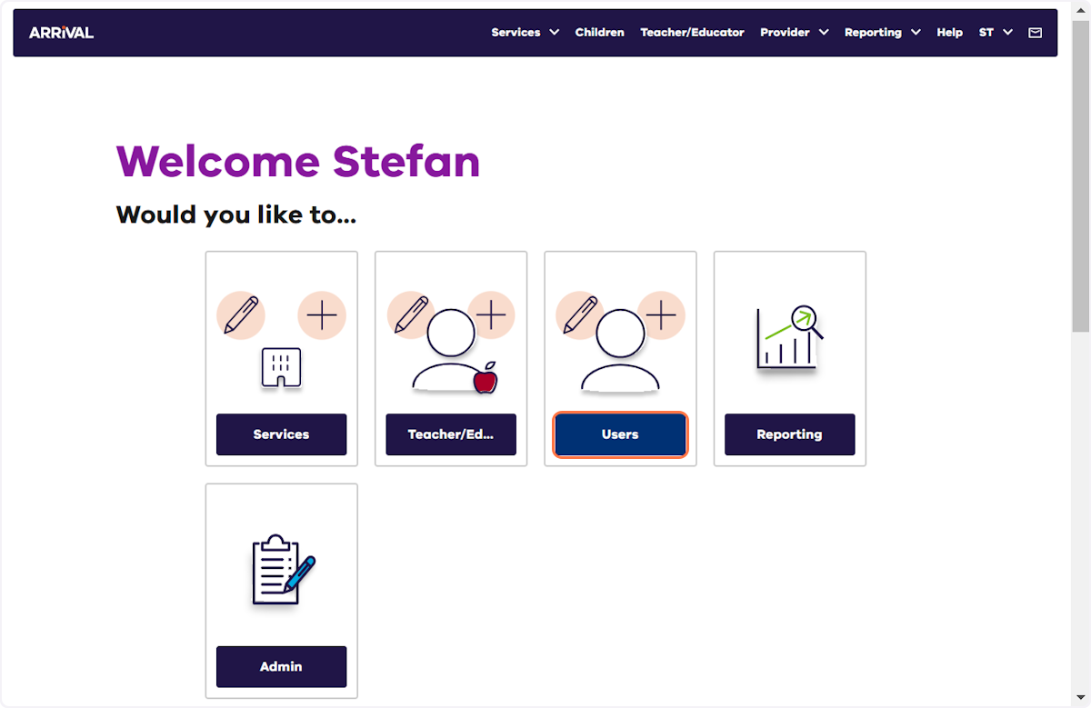
- Click Add user +.
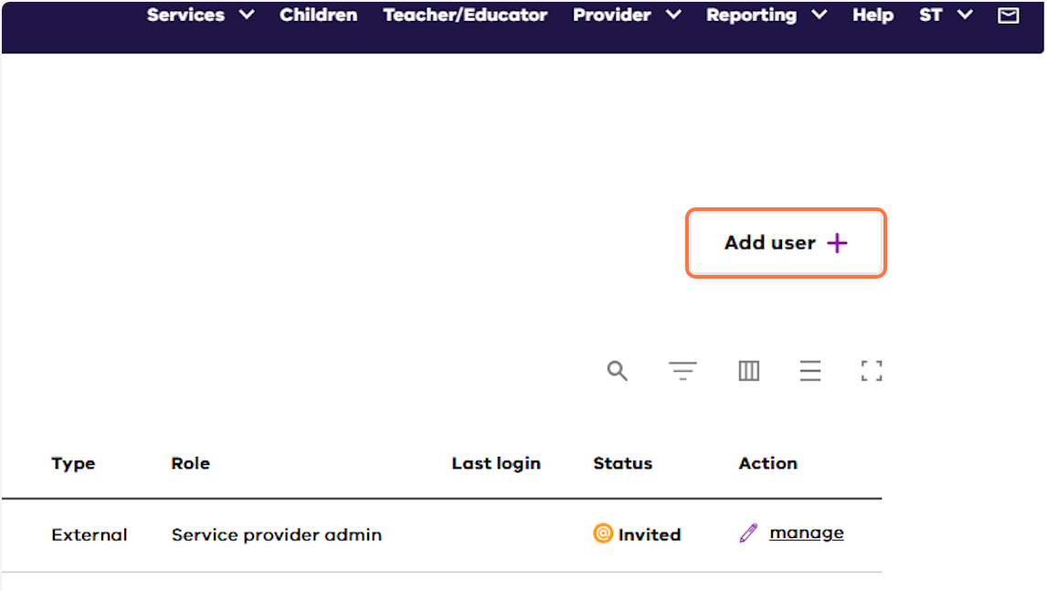
- Click Add provider+.
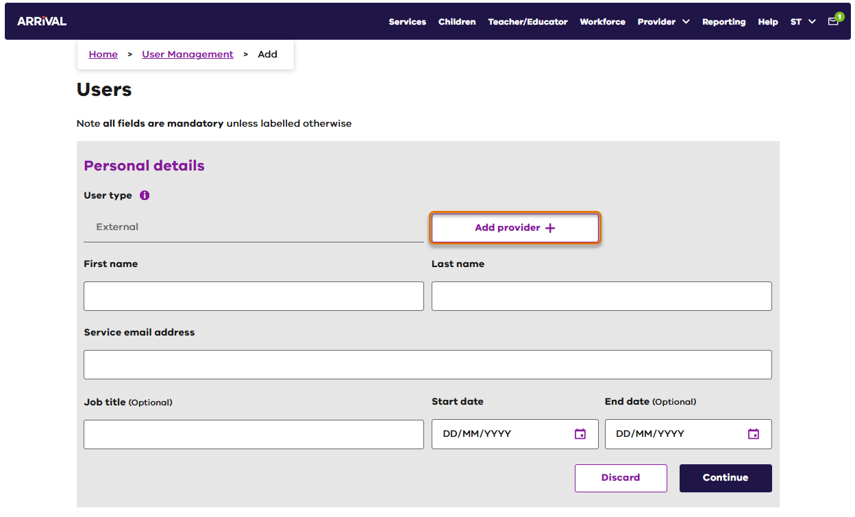

- Select the Service provider then click Add.
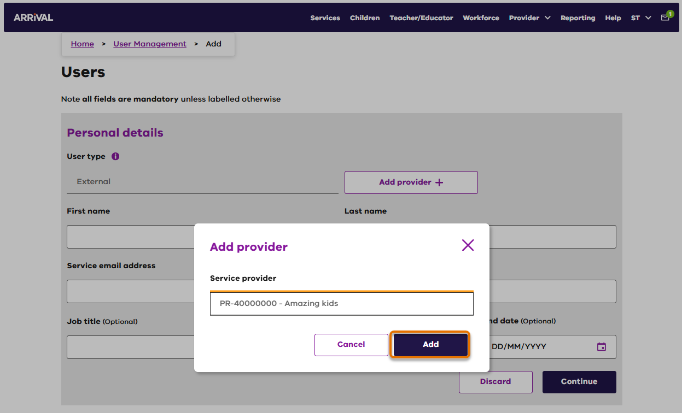
- Click Add role +.
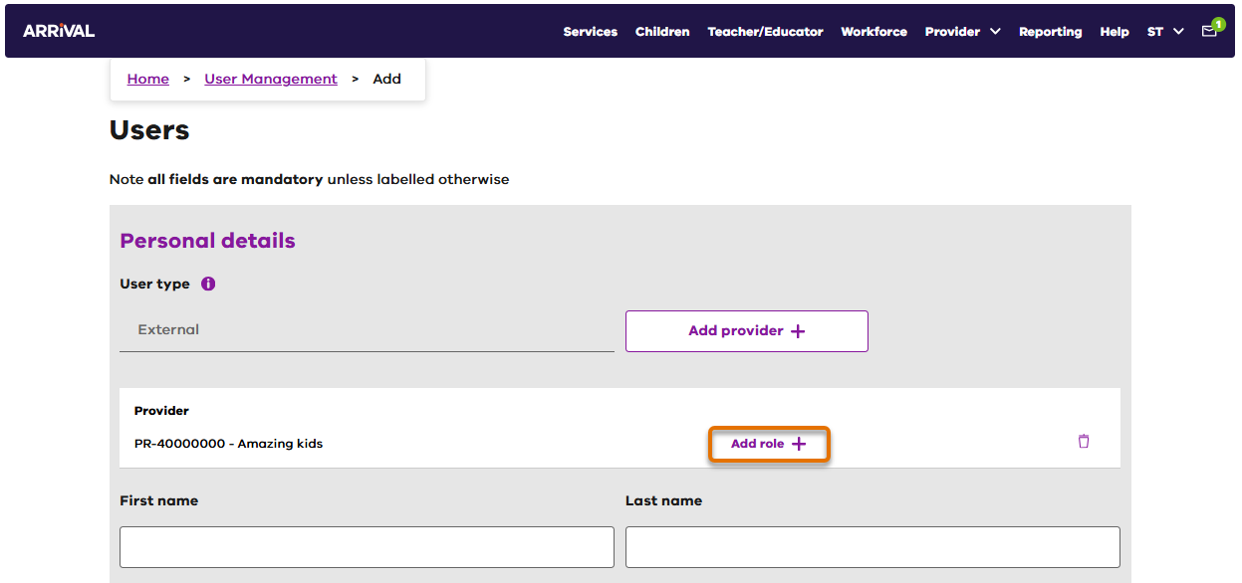

- Select the required Role from the drop-down list.
Note.: refer to the Arrival user roles table below for roles and permissions.
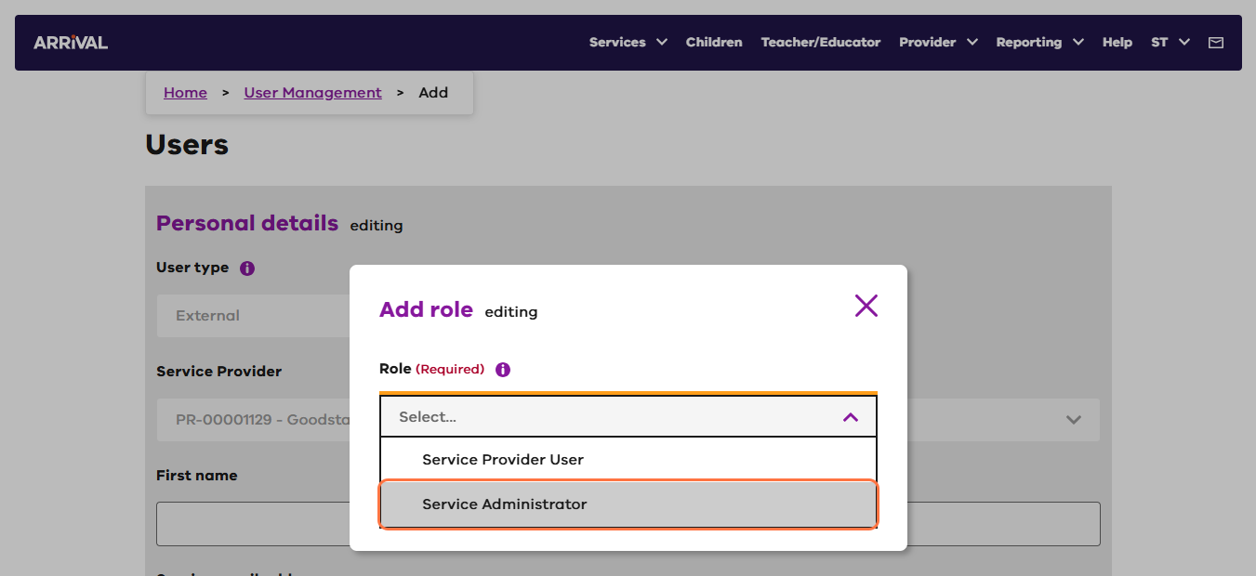
- Select the required services from the drop-down list and click Save.
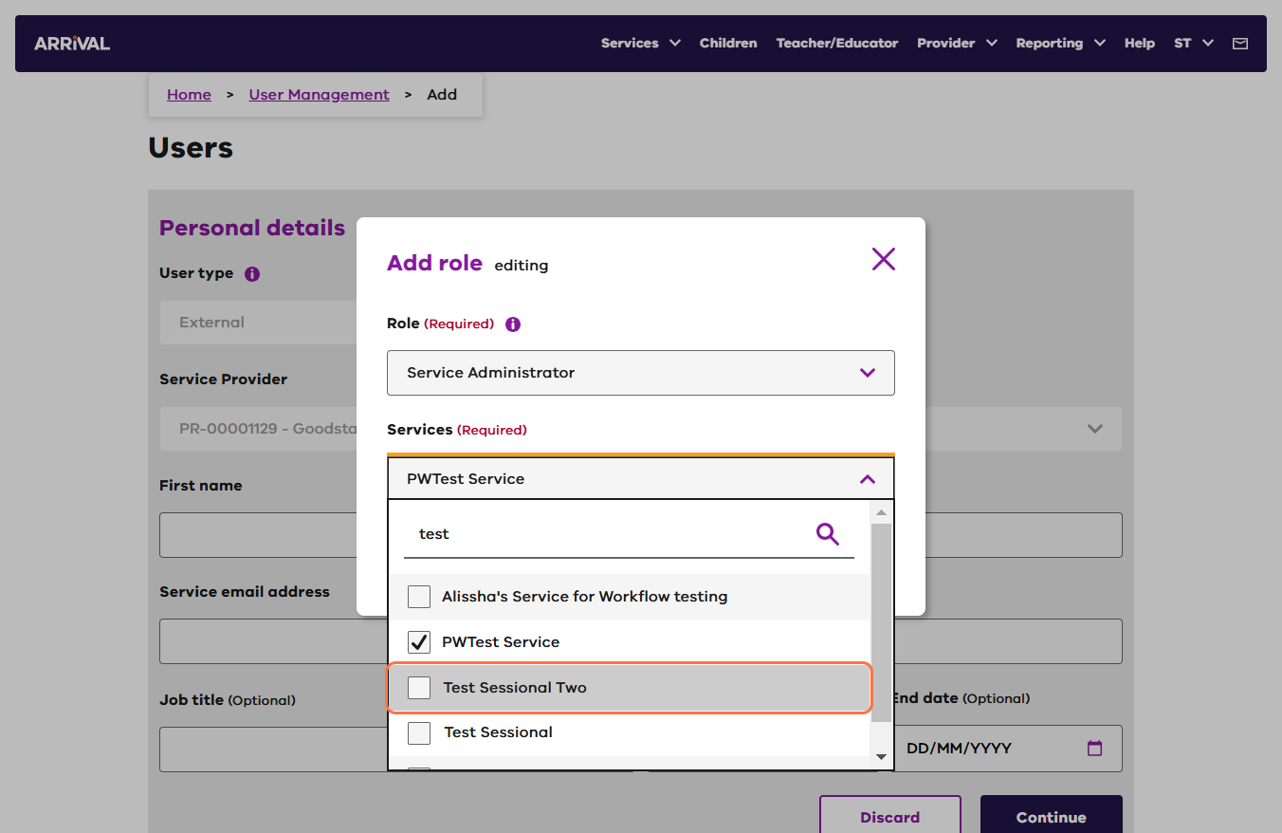

- Complete the remaining user details (First name, Last name, Service email address, Job title - optional, Start date, End date - if required) and click Continue.
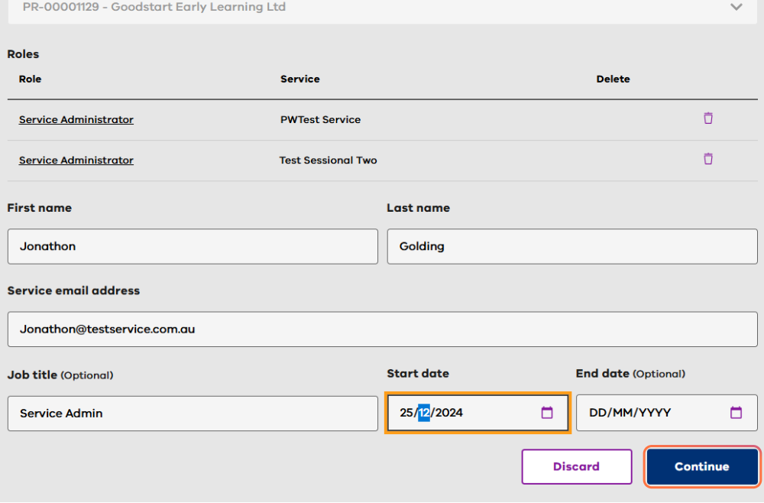
Start Date | Date from which the user will be invited to access Arrival. If today’s date is entered, an email will be sent to the service email address entered as soon as the record is saved.
End Date | Enter a date here if there is a specific date from which the user will no longer need Arrival access. The user will be deactivated on this date.
The new user details will be saved with an onscreen success message indicating the user is ‘pending’. In the background, an invitation to access Arrival will be sent to the user on the required start date.

Additional Roles
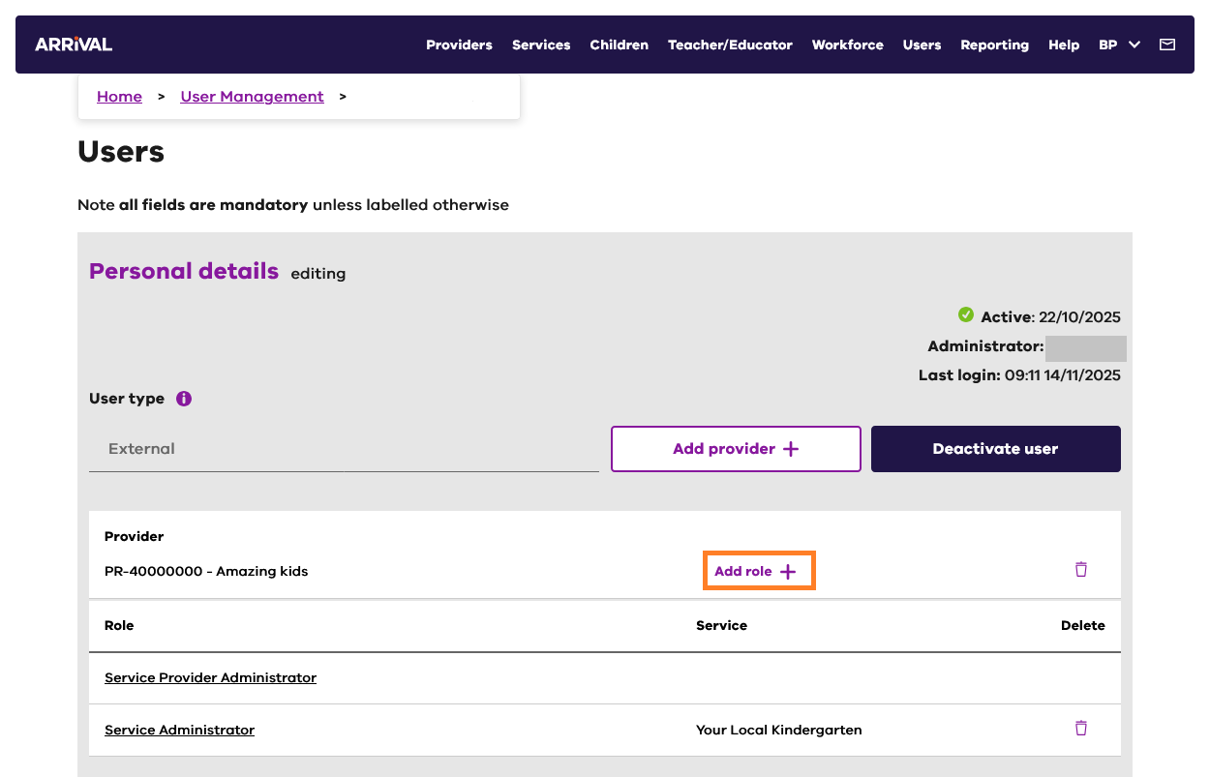
- Additional roles can be added to a User, by editing their record and clicking Add role +.

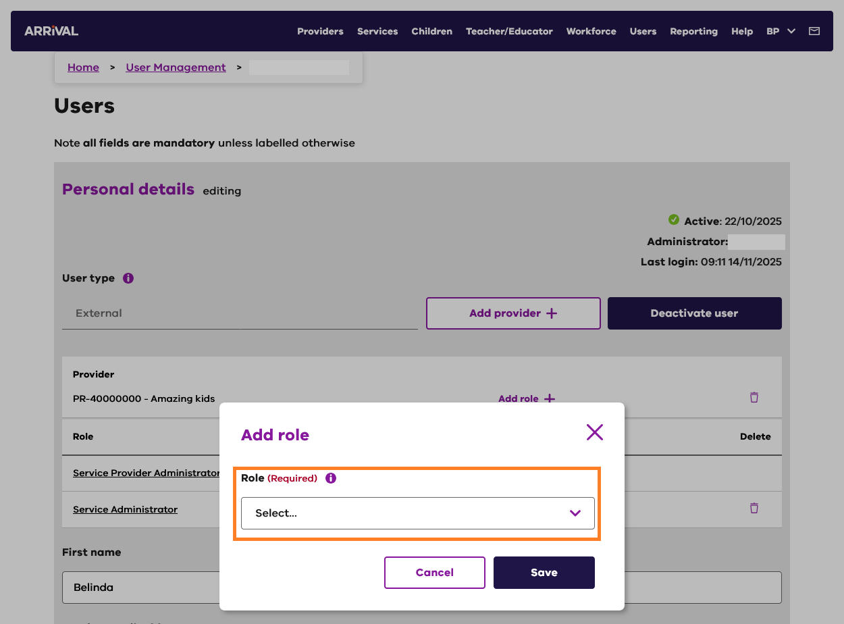
- Select a role from the drop-down menu in the displayed dialog box. If prompted, also select the name of the Service/s the user is connected with.

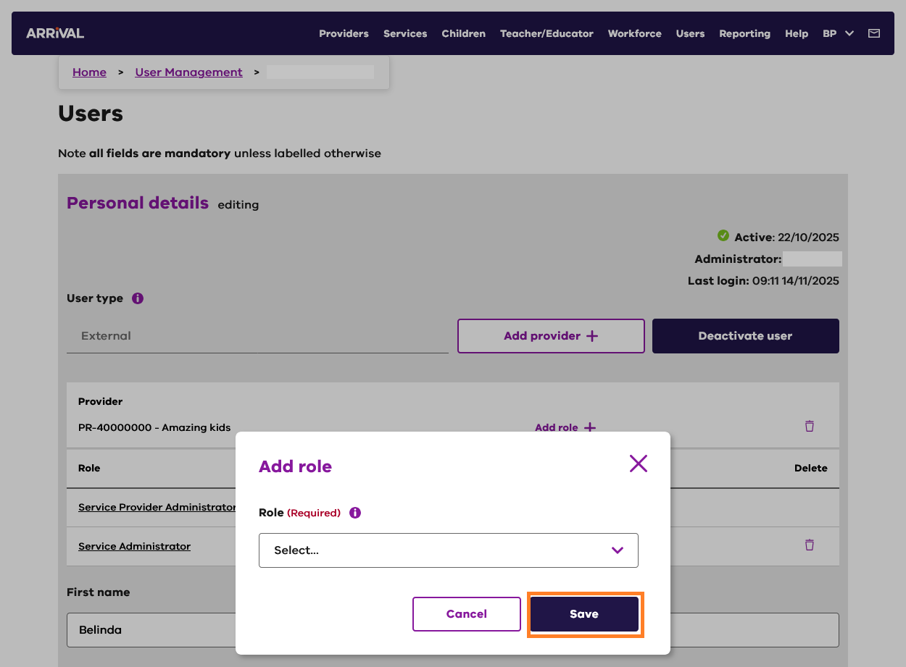
- Click Save.

Arrival user roles
Please see information below regarding user roles and permissions. Additional guidance for users is available in the guidance document: Arrival User Roles and Responsibilities in the Arrival Help.

Role | Description | Create/Manage/View Access | View Access | Create/  Manage Users | Administration
Service Provider Administrator | Service Provider staff who are responsible for administering Arrival access | Service Provider (edit/view only)  Service  Teacher/Educator  Program/Group  Child  Parent/Guardian  Attendance | All | Yes | Administered by: Arrival Administrator (DE)  Administrator for: Service Provider User,Service Administrator User and Service User
Service Provider User | Service Provider staff who require view and edit access to Arrival | Teacher/Educator  Program/Group  Child  Parent/Guardian | Service Provider  Service | No | Administered by: Service Provider Administrator
Service Administrator | Service level staff member/s responsible for administering Arrival access for other service level staff | Teacher/Educator  Program/Group  Child  Parent/Guardian  Attendance | Service | Yes | Administered by: Service Provider Administrator  Administrator for: Service User
Service User | Service level staff who require view and edit access to Arrival | Teacher/Educator  Program/Group  Child  Parent/Guardian  Attendance | Service | No | Administered by: Service Administrator

Resend access invitation to a new user
If the invitation email sent to a user expires, another invitation can be sent with a new 7-day expiry.
- Login to Arrival and click on the Users tile.
- Click the manage (pencil) icon for the required user.
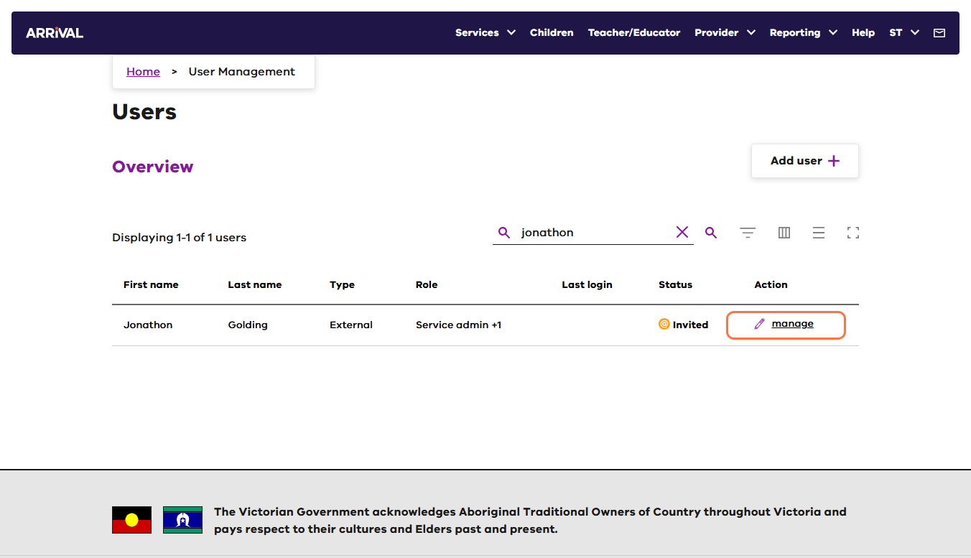
- Click the 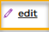 link located toward the top of the page.
- Click Resend Invitation.
Note: The Resend Invitation initiates a new email with a new 7-day expiry.
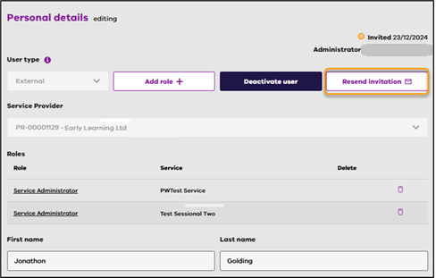

Remove (Deactivate) a user
- Login to Arrival and click on the Users tile.
- Click the manage (pencil) icon for the required user.
- Click the link located toward the top of the page.
- Click Deactivate user.
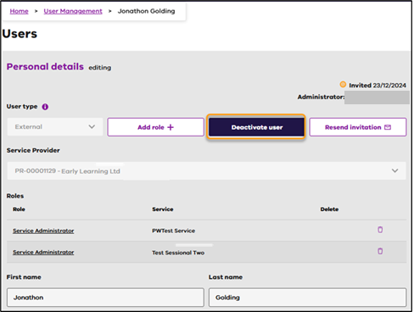

- Click Continue. (No other information is required to deactivate the user).
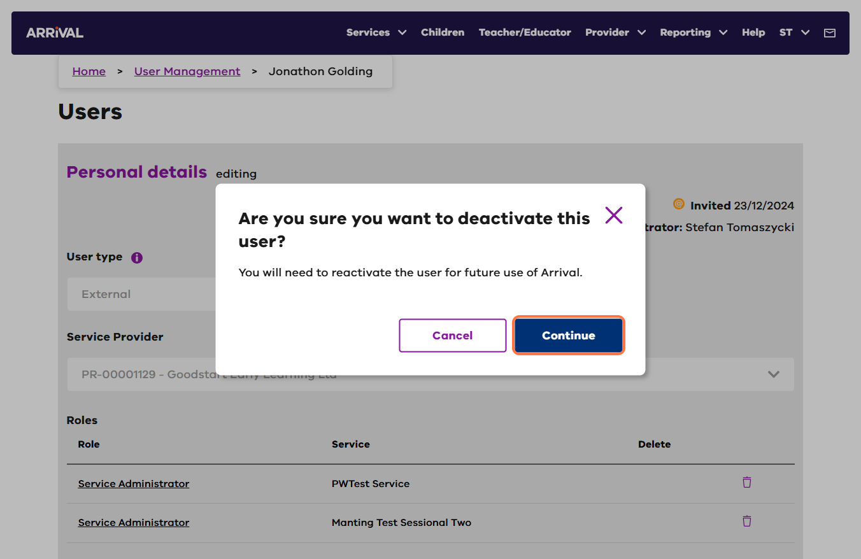
- Arrival will popup a message to confirm ‘You’ve successfully deactivated this user’.
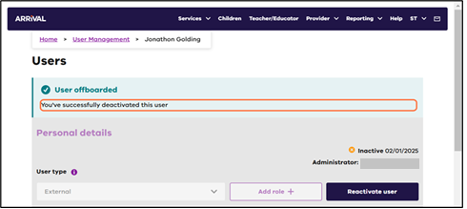
- The user will be sent an email to advise their account is deactivated.
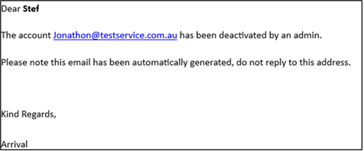

Reactivate a user
- Login to Arrival and click on the Users tile.
- Click the manage (pencil) icon for the required user.
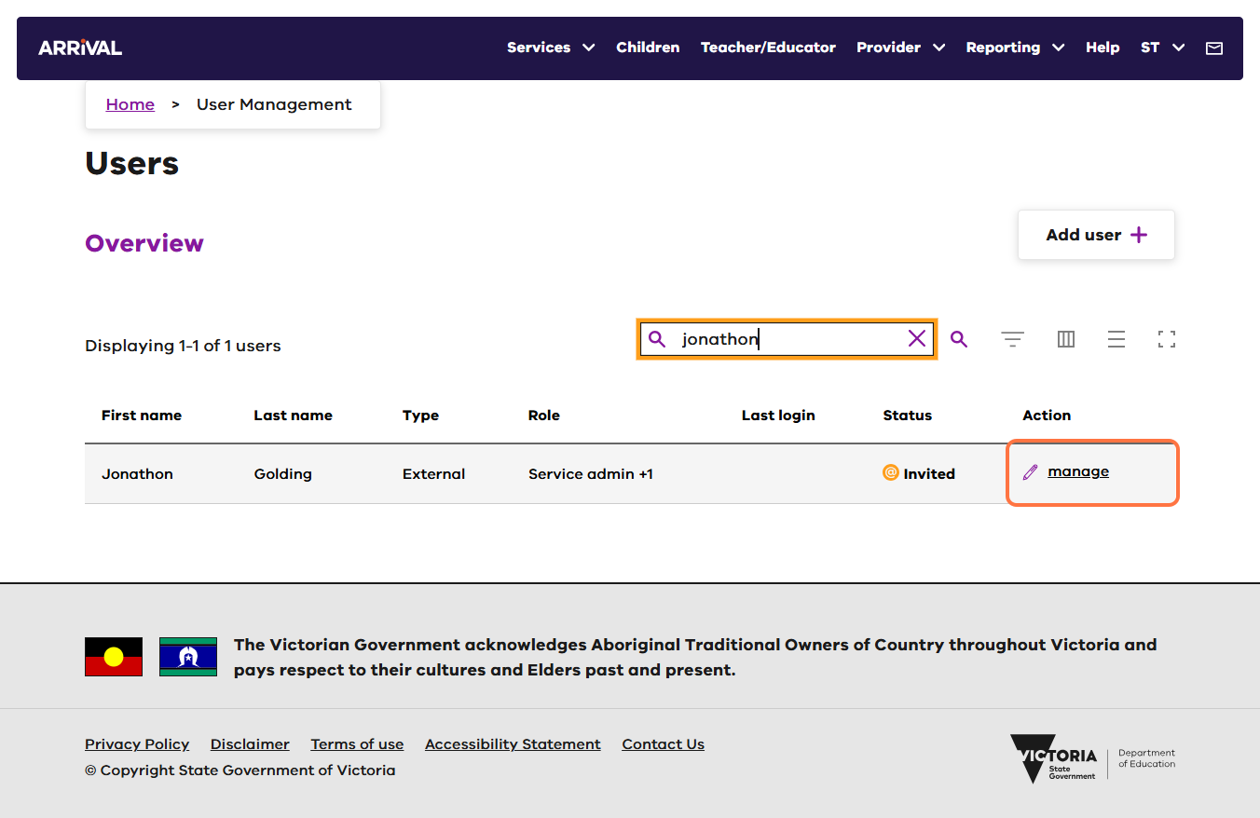
- Click the (edit) link located toward the top of the page.
- Select Reactivate user.
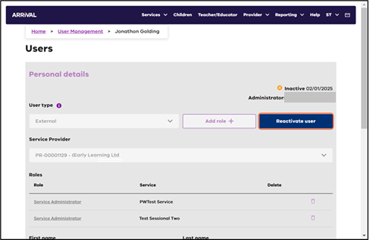

- Arrival will popup a message to confirm ‘You’ve successfully reactivated this user’.
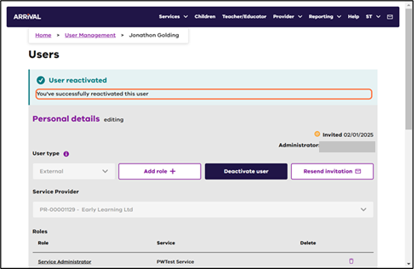

Update a user
- Login to Arrival and click on the Users tile.
- Click the manage (pencil) icon for the required user.
- Click the (edit) link located toward the top of the page.
- Update any information including the email address of the user.

- Click Save.
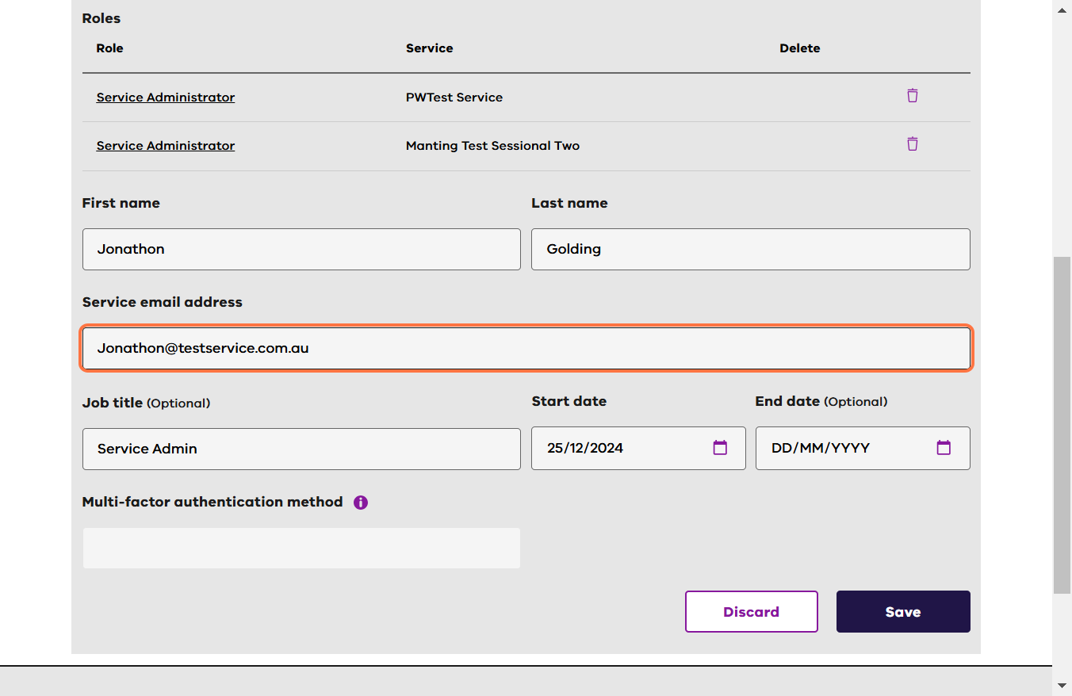

Further information
For further support contact the Arrival Helpdesk on 1800 614 810 or email Arrival.Helpdesk@education.vic.gov.au.

