

Aboriginal Community Initiatives Fund & Prevention Funding
Application form 2025–26
OFFICIAL
Contents
Checklist for your 2025-26 CIF funding application 3
CIF Application process 3
Prevention funding overview and requirements 4
What types of projects are eligible for Aboriginal-led prevention funding 4
Aboriginal-led prevention framework alignments 4
Key dates 6
Application details 6
A. Application summary 6
B. Project description 6
C. Expected project dates 7
Assessment criterion 1 7
Section 1: Applicant organisation details 7
Section 2: Project manager and auspice organisation details 8
Assessment criterion 2 10
Project details 10
Assessment criterion 3 12
Project alignment to Dhelk Dja: Safe Our Way – Strong Culture, Strong Peoples, Strong Families 10 Year Agreement (the Agreement) 12
Assessment criterion 4 – Project Plan 14
Capacity to deliver the project plan 14
Assessment criterion 5 19
Financial details 19
Assessment criterion 6 20
Determining understanding of the funding expectations and declaring any conflict of interest 20
Cover artwork and artist 23

Checklist for your 2025-26 CIF funding application

Checklist | Mark with an X
You have contacted the Regional Coordinator to express your interest in CIF 2025-26 and/or the Prevention funding 2025-26, discuss your project proposal and to obtain the following:
- Copy of Dhelk Dja: Safe Our Way – Strong Culture, Strong Peoples, Strong Families 10 Year Agreement 2018–2028
- Copy of the Dhelk Dja Regional Action Group Plan
- Copy of the Indigenous Family Violence Prevention Framework (2012)
- Information on CIF regional information sessions/forums
Met the eligibility criteria for the CIF 2025-26
- For CIF 2025-26 applications, demonstrating alignment to eligibility criteria as set out in the 2025-26 Funding Guidelines
Completed all sections of the application for the CIF Funding 2025-2026
Completed project plan template
Completed the financial details section
Application signed by the relevant person(s) in your organisation/group and/or auspice
Attached letters of support and any agreements/MOUs with partnering organisations

CIF 2025-26 application process
- Contact the Regional Coordinator who supports the Dhelk Dja Action Group in your region, to express your interest and discuss your project proposal for the Aboriginal Community Initiatives Fund (CIF).
- The Regional Coordinator will provide you with a copy of the Dhelk Dja: Safe Our Way – Strong Culture, Strong Peoples, Strong Families 10 Year Agreement 2018–2028, a copy of the Dhelk Dja Regional Action Group Plan and the Indigenous Family Violence Prevention Framework (2012).The Regional Coordinator will also advise you on regional processes i.e. information sessions/forums being held.
- Complete the CIF 2025-26 Application Form and submit it to the Regional Coordinator, along with all supporting documentation. The closing date for funding applications is 20 February 2026 at 5pm. No late applications will be accepted.
- Applications will be assessed to confirm that all required sections are completed and that the funding eligibility criteria are met. Any application that does not meet the eligibility requirements will not move forward to the Assessment Panels.
- All eligible applications will be presented to the Assessment Panel which comprises:
    - Two Aboriginal community representatives of the Dhelk Dja Action Group
    - Independent Aboriginal representative, as identified by the Dhelk Dja Chairperson/s
    - Senior Aboriginal representative from Department of Families, Fairness and Housing (DFFH), as identified by the Dhelk Dja Chairperson/s
Please note: Team Leader(s), Aboriginal Governance and Engagement, Aboriginal Initiatives Unit (AIU) will provide guidance and ensure compliance with the application process.
The Regional Coordinator will provide secretariat support and advice to the panel and does not have any decision-making capacity.
- The Assessment Panel will assess applications against set criterion. As part of the assessment process, applicants must attend an Assessment Panel Interview to discuss their application. Interviews will be advised by the Region.
- At the completion of the process, you will be advised of the outcome in writing by Aboriginal Initiatives Unit and given the opportunity to obtain feedback about your submission.
- Any queries should be directed to the Regional Coordinator.

Activities must:
- be led by Aboriginal communities
- include a whole of community approach and community strengthening
- be grounded in cultural respect and cultural strengthening
- promote non-violent social norms and strengthen protective factors in communities
- improve access to resources and systems of support.

Please note that any breach of the funding expectations may result in your project being cancelled, funding being returned and may impact your ability to receive future funding.

Key dates
Process | Date
Call for applications | 15 December 2025
Application closing date and time | 20 February 2026 at 5pm
Assessment Panels | 23 February 2026 to  6 March 2026
Applicant interviews convened | TBC by Regions
All applicants advised of outcome by | April 2026
Project commencement from | June 2026
Project completion by | June 2027
The Department of Families, Fairness and Housing reserves the right to vary the key dates as necessary in its absolute discretion.

Application details

A. Application summary
Information required | Your details
Project name
Department of Health
Applicant
Project manager
Auspice organisation (if applicable)
Dhelk Dja Action Group Region
Project Funding (total amount applying)

B. Project description
Project descriptions should provide details of your project, including the aim of project to educate, prevent, reduce, and respond to family violence within the Aboriginal community and how it aligns with the Regional Action Group Dhelk Dja Plan, the strategic priorities of the Dhelk Dja 3 Year Action Plan 2023-2025 and the Indigenous Family Violence Prevention Framework (2012) (as applicable)..

Project description

C. Expected project dates
Please note: projects must be completed by June 2027.
Information required | Date
Start date
End date

Assessment criterion 1

Section 1: Applicant organisation details

If you are an unincorporated Aboriginal community group applying for funds, refer to ‘Eligibility’ in the Funding guidelines 2025–26.
Name of organisation
Type of organisation/group (please indicate with an X)
Incorporated not-for-profit Aboriginal organisation with a current Service Agreement with DFFH
Incorporated not-for-profit mainstream organisation delivering an Aboriginal program in partnership with an Aboriginal organisation/group with a current Service Agreement with DFFH
Incorporated not-for-profit Aboriginal/mainstream organisation with no current Service Agreement with DFFH or unincorporated Aboriginal community group – complete auspice organisation details in Section 2

Organisation contact person
Email
Phone number
Street address
Town/suburb
Postcode
Australian Business Number (ABN)
Registered for GST
- I am authorised by the organisation named in Section One of this form to submit this application on behalf of the organisation/community group
- I confirm that the organisation has a current Service Agreement with DFFH
- The provision of funding by the department is subject to the terms and conditions of the Service Agreement
- I will notify the department of any changes to the application information and any circumstances that may affect the project prior to commencement
- I confirm that the organisation has no outstanding program reporting or financial acquittal requirements with the department
- I understand that this is an application only and may not necessarily result in funding approval
- I state that the information in this application is true and correct to the best of my knowledge.
Name
Date
Position
Position type (please indicate which applies) | CEO, Other (if other, please specify)
Signature

Section 2: Project manager and auspice organisation details

Project manager
Name and position title of project contact person
Email
Phone number
Street address
Town/suburb
Post code

Secondary contact
Name and position title of project contact person
Email
Phone number
Street address
Town/suburb
Post code

Auspice organisation
Name of auspice organisation

Type of organisation (Please indicate with an X)
Incorporated not-for-profit Aboriginal organisation (must have a current Service Agreement with DFFH)
Incorporated not-for-profit mainstream organisation (must have a current Service Agreement with DFFH)

Auspice contact person
Name of auspice contact person
Email
Phone number
Street address
Town/suburb
Post code
Australian Business Number (ABN)
Registered for GST | Yes / no – please delete whichever not applicable
Does your organisation have a DFFH service agreement?
MOU developed with applicant organisation/group?
- I am authorised by the organisation/community group named in Section 2 of this form to submit this application on behalf of the organisation/community group
- As the applicant does not have an active Service Agreement with DFFH or is an unincorporated Aboriginal community group, an agreement has been made with an incorporated auspice organisation
- A Memorandum of Understanding (MOU) has been developed with the applicant and signed by both parties
- The auspice organisation has a current Service Agreement with DFFH
- The auspice arrangement and MOU will ensure that the obligations in the Service Agreement are met, including service delivery, financial accountability, and client confidentiality requirements
- Both parties are clear on their obligations and responsibilities, as outlined in the MOU, including agreement on the auspice fee (cannot be more than 10%)
- I have ensured that correct and adequate insurance policies are held
- The auspice organisation will arrange for payment of invoices in a timely manner, as outlined in the MOU
- Notification seeking any changes or variation to the project and project budget must be submitted to the Department
- I will notify the department of any changes to the application information and any circumstances that may affect the project prior to commencement
- I confirm that the auspice organisation has no outstanding program reporting or financial acquittal requirements with the department
- I state that the information in this application is true and correct to the best of my knowledge.

Project manager – Aboriginal lead
Name
Date
Position
Signature

Auspice organisation
Name
Date
Position
Position type (please indicate which applies) | CEO, Other (if other, please specify)
Signature

Assessment criterion 2

Project details
The following sections provide further details of the project description.

2.1 In the box below please tick the appropriate target audience(s) that your project aims to address.
Target audience | Please mark with an X
Aboriginal Elders
Women
Men
Children and young people
People from the LGBTIQA+ community
People living with disabilities
People living in rural, remote, or regional communities
People exiting prisons

If other, please specify:

2.2 Briefly describe what the process will be in selecting participants, i.e. being referred, selected, and/or engaged?

2.3 Provide details of the areas where the project will be delivered within your region

2.4 Describe how the project aims to implement a community led project(s) that educates, prevent, reduce, and respond to family violence in Aboriginal communities. This includes needs identified by the Dhelk Dja Action Group in the region, as outlined in their Action Plan. If relevant, describe how the project aligns to the Indigenous Primary Prevention Framework (2012).

Assessment criterion 3

Project alignment to Dhelk Dja: Safe Our Way – Strong Culture, Strong Peoples, Strong Families 10 Year Agreement (the Agreement)

3.1 List the project objectives and how they align with the strategic priorities of the agreement
The strategic priorities are:
- Strategic Priority 1 – Aboriginal Culture and Leadership
- Strategic Priority 2 – Aboriginal-led Prevention
- Strategic Priority 3 – Self-determining Aboriginal family violence support and services
- Strategic Priority 4 – System transformation based on self-determination
- Strategic Priority 5 – Aboriginal-led and informed innovation, data and research
Project objective | Describe how the objective aligns with the strategic priorities (specify the strategic priority number(s)

Assessment criterion 4 – Project Plan

Capacity to deliver the project plan4.1 Provide details of the project plan
Complete the project plan, listing how the project will be implemented, activities, tasks, timelines, and strategies for evaluating success of the project.
The plan should be specific detailing the frequency and length of activities (i.e. Aboriginal women’s group, delivered once a week for 12 weeks or 5 one-day workshops held monthly, over 5 months).

Example project plan
Examples are included in the table below in red text.
Activity examples  (What are you going to do?) | Description  (Details of activities) | Who is responsible? | Start date  (month) | End date  (month) | Total cost per activity | Cost breakdown
Establish a project steering committee | This committee will meet regularly to monitor the project. The committee will include key project partners, including local Elders and Dhelk Dja Action Group members. | Project Manager | May 2026 | September 2024 | $0
Promote project | The workshops will be promoted through community network email lists, flyers, newsletters and visits to local organisations. | Project Committee | May 2026 | November 2024 | $150 | Printing materials for flyers  $50 paper  $100 printer cartridges
Run program | Two-hour, Aboriginal women’s group sessions delivered every week for 12 weeks. Maximum of 10 participants in the group. | Project Manager, Facilitator | June 2026 | April 2025 | $12,000 | Facilitator $6000  Venue hire $1200  Catering $2400  Workshop materials $2400

Project Plan
Activity  (What are you going to do?) | Description  (Details of activities) | Who is responsible? | Start date  (month) | End date  (month) | Total cost per activity | Cost breakdown

4.2 Demonstrate what measures will be used to evaluate success of the project
Examples are included in the table below in red text.
Achieving Outcomes  What would success look like? | Performance indicators  How will you know that you have been successful in meeting the deliverable of the CIF and/or Aboriginal – led Prevention project? i.e. worked shops, participant feedback, photographs of activity
- Participants have strengthened cultural knowledge and identity  - Participants have improved overall social emotional health and wellbeing  - New partnerships and ways of working  - Increased skills and capacity in the community  - Increase in Aboriginal community members accessing services | - Pre and post workshop questionnaire  - We will keep attendance sheets for every activity  - Increased participation levels at forums and workshops

4.3 List other CIF projects your organisation/group have managed and delivered over the last three years (if applicable)

Assessment criterion 5

Financial details

5.1 List the income and expenditure for the project
Expenditure must not include equipment or capital items. All figures must include GST and be rounded to the nearest dollar.
Income item | $
Amount requested in this application
Funds contributed by any other organisation/group (please specify in section 5.2)
In kind support (please specify in section 5.2)
Other (please specify)
Total income

Expenditure item | $
Auspice fee (cannot be more than 10%)
Fee for service (specialist facilitators)
Advertising
Materials / consumables’ including resource development (please specify)
Travel costs (please specify)
Community consultation costs including catering, venue hire and community transport
(please specify)
Other (please specify)
Total expenditure

5.2 Provide details of financial or in-kind contributions from the applicant organisation or any other partners (if applicable)
Please list what the in-kind supports are by cost $$

Assessment criterion 6

Determining understanding of the funding expectations and declaring any conflict of interest

6.1 Provide details on how you will address the CIF unding expectations
Refer to ‘Funding expectations’ in Aboriginal Community Initiatives Fund: Funding guidelines 2025-26.

6.2 Declaration of interest
Declaration | Please mark with an X
I do not have a conflict of interest, to the best of my knowledge, in relation to this application.
- I have read and understood Aboriginal Community Initiatives Fund: Funding guidelines 2025-26 – Attachment 1: Conflict of interest
A conflict of interest has been identified and declared.
I have read and understood Aboriginal Community Initiatives Fund: Funding guidelines
2025-26 – Attachment 1: Conflict of interest
If you declare a conflict of interest, please:
- summarise the situation below
- advise strategies you will put in place to minimise the conflict of interest below
Please summarise the situation
Strategies you will put in place to minimise the conflict of interest
The completed application must be provided to the Regional Coordinator by 5 pm on 20 February 2026.
No late applications will be accepted.
Please refer to ‘Where do I obtain further information?’ in Aboriginal Community Initiatives Fund: Funding guidelines 2025-26 for the contact details of the Regional Coordinator based in your area.

We acknowledge the Traditional Owners of Country throughout Victoria and pay respects to their Elders past and present. We acknowledge that Aboriginal self-determination is a human right and recognise the hard work of many generations of Aboriginal people.

Cover artwork and artist
Trina Dalton-Oogjes is a proud Wadawurrung/Wathaurung woman.
Trina’s painting centres around the 11 community Dhelk Dja Action Groups across Victoria, leading into a central gathering/yarning circle, empowering Aboriginal communities based on a healing and trauma informed process, to lead collaborative partnerships through a culturally safe service system.
Around the 11 community Dhelk Dja Action Groups are Aboriginal organisations/agencies, government departments and non-government agencies working together to address family violence.
Bunjil the Creator oversees to empower strength and self-determination.
Hand prints of the adults and children represent the family unit.
The kangaroo and emu footprints represent partnership moving forward (kangaroos and emus only move forward).
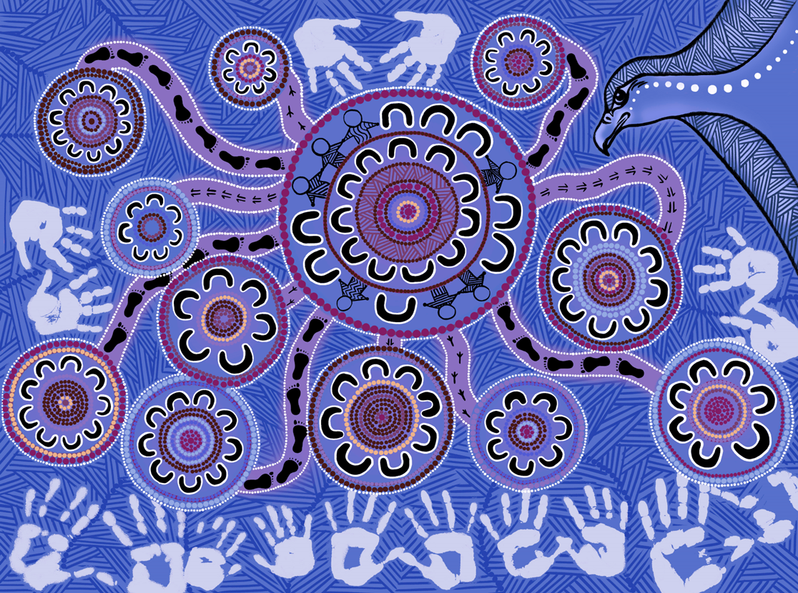

To receive this document in another format, email dhelkdja@familysafety.vic.gov.au
Authorised and published by the Victorian Government, 1 Treasury Place, Melbourne.
© State of Victoria, Australia, Department of Families, Fairness and Housing, December 2025.

With the exception of any images, photographs or branding (including, but not limited to the Victorian Coat of Arms, the Victorian Government logo or the Department of Families, Fairness and Housing logo), this work, Victorian Aboriginal Community Initiatives Fund: funding guidelines 2025–26, is licensed under a Creative Commons Attribution 4.0 licence.
The terms and conditions of this licence, including disclaimer of warranties and limitation of liability are available at Creative Commons Attribution 4.0 International Public License https://creativecommons.org/licenses/by/4.0/.
You are free to re-use the work under that licence, on the condition that you credit the State of Victoria, Australia (Department of Families, Fairness and Housing) as the author, indicate if any changes have been made to the work and comply with the other licence terms.
In this document, ‘Aboriginal’ refers to both Aboriginal and Torres Strait Islander people. ‘Indigenous’ or ‘Koori/Koorie’ is retained when part of the title of a report, program or quotation.
Available at Aboriginal Community Initiatives Fund: 2025–2026 funding round https://www.vic.gov.au/aboriginal-cif
(2510451)

