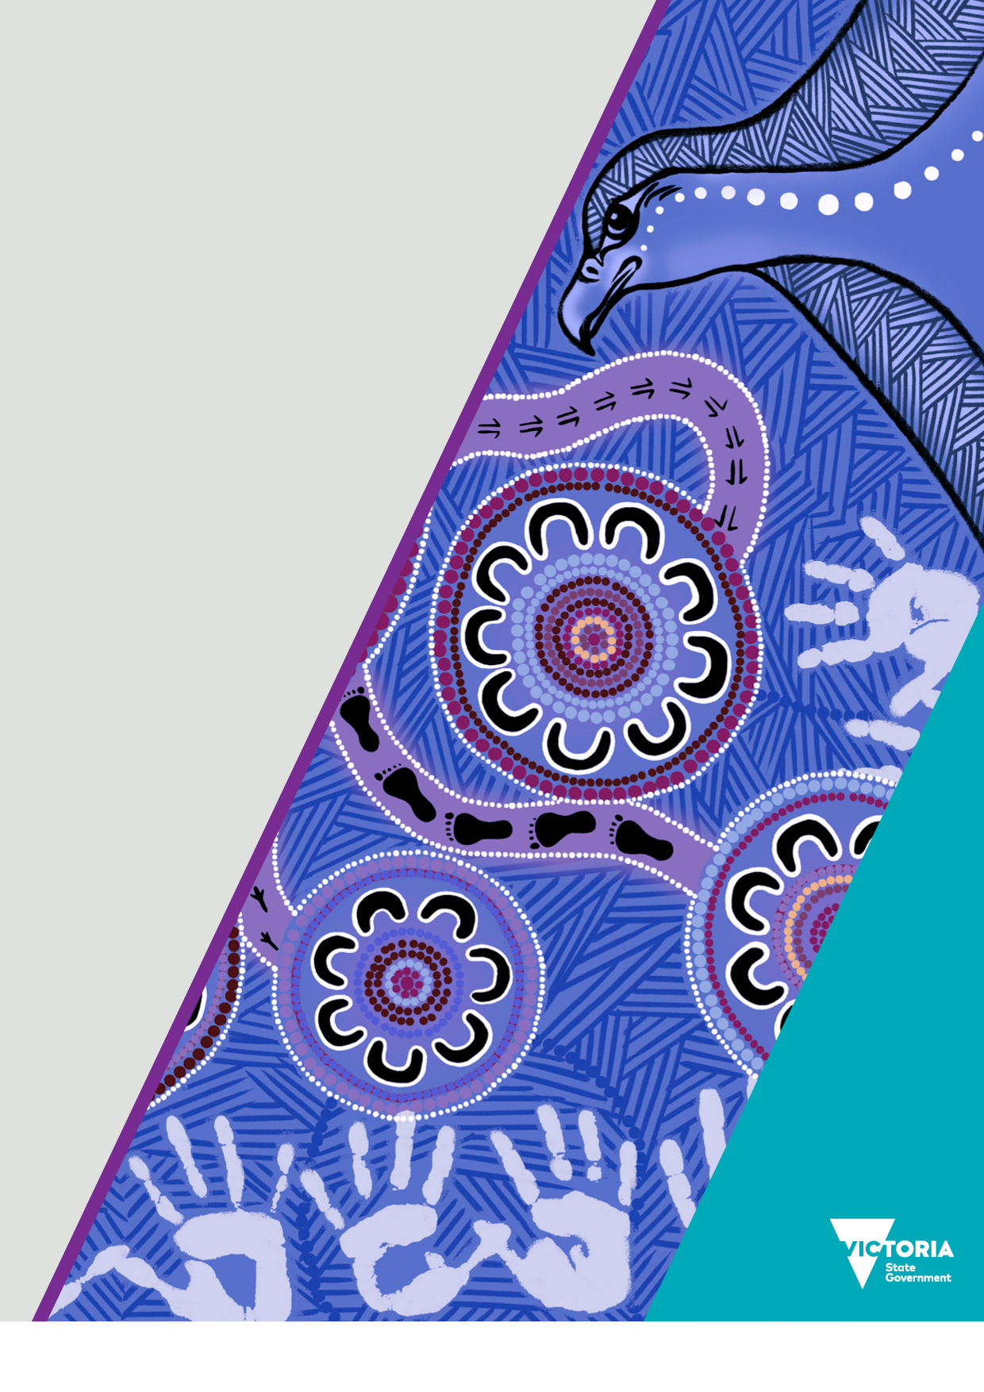
Victorian Aboriginal Community Initiatives Fund
Funding guidelines
2025–26
OFFICIAL

We acknowledge the Traditional Owners of Country throughout Victoria and pay respects to their Elders past and present. We acknowledge that Aboriginal self-determination is a human right and recognise the hard work of many generations of Aboriginal people.

Cover artwork and artist
Trina Dalton-Oogjes is a proud Wadawurrung/Wathaurung woman.
Trina’s painting centres around the 11 community Dhelk Dja Action Groups across Victoria, leading into a central gathering/yarning circle, empowering Aboriginal communities based on a healing and trauma informed process, to lead collaborative partnerships through a culturally safe service system.
Around the 11 community Dhelk Dja Action Groups are Aboriginal organisations/agencies, government departments and non-government agencies working together to address family violence.
Bunjil the Creator oversees to empower strength and self-determination.
Hand prints of the adults and children represent the family unit.
The kangaroo and emu footprints represent partnership moving forward (kangaroos and emus only move forward).
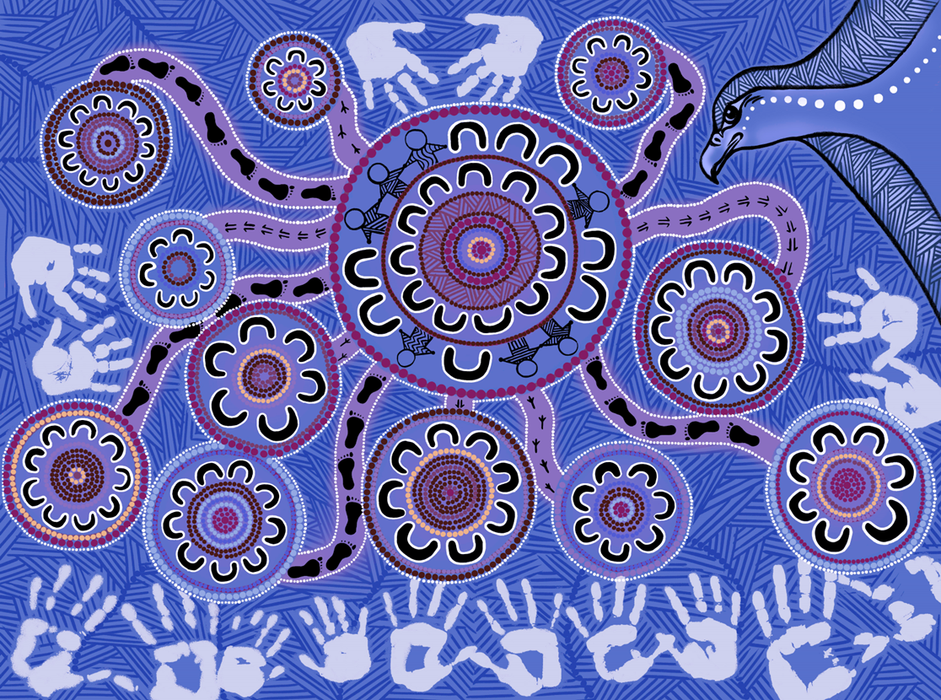

To receive this document in another format, email dhelkdja@familysafety.vic.gov.au
Authorised and published by the Victorian Government, 1 Treasury Place, Melbourne.
© State of Victoria, Australia, Department of Families, Fairness and Housing, December 2025.

With the exception of any images, photographs or branding (including, but not limited to the Victorian Coat of Arms, the Victorian Government logo or the Department of Families, Fairness and Housing logo), this work, Victorian Aboriginal Community Initiatives Fund: funding guidelines 2025–26, is licensed under a Creative Commons Attribution 4.0 licence.
The terms and conditions of this licence, including disclaimer of warranties and limitation of liability are available at Creative Commons Attribution 4.0 International Public License https://creativecommons.org/licenses/by/4.0/.
You are free to re-use the work under that licence, on the condition that you credit the State of Victoria, Australia (Department of Families, Fairness and Housing) as the author, indicate if any changes have been made to the work and comply with the other licence terms.
In this document, ‘Aboriginal’ refers to both Aboriginal and Torres Strait Islander people. ‘Indigenous’ or ‘Koori/Koorie’ is retained when part of the title of a report, program or quotation.
ISBN 978-1-76130-899-4 (pdf/online/MS word)
Available at Aboriginal Community Initiatives Fund: 2025–2026 funding round https://www.vic.gov.au/aboriginal-cif
(2510451)

Contents
Cover artwork and artist 2
Victorian Aboriginal Community Initiatives Fund 6
Aboriginal-led prevention funding 6
Key dates 6
Dhelk Dja Action Groups 7
Whole of Victoria – DFFH divisions and areas and local government authority areas 7
Metro Melbourne – DFFH divisions and areas and local government authority areas 8
West division areas 8
Wimmera South West – local government areas 8
Barwon – local government areas 8
Central Highlands – local government areas 8
Western Melbourne – local government areas 9
Brimbank Melton – local government areas 9
North division areas 9
Mallee – local government areas 9
Loddon – local government areas 9
Hume Merri-bek – local government areas 9
North Eastern Melbourne – local government areas 9
East division areas 10
Ovens Murray – local government areas 10
Goulburn – local government areas 10
Outer Eastern Melbourne – local government areas 10
Inner Eastern Melbourne – local government areas 10
South division areas 10
Outer Gippsland – local government areas 10
Inner Gippsland – local government areas 10
Southern Melbourne – local government areas 11
Bayside Peninsula – local government areas 11
Funding 11
Eligibility 12
Who is eligible to apply for CIF and Aboriginal-led prevention funding? 12
Eligibility criteria 13
Who is not eligible to apply for CIF funding? 13
What is not eligible for CIF funding? 13
What types of projects are eligible for CIF funding 14
Application process 14
How will applications be assessed? 15
Where do I obtain further information? 16
What happens if my application is successful? 18
Attachment 1: Conflict of interest 20
Financial interest 20
Immediate family 20
Personal obligation 20
Perceived conflict of interest 20
Management of conflict of interest 20
Dhelk Dja Action Groups 20
CIF Assessment Panel 20

Victorian Aboriginal Community Initiatives Fund
The Victorian Government, through the Department of Families, Fairness and Housing is providing $1.76 million for the Aboriginal Community Initiatives Fund (CIF) in 2025-26. The funds are to implement community-led projects that educate, prevent, reduce, and respond to family violence in Aboriginal communities across Victoria. Of the $1.76 million, $660,00 is specifically identified for Aboriginal-led prevention projects. Projects funded through CIF support and address priorities that are identified by the 11 Dhelk Dja action groups to address family violence at a local level.
It supports projects that:
- are Aboriginal led, including Aboriginal led partnerships
- are consistent with the goals and objectives of action groups and strengthen the capacity of Aboriginal communities and Aboriginal organisations to address family violence at a local level
- will provide an ongoing or long-term benefit to the community
- complement existing local community projects or initiatives and demonstrate partnerships with other government or non-government initiatives
- align with the Dhelk Dja: Safe Our Way – Strong Culture, Strong Peoples, Strong Families 10 Year Agreement (2018-2028).
- For projects aimed at preventing family violence, align to the Indigenous Family Violence Prevention Framework (2012).

Key dates
Process | Date
Call for applications | 15 December 2025
Application closing date and time | 20 February 2026 at 5 pm
Pre-panel applicant contact | TBC by the Region
CIF Assessment Panels | 23 February 2026 to 6 March 2026
Applicant interviews convened | TBC by the Region
All applicants advised of outcome by | April 2026
Project commencement from | June 2026
Project completion by | June 2027
The Department of Families, Fairness and Housing reserves the right to vary the key dates as necessary at its absolute discretion.

Dhelk Dja Action Groups
The 11 action groups play a leadership role across Victoria. They are Aboriginal community-led structures to drive local and regional responses to prevent and respond to family violence. See the Department of Families, Fairness and Housing’s local government area map. For details regarding any of the regional Dhelk Dja Action Groups, please consult with the relevant Regional Coordinator of the region for details. This information can be found in the ‘Regional Coordinator contact information’ section of this document.
At a statewide level, the 11 action group chairpersons influence change and support family violence reform in Victoria. The chairpersons represent Aboriginal communities on the Dhelk Dja Partnership Forum (Partnership Forum). The Partnership Forum:
- is the strategic leadership group that brings together Aboriginal communities, Aboriginal services and Government
- drives reform to aim to prevent and respond to family violence affecting Aboriginal communities.
At a local and regional level, action group chairpersons and members:
- develop action plans that aim to respond to local community needs through the establishment of strategies and initiatives
- play a key role in supporting Aboriginal community-led projects to prevent and respond to family violence. They do this by managing, reporting, and implementing CIF processes at the local and regional level.

Whole of Victoria – DFFH divisions and areas and local government authority areas
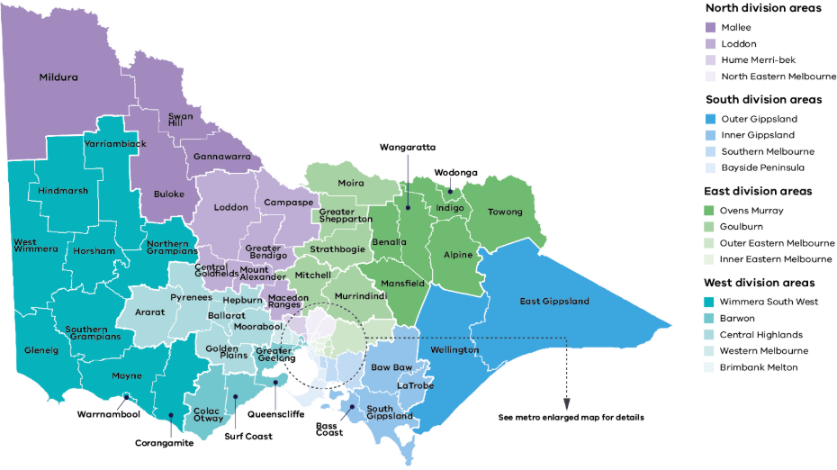

Metro Melbourne – DFFH divisions and areas and local government authority areas
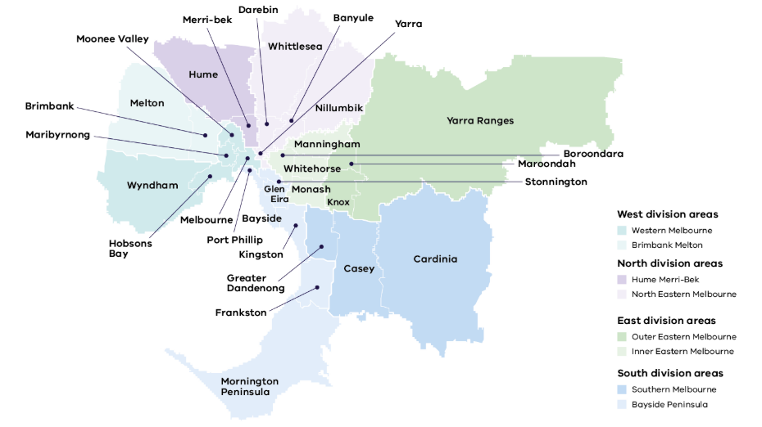

West division areas

South West – local government areas (BSW Region)
- Corangamite
- Glenelg
- Southern Grampians
- Warrnambool
- Moyne

Barwon – local government areas (BSW Region)
- Colac Otway
- Queenscliffe
- Greater Geelong
- Surf Coast

Central Highlands – local government areas (Grampians Region)
- Ararat
- Ballarat
- Golden Plains
- Hepburn
- Moorabool
- Pyrenees

Wimmera-local government (Grampians Region)
- Yarriamblack
- Northern Grampians
- West Wimmera
- Horsham
- Hindmarsh

Western Melbourne – local government areas
- Hobsons Bay
- Maribyrnong
- Melbourne
- Moonee Valley
- Wyndham

Brimbank Melton – local government areas
- Brimbank
- Melton

North division areas

Mallee – local government areas
- Mildura
- Swan Hill
- Buloke
- Gannawarra

Loddon – local government areas
- Campaspe
- Central Goldfields
- Greater Bendigo
- Loddon
- Macedon Ranges
- Mount Alexander

Hume Merri-bek – local government areas
- Hume
- Merri-bek

North Eastern Melbourne – local government areas
- Banyule
- Darebin
- Nillumbik
- Whittlesea
- Yarra

East division areas

Ovens Murray – local government areas
- Alpine
- Benalla
- Indigo
- Mansfield
- Towong
- Wangaratta
- Wodonga

Goulburn – local government areas
- Greater Shepperton
- Mitchell
- Moira
- Murrindindi
- Strathbogie

Outer Eastern Melbourne – local government areas
- Knox
- Maroondah
- Yarra Ranges

Inner Eastern Melbourne – local government areas
- Boroondara
- Manningham
- Monash
- Whitehorse

South division areas

Outer Gippsland – local government areas
- East Gippsland
- Wellington

Inner Gippsland – local government areas
- Bass Coast
- Baw Baw
- LaTrobe
- South Gippsland

Southern Melbourne – local government areas
- Cardinia
- Casey
- Greater Dandenong

Bayside Peninsula – local government areas
- Frankston
- Glen Eira
- Kingston
- Mornington Peninsula
- Port Phili
- Stonnington

Funding
CIF funding will be made available for local and/or regional based Aboriginal-led projects that educate, prevent, reduce, and respond to family violence in Aboriginal communities across Victoria. Only Aboriginal-led organisations and/or community groups can apply.
Funding is equally divided across the 11 Action Group regions. A total of $160,000 is allocated to each Action Group region to support multiple projects of varying amounts, with $60,000 of this funding specifically targeted for prevention projects that align to Dhelk Dja: Safe Our Way – Strong Culture, Strong Peoples, Strong Families 10 Year Agreement (2018-2028), Strategic Priority Two and the Indigenous Family Violence Prevention Framework (2012). Projects are to be delivered from June 2026 to June 2027.
The CIF aims to:
- support Aboriginal self-determination
- support community groups or activities to strengthen ability to make positive choices about their lives, building leadership skills and confidence as well as sharing knowledge
- support innovative Aboriginal-led prevention and early intervention initiatives to address family violence
- deliver positive outcomes which will benefit the Aboriginal community in addressing family violence
- demonstrate inclusiveness of all Aboriginal people. This includes:
  - Elders
  - women
  - men
  - children and young people (including those in out of home care)
  - people from the lesbian, gay, bisexual, trans and gender diverse, intersex, queer, and asexual (LGBTIQA+) community
  - people living with disabilities or mental health issues
  - people living in rural, remote or regional communities
  - people exiting prisons.
- complement but not duplicate existing funded community initiatives. CIF is unlikely to support activities or projects that the applicant is currently funded for and considered as ‘core business’ or ‘business as usual’.
The following funding expectations will apply to all projects that receive CIF funding:
- provide an alcohol, drug and smoke free environment
- provide a culturally safe environment free from violence
- volunteers and staff to hold a current Working with Children’s Check
- be covered be all appropriate insurance, including public liability insurance for not less than $5 million
- have a positive working relationship with the Dhelk Dja Action Group.
In addition, all publicity, promotional materials and signage relating to the project must prominently display the Dhelk Dja Action Group logo from your region (available from the Regional Coordinator).
All media/promotional material generated by the funded organisation relating to the project must include the line:
‘The (insert name of region) Dhelk Dja Action Groups supports this event, with funds provided by the Victorian Government Aboriginal Community Initiatives Fund.’

Please note that any breach of CIF funding by not adhering to the funding expectations may result in your project being cancelled, funding being returned and may impact your ability to receive future funding.

Eligibility

Who is eligible to apply for CIF funding?
Funding is available to:
- Victorian Aboriginal led not-for-profit organisations that have a current Service Agreement with the Department of Families, Fairness and Housing, or
- Victorian Aboriginal led not-for-profit organisations that have secured an auspice agreement with an organisation with a current Service Agreement with the Department of Families, Fairness and Housing, or
- Victorian Aboriginal community groups whose work supports Aboriginal families and/or communities in Victoria that have secured an auspice arrangement with an organisation that currently has a Service Agreement with the Department of Families, Fairness and Housing.
To check the status of your Service Agreement or discuss auspice requirements please contact the relevant Regional Coordinator in the region you are applying for funding.
Aboriginal-led organisations may choose to partner with non-Aboriginal organisations where specific content knowledge or other expertise is required. However, the Aboriginal-led organisation and/or community group must be the lead or senior partner throughout the partnership-based project(s) to be considered for CIF funding.

Eligibility criteria
Eligible organisations must demonstrate:
- they are controlled, led or directed by Aboriginal Victorians and are not-for-profit
- they are established for the purpose of promoting Aboriginal community objectives or outcomes in Victoria
- they are legally Incorporated under Victorian or Commonwealth legislation
- financial capacity to administer and manage funds of the project.
- capacity to undertake and complete a project within agreed timeframes
- any person representing a volunteer based Aboriginal community group (Authorised Signatory) has partnered with an organisation who has a current Service Agreement with the Department of Families, Fairness and Housing
- if they have previously received funding from the CIF, that they are compliant with reporting requirements in order to be eligible to apply for further funding.
- you have an Australian Business Number (ABN) or be willing to provide a Statement by Supplier Form (reason for not quoting an ABN).

Who is not eligible to apply for CIF funding?
Organisations that are not eligible to apply for funding include, but are not limited to:
- sole traders
- for-profit organisations
- professional associations
- non-corporate Commonwealth entity
- non-corporate State/Territory entity
- non-corporate Commonwealth Statutory Authority
- local government entities
- organisations outside of Victoria
- individuals who are not office holders or authorised signatories of volunteer-based community groups.

What is not eligible for CIF funding?
The Aboriginal Community Initiatives Fund will not fund the following:
- wages/salaries for staff
- infrastructure, major planning or capital projects
- court/legal costs
- emergency relief/brokerage funding
- funeral funds and expenses
- commercial or business ventures
- purchase or large non portable and tangible equipment
- projects currently receiving funding from another government department
- donations
- sponsorships
All eligibility requirements also apply to Aboriginal-led prevention funding

What types of projects are eligible for CIF funding
Table 1: Project examples that align with the Strategic Priorities of Dhelk Dja: Safe Our Way – Strong Culture, Strong Peoples, Strong Families 10 Year Agreement
Strategic priority | Project examples
Strategic Priority 1 – Aboriginal Culture and Leadership | Cultural activities such as traditional dance, shield making and basket weaving
Strategic Priority 2 – Aboriginal-led Prevention | Activities that support and strengthen families in finding solutions to negative behaviours such as family violence
Strategic Priority 2 – Aboriginal-led Prevention | Sporting events and family days that provide community with messages about respectful behaviour and information on support services
Strategic Priority 3 – Self-determining Aboriginal family violence support and services | Support groups or activities to strengthen ability to make positive choices about their lives, building leadership skills and confidence as well as sharing knowledge
Strategic Priority 3 – Self-determining Aboriginal family violence support and services | Workshops and training to improve cultural safety and responsiveness to family violence
Strategic Priority 4 – System transformation based on self-determination | Youth forums to ensure the voices of Aboriginal children & young people are embedded in system transformation work
Strategic Priority 5 – Aboriginal-led and informed innovation, data, and research | Feasibility studies or evaluations of existing CIF projects with objective of building on what works

Application process
The application process is as follows:
- Contact the Regional Coordinator who supports the Dhelk Dja Action Group in your region, to express your interest and discuss your project proposal for the Aboriginal Community Initiatives Fund. The Regional Coordinator will advise you on regional processes i.e. information sessions/forums being held.
- The Regional Coordinator will provide you with a copy of the Dhelk Dja: Safe Our Way – Strong Culture, Strong Peoples, Strong Families 10 Year Agreement 2018–2028, the Dhelk Dja Regional Action Group Plan and the Indigenous Family Violence Prevention Framework.
- Complete the CIF 2025-26 Application Form and submit it to the Regional Coordinator, along with all supporting documentation. The closing date for applications is 20 February 2026 at 5 pm. No late applications will be accepted.
- Applications will be reviewed to ensure that the eligibility criteria are met and that all sections are completed. Applications that do not meet the eligibility criteria will not proceed to the Assessment Panel.
- Team Leader(s), Aboriginal Governance and Engagement, Aboriginal Initiatives Unit (AIU) will provide guidance and ensure compliance with the CIF process.
- All eligible applications will be presented to the CIF Assessment Panel which comprises:
- Two Aboriginal community representatives of the Dhelk Dja Action Group
- Independent Aboriginal representative, as identified by the Dhelk Dja Chairpersons
- Senior Aboriginal representative from Department of Families, Fairness and Housing (DFFH), as identified by the Dhelk Dja Chairpersons
The Regional Coordinator provides secretariat support and advice to the panel and does not have any decision-making capacity.
- The CIF Assessment Panel will assess applications against set criterion. As part of the assessment process, applicants must attend an Assessment Panel Interview to discuss their application. Interviews will be advised by the Regions.
- At the completion of the process, you will be advised of the outcome in writing by Aboriginal Initiatives Unit and given the opportunity to obtain feedback about your submission
- Any queries should be directed to the relevant Regional Coordinator.

How will applications be assessed?
Eligible applications will be assessed against the following assessment criteria:

Assessment criterion 1: Eligibility to apply for funding
- Confirmation of eligible organisations
- Confirmation of eligibility of project criterion
- Applicant details (sections 1 and 2 of the application completed and signed)
- All supporting documents are provided:
  - Copy of the organisation’s Certificate of Incorporation and Statement of Purpose (or where applicable, a copy of the auspice organisation)
  - Copy of the organisation’s (or where applicable, the auspice organisation) previous years audited financial statements
  - Letters of support and any agreements/Memorandum of Understanding (MOU) with partnering organisations

Assessment criterion 2: Level of need for the project in your community
- Details of proposed target audience participants in the project provided
- Details provided of how participants will be selected.
- How will the project be inclusive of different groups in your local Aboriginal communities?
- Provide details of the areas where the project will be delivered within your region
- Describe how the project addresses local needs in your community (as identified by the Dhelk Dja Action Group) Refer to the Regional Dhelk Dja Action Plan

Assessment criterion 3: Project alignment to Dhelk Dja: Safe Our Way – Strong Culture, Strong Peoples, Strong Families 10 Year Agreement (the Agreement)
- List the project objectives and how they align with the Strategic Priorities of the Agreement.

Assessment criterion 4: Capacity of project manager to deliver the project
- Provide details of the Project Plan
- Demonstrate what measures will be used to evaluate success of the project
- Provide any previous performance on CIF projects

Assessment criterion 5: Financial details
- List the income and expenditure for the project
- Provide details of financial or in-kind contributions from the applicant organisation or any other partners

Assessment criterion 6: Determining understanding of the funding expectations and declaring any conflict of interest
- Provide details on how you will address the CIF funding expectations
- Declaration of Interest

Where do I obtain further information?
The Aboriginal Community Initiatives Fund Guidelines and Application Form can be downloaded from the Aboriginal Community Initiatives Fund webpage https:// www.vic.gov.au/aboriginal-cif.

Regional Coordinator contact information
For further information contact the Regional Coordinator or regional representative at the relevant office listed below:

Metro

East Metro Region
Trudy Hunt
Regional Coordinator
Mob: 0418 380 543
Email: age.aiu@dffh.vic.gov.au

North Metro Region
Lynda Whitaker
Regional Coordinator
Mob: 0418 900 718
Email: Lynda.Whitaker@familysafety.vic.gov.au

South Metro Region
Sam Lampard
Team Leader South-East
Mob: 0457 335 219
Email: sam.lampard@familysafety.vic.gov.au

West Metro Region
Ashlee Feeney
Regional Coordinator
Mob: 0418 611 896
Email: ashlee.feeney@familysafety.vic.gov.au

Regional

Barwon South West Region
Tania Dalton
Regional Coordinator
Mob: 0417 396 946
Email: tania.dalton@familysafety.vic.gov.au

Grampians Region
Nicole Rethus
Regional Coordinator
Mob: 0409 347 537
Email: nicole.rethus@familysafety.vic.gov.au

Regional

Hume Region
Kellie Marsters
Regional Coordinator
Mob: 0448 946 101
Email: kellie.marsters@familysafety.vic.gov.au

Inner Gippsland Region
Shannon Nicholson
Regional Coordinator
Mob: 0429 423 152
Email: shannon.nicholson@familysafety.vic.gov.au

Loddon Campaspe Region
Marianne Atkinson
Manager, Aboriginal Governance and Engagement, Aboriginal Initiatives Unit
Email: Marianne.atkinson@familysafety.vic.gov.au

Mallee Region
Shannon Oates
Team Leader North - West
Mob: 0428 760 396
Email: shannon.oates@familysafety.vic.gov.au

East Gippsland Region
Jodie Douthat
Regional Coordinator
Mob: 0457 229 908
Email: jodie.douthat@familysafety.vic.gov.au

What happens if my application is successful?

Applicants with a current Service Agreement with the Department of Families, Fairness and Housing
The Department of Families, Fairness and Housing (DFFH) will vary its Service Agreement with the successful applicants. This agreement specifies the services to be delivered and sets out funding conditions and reporting requirements.
Any proposed changes or variation to the project and project budget must be submitted to the Regional Coordinator and approved by the department.
Projects are to be compliant with the reporting requirements. A standard template will be provided for reporting purposes. The reporting requirements include:
- verbal reports updating the Regional Coordinator and by attending the Dhelk Dja Action Group meetings in your region, throughout the duration of the project
- a written progress report halfway throughout the project timeline, providing a summary of the activities against milestones provided in the project plan
- a final written report within six weeks of completion of the project, including photographs, films, or mixed media, where appropriate
- a financial acquittal
Reports are to be submitted to the Regional Coordinator.

Applicants that do not have a Service Agreement the Department of Families, Fairness and Housing
Applicants that do not have a current Service Agreements with the Department of Families, Fairness and Housing must enter into an auspice agreement with an organisation that has a current Service Agreement with the Department of Families, Fairness and Housing to be eligible for funding.
The auspice organisation must vary its Service Agreement with DFFH. The auspice organisation must ensure that all obligations in the Service Agreement are met, including service delivery, financial accountability, and client confidentiality requirements.
To avoid any misunderstanding in relation to the responsibilities and accountability, both parties must undertake the following steps prior to applying for CIF funding:
- clarify the obligations and responsibilities of both parties in the form of a written MOU. A copy of the MOU must be provided to the Regional Coordinator.
- agree on the budget and project plan, including the auspice fee (no more than 10%)
- ensure that correct and adequate insurance policies are held.
Once the project has commenced, the auspice organisation will arrange for payment of invoices submitted in relation to the budget lines specified in the project plan. A standard template will be provided for reporting purposes. The reporting requirements include:
- verbal reports updating the Regional Coordinator and by attending the Dhelk Dja Action Group meetings in your region, throughout the duration of the project
- a written progress report halfway throughout the project timeline, providing a summary of the activities against milestones provided in the project plan
- a final written report within six weeks of completion of the project, including photographs, films, or mixed media, where appropriate
- a financial acquittal
Reports are to be submitted to the Regional Coordinator.
Where a community group is partnering with an incorporated organisation who auspices the grant (or its funds):
- the community group delivering the project will provide the verbal and written reports
- the organisation who auspices the funding will submit the financial acquittal.
The Regional Coordinator, Dhelk Dja Action Group Chairperson and DFFH will make reasonable efforts to work with the community group and auspice organisation to resolve any disputes or grievances that may arise during the project.

Attachment 1: Conflict of interest
A conflict of interest is deemed to occur where an individual has any of the following:

Financial interest
Any individual having a direct or indirect financial interest in any of the applications for funding constitutes a conflict of interest. This includes an individual being an employee, board member or a member of a committee of management of an organisation that is seeking funding.

Immediate family
Any individual having an immediate family member who is likely to receive a financial benefit from an application for funding, or who would be involved in the delivery of the proposed project constitutes a conflict of interest.
An ‘immediate family member’ is considered as a sibling, parent, child, partner or any other person whom the individual considers as immediate family.

Personal obligation
Any personal obligation, allegiance, or loyalty (either actual or perceived) which affects the member’s ability to make an unbiased decision (in relation to the funding application) constitutes a conflict of interest.

Perceived conflict of interest
If it could be perceived that an individual has private interests’ that could conflict with their public or official duties. If a third party could form the view that an individual interests or obligations could influence their decision making or performance.

Management of conflict of interest
The Department of Families, Fairness and Housing will effectively manage any conflict of interest (actual, potential, or perceived) that any person involved in the selection process has with any application or any applicant organisation, to produce results that are in the best interests of the Victorian Aboriginal community.

Dhelk Dja Action Groups
Each Action Group is responsible for ensuring adherence to its own conflict of interest procedures as stated in the guidelines, taking into account that any person, who has an actual, potential, or perceived conflict of interest, must declare their interest and note this in the template that accompanies the completed CIF application.

CIF Assessment Panel
The CIF Assessment Panel is formed by identifying members who would have no or limited conflict of interest with regards to incoming applications. All members must declare any conflict of interest with any application. Assessment Panel members will not assess any application where they have a conflict of interest but may still participate in discussions about that project. In addition, Regional Coordinators only have an administrative role in the panel process and do not assess any application.

