
Victorian Government and Victorian
Veterans Council grants
acknowledgement and publicity guidelines
For organisations receiving grants from the Department of Families, Fairness and Housing
OFFICIAL
Contents
Keeping the grant funding confidential 1
Government representative opportunities 1
Inviting a minister to an event 2
Inviting departmental staff to an event 2
Printed and verbal acknowledgement 2
Capital works projects acknowledgement 2
Department signage at events 2
Reporting on acknowledgement of government grants 3
Written acknowledgement statement of Victorian Government funding 3
Victorian Government logo for publishing, printing and signage 3
How to access the logo 3
Which logo to use 3
Official colours and correct logo usage 3
Logo usage and placement 4
Further information 5
Funded organisations 5
Department staff 6

It is a standard condition of Victorian Government grants that recipients must agree to follow these guidelines to acknowledge funding.
These guidelines are applicable to the following grant programs:
• ANZAC Day Proceeds Fund
• Victoria Remembers

Keeping grant funding confidential
You may need to keep your funding confidential until a there is a public announcement.
Once approved, many grants remain highly confidential until the relevant minister or their representative publicly announces the funding. The department will advise you in writing if this applies to your grant.

Victorian Government and Victorian Veterans Council (VVC) representative opportunities
If you launch or open the grant project or funded activity at a public event or similar, you must:
- give the relevant minister and the VVC Chair the opportunity to open or launch the project or funded activity
- invite the minister and VVC Chair to all significant events associated with the project or funded activity
- give adequate notice (the department recommends at least two months’ lead time)
- work with the department to coordinate the minister, VVC Chair and/or their representative’s role in the opening or launch, or their attendance at events.

Inviting a minister to an event
Organisations may contact a minister’s office directly to invite them to an event or launch. The contact details for ministerial offices are available at Premier of Victoria – The team.

Inviting the Victorian Veterans Council to an event
Organisations may contact the VVC directly to invite them to an event or launch. The contact details for the Victorian Veterans Council office is vicvetcouncil@dffh.vic.gov.au.
Organisations must acknowledge the Victorian Government and the Victorian Veterans Council’s funding support via any key messages about the grant program including:
- speeches and presentations about the grant project or funded activity
- media releases
- relevant job advertisements
- on documents, publications, reports, brochures, posters, flyers and the like. You must give the government the opportunity to contribute a sponsor’s message for any relevant publication
- on websites or other digital communications developed with the government’s funding support. These should also include a link to the department website. Contact the department for the relevant department website URL.
- in social media text and/or images. Where possible, the social media executions should include a written acknowledgement of Victorian Government funding and/or the Victoria State Government and the VVC logos and a link to the relevant departmental website (depending on the social media channel).

Reporting on acknowledgement of government and VVC grants
You may need to provide details of how the government and VVC grants was/is being acknowledged.
The department will request this information as part of your final/acquittal reporting template or in instructions in relation to the grant project or funded activity.

Written acknowledgement statement of Victorian Government and VVC funding
Include one of the statements below in acknowledgement statements associated with the grant activity:
The [name of program/s/projects/s/ activity] was/were supported by the Victorian Government and the
Victorian Veterans Council.
The [name of program/s/projects/s/ activity] are/is supported by the Victorian Government and the
Victorian Veterans Council.
[Name of organisation] acknowledges the support of the Victorian Government and the
Victorian Veterans Council.
Please note: you must acknowledge the Victorian Government, not the individual department.

Victorian Government and Victorian Veterans Council logo for publishing, printing and signage
You must use the Victorian Government logo on all published or printed materials or signage associated with the grant project or funded activity.

How to access the logo
You can download the Victorian Government logo from Brand Victoria - using our logos https://www.vic.gov.au/brand-victoria-using-our-logos.
The Victorian Veterans Council has various formats of its logo. To request the correct logo format please email the Office for Veterans veteransgrants@dffh.vic.gov.au. In your email include information about where you will use the logo, version, and the image file formats required.
You cannot alter these logos under any circumstances. Do not copy and paste the logo from this document or any other Victorian Government publication or website. Use the downloadable logos.


Which logos to use


Official colours and correct logo usage
Do not alter the logo.
- Black is the official colour of the Victoria state government logo. The web-safe colour is RGB (R = 0, G = 0, B =0).
- Make sure there is enough contrast between the background and the logo.
  - Where the background is a solid dark colour, use a white logo.
  - Where the background is a light colour, use a black logo.
- Don’t place the logo over an image or a pattern unless there is enough contrast to show the logo clearly.
- Don’t place the logo over other text.
- Don’t stretch or distort logos. Always keep the ratio between width and height measurements the same.
- The area surrounding the text and triangle should show the underlying background colour.
- It should never appear with a white box around it.
The following examples show correct and incorrect use of the logo. Note that the organisation own brand colours can be in the background.
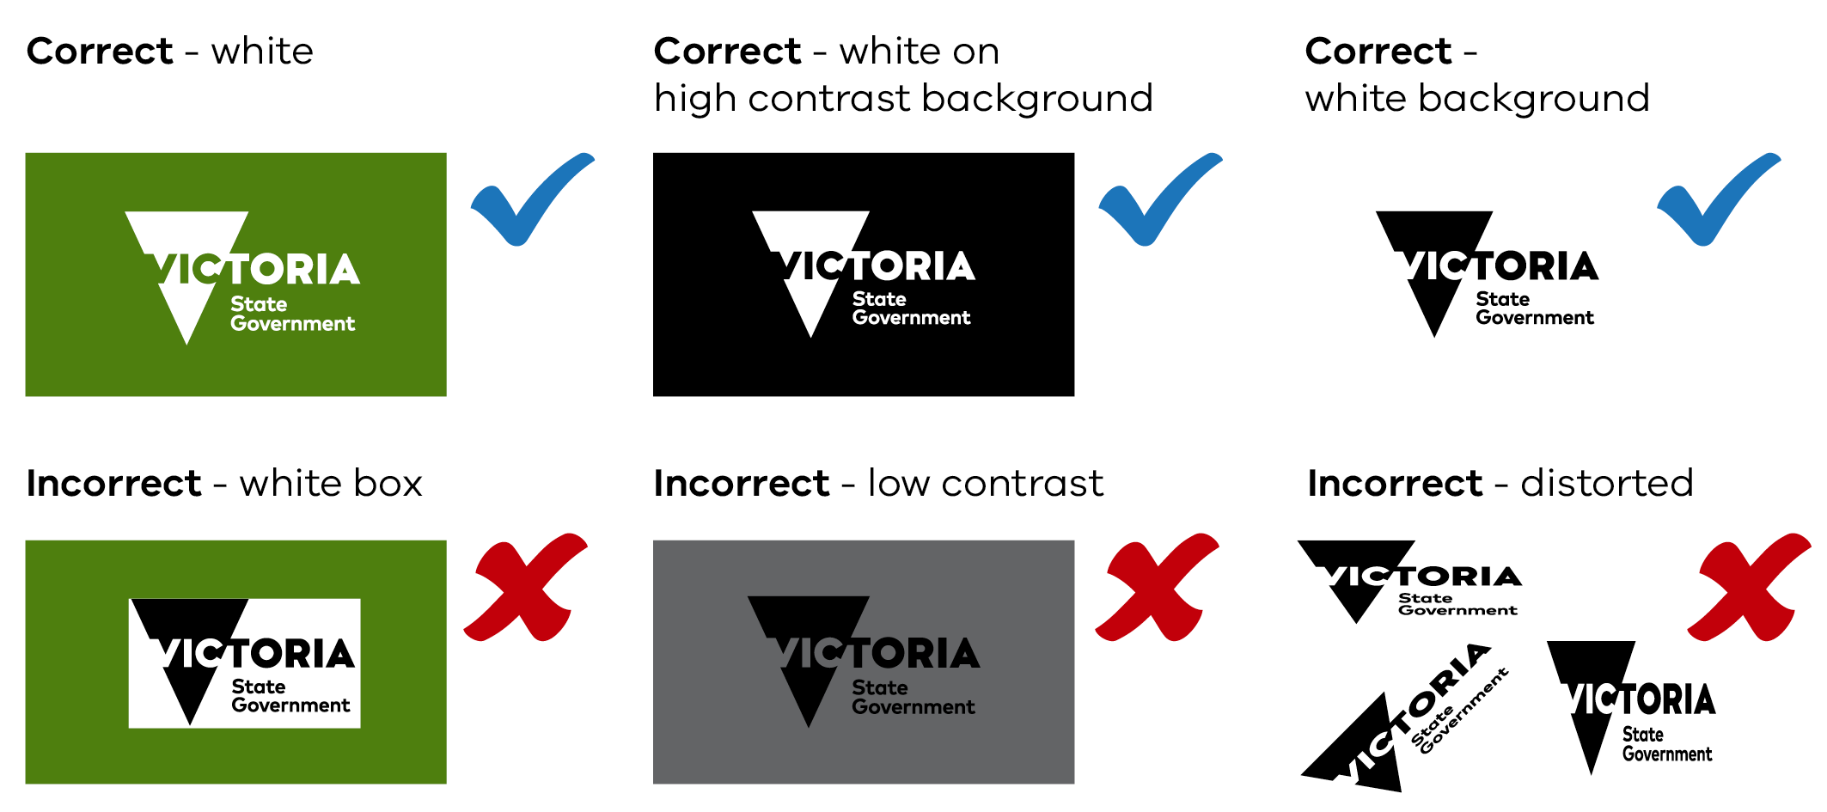

Victorian Veterans Council Logo Variations
Vertical

Horizontal


Logo usage and placement
The organisation receiving the grant funding should use their own brand or visual style. They can place the Brand Victoria logo on either side or above or below their own logo.

Clear space
Maintain ‘clear space’ around the Brand Victoria logo.
Clear space creates an invisible frame that is a minimum area surrounding the logo. It must remain free of any conflicting visual element.
Wherever possible, apply additional clear space beyond the minimum requirement.

Clear space for print applications
The clear space for print applications is at least 50 per cent of the height of the triangle in the logo.
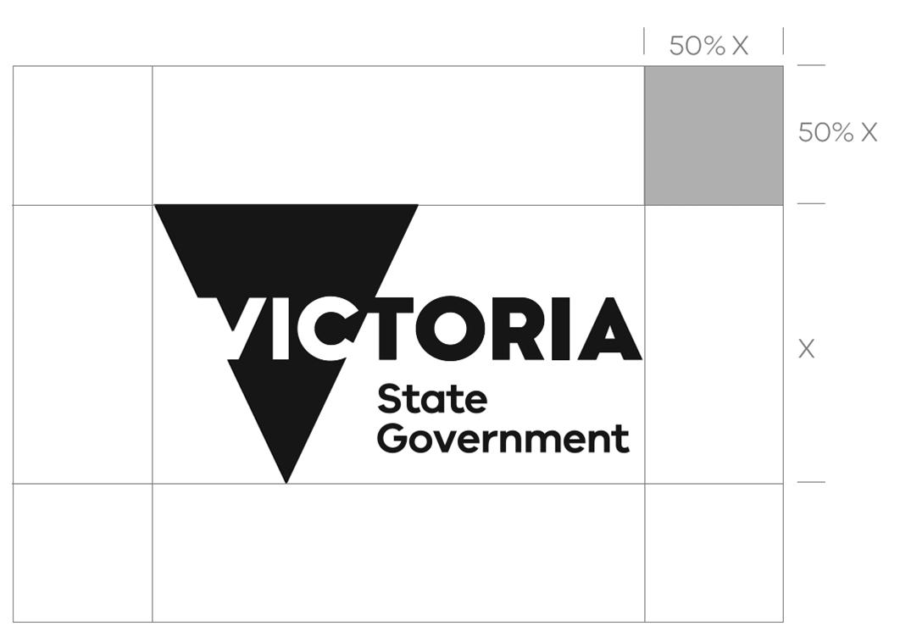

Clear space for screen applications
The clear space for screen applications is at least 20 per cent of the height of the triangle in the logo.
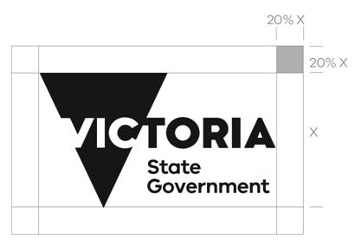

Minimum size of logos
The minimum size for print applications is 10 mm from the top to the bottom of the triangle in the Brand Victoria logo.

The minimum size for screen applications is 60 pixels from the top to the bottom of the triangle in the Brand Victoria logo.

Use the logo at larger than the minimum size if there a question about the quality of reproduction.

Funded organisations
Organisations should contact the department staff member named in their grant agreement for any questions about:
- these acknowledgement and publicity guidelines
- how to the use the logo.
The department staff member will contact the department’s Design and Publications team on their behalf to clarify about logo usage, where necessary.

To receive this document in another format, email Office for Veterans
veteransgrants@dffh.vic.gov.au
Authorised and published by the Victorian Government, 1 Treasury Place, Melbourne.
© State of Victoria, Australia, Department of Families, Fairness and Housing, November 2025. (230855)

https://www.premier.vic.gov.au/team

