Responding to family violence
capability framework
Accessible
OFFICIAL


To receive this document in another format, email the Centre for Workforce Excellence, cwe@dffh.vic.gov.au
Authorised and published by the Victorian Government, 1 Treasury Place, Melbourne.
© State of Victoria, Australia, Department of Families, Fairness and Housing, November 2025.

With the exception of any images, photographs or branding (including, but not limited to the Victorian Coat of Arms, the Victorian Government logo or the Department of Families, Fairness and Housing logo), this work, Responding to family violence capability framework, is licensed under a Creative Commons Attribution 4.0 licence.
The terms and conditions of this licence, including disclaimer of warranties and limitation of liability are available at Creative Commons Attribution 4.0 International Public License https://creativecommons.org/licenses/by/4.0/.
You are free to re-use the work under that licence, on the condition that you credit the State of Victoria, Australia (Department of Families, Fairness and Housing) as the author, indicate if any changes have been made to the work and comply with the other licence terms.
In this document, ‘Aboriginal’ refers to both Aboriginal and Torres Strait Islander people. ‘Indigenous’ or ‘Koori/Koorie’ is retained when part of the title of a report, program or quotation.
ISBN/ISSN 978-1-76130-757-7 (pdf/online/MS word)
Available at VIC.GOV.AU – Responding to family violence capability framework https://www.vic.gov.au/responding-family-violence-capability-framework (2405069)

Contents
Acknowledgements 4
Aboriginal acknowledgement 4
Acknowledgement of victim survivors of family violence 4
Family violence services and support 4
Introduction 5
What is the capability framework? 5
The capability framework and MARAM 5
Why have a capability framework? 6
Capability frameworks and workforce development 6
Who is this capability framework for? 7
How different roles can use this framework 7
Language and terminology 8
A coordinated approach to capability building 8
How to use this framework 9
For all workers 9
For specialist family violence practitioners 9
Figure 1: Structure of the Responding to family violence capability framework 10
Figure 2: Capabilities for all workers across the service system 11
Figure 2: Capabilities for all workers across the service system (continued 2) 12
Figure 2: Capabilities for all workers across the service system (continued 3) 13
Figure 2: Capabilities for all workers across the service system (continued 3) 14
Figure 3: Capabilities for specialist practitioners 15
Plain figure text 16
Figure 1 text: Structure of the Responding to family violence capability framework 16
Figure 2 text: Capabilities for all workers across the service system 17
Figure 3 text: Capabilities for specialist practitioners 26

Acknowledgements
Many people contributed to this capability framework. The department acknowledges and thanks those across the family violence and sexual assault sectors and broader service system that contributed. We also acknowledge the members of a dedicated working group that guided development of this framework and thank them for their dedication, collaboration and expertise. This was instrumental in shaping this capability framework. These include Safe and Equal, No to Violence and Sexual Assault Services Victoria.

Aboriginal acknowledgement
The Victorian Government acknowledges Victorian Aboriginal people as the First Peoples and Traditional Owners and Custodians of the land and water on which we rely. We acknowledge and respect that Aboriginal communities are steeped in traditions and customs built on a disciplined social and cultural order that has sustained 60,000 years of existence. We acknowledge the significant disruptions to social and cultural order and the ongoing hurt caused by colonisation. We acknowledge the ongoing leadership role of Aboriginal communities, particularly Aboriginal women, in addressing and preventing family violence and will continue to work in collaboration with First Peoples to eliminate family violence from all communities.

Acknowledgement of victim survivors of family violence
We pay our respects to victims and victim survivors of family violence and violence against women. We acknowledge their resilience and courage. They remain at the forefront of our work.
We acknowledge the Victim Survivors Advisory Committee. We consulted with committee members to develop this capability framework. Members provided valuable insights into how this framework could improve the experiences of people experiencing family violence.

Family violence services and support
If you have experienced violence or sexual assault, contact 1800 RESPECT (1800 737 732). You can get immediate help. You can also get ongoing help. When you call, you will talk to a counsellor from the National Sexual Assault and Domestic Violence hotline.
For confidential support and information, contact Safe Steps’ 24/7 family violence response line on 1800 015 188.
If you are concerned for your safety or that of someone else, contact the police or call Triple Zero (000) for emergency help.

Introduction

What is the capability framework?
The capability framework describes the knowledge and skills workers need to respond to family violence in a way that is safe and effective. It is for all workers whose roles intersect with family violence. It supports workers to deliver services that are:
- effective
- safe
- culturally responsive.
This framework is for those who work in specialist family violence services, as well as the broader health, justice and social services. By following this framework, organisations contribute to a workforce that is:
- informed
- capable
- culturally responsive.
The framework defines the skills and capabilities that these workforces need to:
- meet the challenges of family violence work
- improve the safety and wellbeing of victim survivors and their families.

The capability framework and MARAM
MARAM is the foundational policy, embedded in Part 11 of the Family Violence Protection Act that outlines how Victorian services and systems respond to family violence. MARAM sets out a shared understanding of family violence. It also includes the responsibilities of services, professionals and systems to work together to identify, assess and manage family violence risk.
MARAM guidance and resources define the practice requirements in line with these responsibilities. Read this capability framework alongside:
- the MARAM Foundation knowledge guide
- the relevant practice guides and resources.
This framework outlines the breadth of capabilities professionals need across the service system to respond to family violence and meet their responsibilities under MARAM. These capabilities include those needed to:
- identify and assess family violence risk
- manage risk and put in place strategies that prioritise victim survivors’ safety and needs
- seek or provide secondary consultation and referrals in line with information sharing laws and regulations
- work with other services to achieve integrated and consistent responses.
MARAM provides the core knowledge, practice guidance and tools for responding to family violence. It does this according to defined responsibilities of different workforces. This framework emphasises workforce capability by outlining the skills needed to carry out family violence practice. To be consistent with MARAM requirements, it supports organisations to:
- identify skills gaps
- develop roles and positions
- design targeted training
- develop career pathways.
Organisations should define and build workforce capabilities in a way that aligns with the MARAM framework in order to support a more consistent system-wide response to family violence.

Why have a capability framework?
A capability framework identifies what workers need to perform their role in a given field. It offers a structured approach to identifying the skills that people need. It can guide workforce development by individuals or organisations.

Capability building
Capability frameworks outline the skills and knowledge needed at varying levels of practice. This can be from entry-level to specialist roles. Capability frameworks enable:
- targeted training
- professional development
- role-specific development.

Organisational planning
Capability frameworks offer a consistent language and structure to inform workforce strategies. This includes for:
- recruitment
- performance management
- succession planning.

Performance and development
Capability frameworks provide a structured way to assess performance. This helps staff understand their roles and the value they contribute.

A system that works together
Capability frameworks improve cross-sector collaboration. This framework helps align workforce capabilities with critical system features such as the MARAM framework. This can help coordinate responses to family violence.

Capability frameworks and workforce development
A capability framework is often used alongside other workforce development documents. Each have a different purpose.

Capability framework
This outlines the skills, knowledge and behaviours expected across the organisation/sector. It offers a foundation for role-specific requirements and development.

Practice guidance
These detail guidelines, best practice or procedures for specific professional activities and in organisations.

Job descriptions
These outline tasks, responsibilities and skills needed for a role. They help workers understand what is expected of them and how they can grow in their role.

Who is this capability framework for?
This capability framework is for:
- organisations
- government departments
- sector peaks
- professional groups
- education and training providers
- workers – both new and existing.
It helps everyone understand, plan and develop the skills needed to respond to family violence. Listed below are examples of how different roles might use the framework.

How different roles can use this framework

Workers
- Identify current capabilities.
- Assess any skills gaps for professional development.
- Organise professional development and training plans.
- Guide professional development conversations.
- Develop goals to support career pathway planning and development.

Managers
- Guide skills and gaps analysis to inform:
  - team training plans
  - professional development opportunities.
- Use as a foundation for performance reviews.
- Support reflective supervision conversations.
- Help provide clear feedback and guidance.

Organisations
- Guide recruitment processes such as writing position descriptions and assessing candidates’ competencies.
- Inform strategic workforce planning including:
  - succession planning
  - resource allocation
  - training investment.
- Build organisational capacity by integrating the skills into:
  - staff induction programs
  - ongoing professional development.

Human resources staff
- Based on the capabilities, develop:
  - position descriptions
  - job advertisements
  - interview questions.
- Design professional development pathways and learning opportunities aligned with the framework. This will help in meeting organisational and sector goals.
- Assess and enhance performance management systems. This helps ensure they reflect the framework’s capabilities.

Trainers and training providers
- Design education and training programs that align with the framework.
- Design education and training programs around the capabilities outlined in the framework. This helps ensure targeted skill development.
- Identify any gaps in existing training content. Develop new content to address them.
- Integrate capabilities into qualification pathways. Align training with professional expectations and needs.

Language and terminology
Language around identities is always evolving. This is especially the case for diverse groups of people. The terms used in this framework reflect the accepted language at the time of writing. But we understand that one term or description may not capture the full breadth of individual identity. It may not be the language that individuals or groups identify with.
Language is a social construct. Our intent is to be inclusive and respectful of everyone. We commit to evolve our language as it changes to create inclusive practice.
‘Language is empowering and having a strengths-based approach to language [means that] workers fully advocate for people experiencing family violence when [they are] not in the room.’

A coordinated approach to capability building
This framework is part of Victoria’s Building from strength: 10-year industry plan for family violence prevention and response. It is 1 of 3 interconnected capability frameworks. It supports workforce capability for all professionals who intersect with family violence. The 2 other frameworks are:
- Preventing family violence and gender-based violence capability framework. This will set out the skills and knowledge needed to address the social norms, structures, systems and behaviours that drive family violence and gender inequality. It aims to support those working to prevent family violence and gender-based violence across a range of:
  - roles
  - organisations
  - sectors
  - settings
  - communities.
- Responding to sexual violence and harmful sexual behaviours capability framework. This framework aims to support capability for workers who respond to sexual assault and harmful sexual behaviours. It will outline the knowledge and skills needed to support recovery and healing. It will also describe the knowledge and skills needed to identify and respond to experiences of:
  - sexual assault
  - sexual violence
  - harmful sexual behaviours.
Together, these frameworks will support workforce planning and development across the family violence and sexual assault sectors. They will spell out the unique skills needed in these areas. They will also reinforce the shared skills needed across different sectors. This will help workforces to collaborate better.

How to use this framework

For all workers
This framework outlines the workforce capabilities for responding to family violence using knowledge and skills. These capabilities relate to the responsibilities of workforces outlined in the MARAM framework. There are 3 levels of responsibilities:
- identification
- intermediate
- comprehensive.
The capabilities build across the 3 levels. Workers with responsibilities at the identification level should refer to the indicators listed as ‘identification’. Those with responsibilities at the intermediate level should refer to the indicators at both the identification and intermediate levels. Those with comprehensive responsibilities should refer to the whole framework.
Key knowledge underpinning most of the capabilities is found in the MARAM Foundation knowledge guide. Some extra knowledge indicators for intermediate and comprehensive responsibilities are included in this framework.
The framework includes different domains of family violence response. Skill indicators are listed under each domain heading. They are then grouped in relation to a specific topic or cohort. For example, capabilities for working with children and young people are grouped across domains. This structure helps identify capabilities that are most relevant to roles or contexts.

For specialist family violence practitioners
There are specific capabilities for specialist family violence practitioners. These describe growing levels of expertise in specialist practice. Levels of expertise are set out across 4 levels:
- entry
- mid
- senior
- expert.
These capabilities recognise increasing levels of skill for practitioners as they develop. They help define more senior practice roles and career pathways in specialist practice.
Increasing specialist expertise is specialist family violence practice delivered with increasing levels of:
- professional autonomy and judgement
- managing comprehensive risk and complexity
- system collaboration
- reflective practice and supervision
- service and system improvement
- applying and building on evidence and research.

Readable figure text
The following figures provide a visual overview of the workforce capabilities for responding to family violence. The figures are also available as plain figure text at the back of this document.
All figures are available as printable PDFs: www.vic.gov.au/responding-family-violence-capability-framework

Figure 1: Structure of the Responding to family violence capability framework
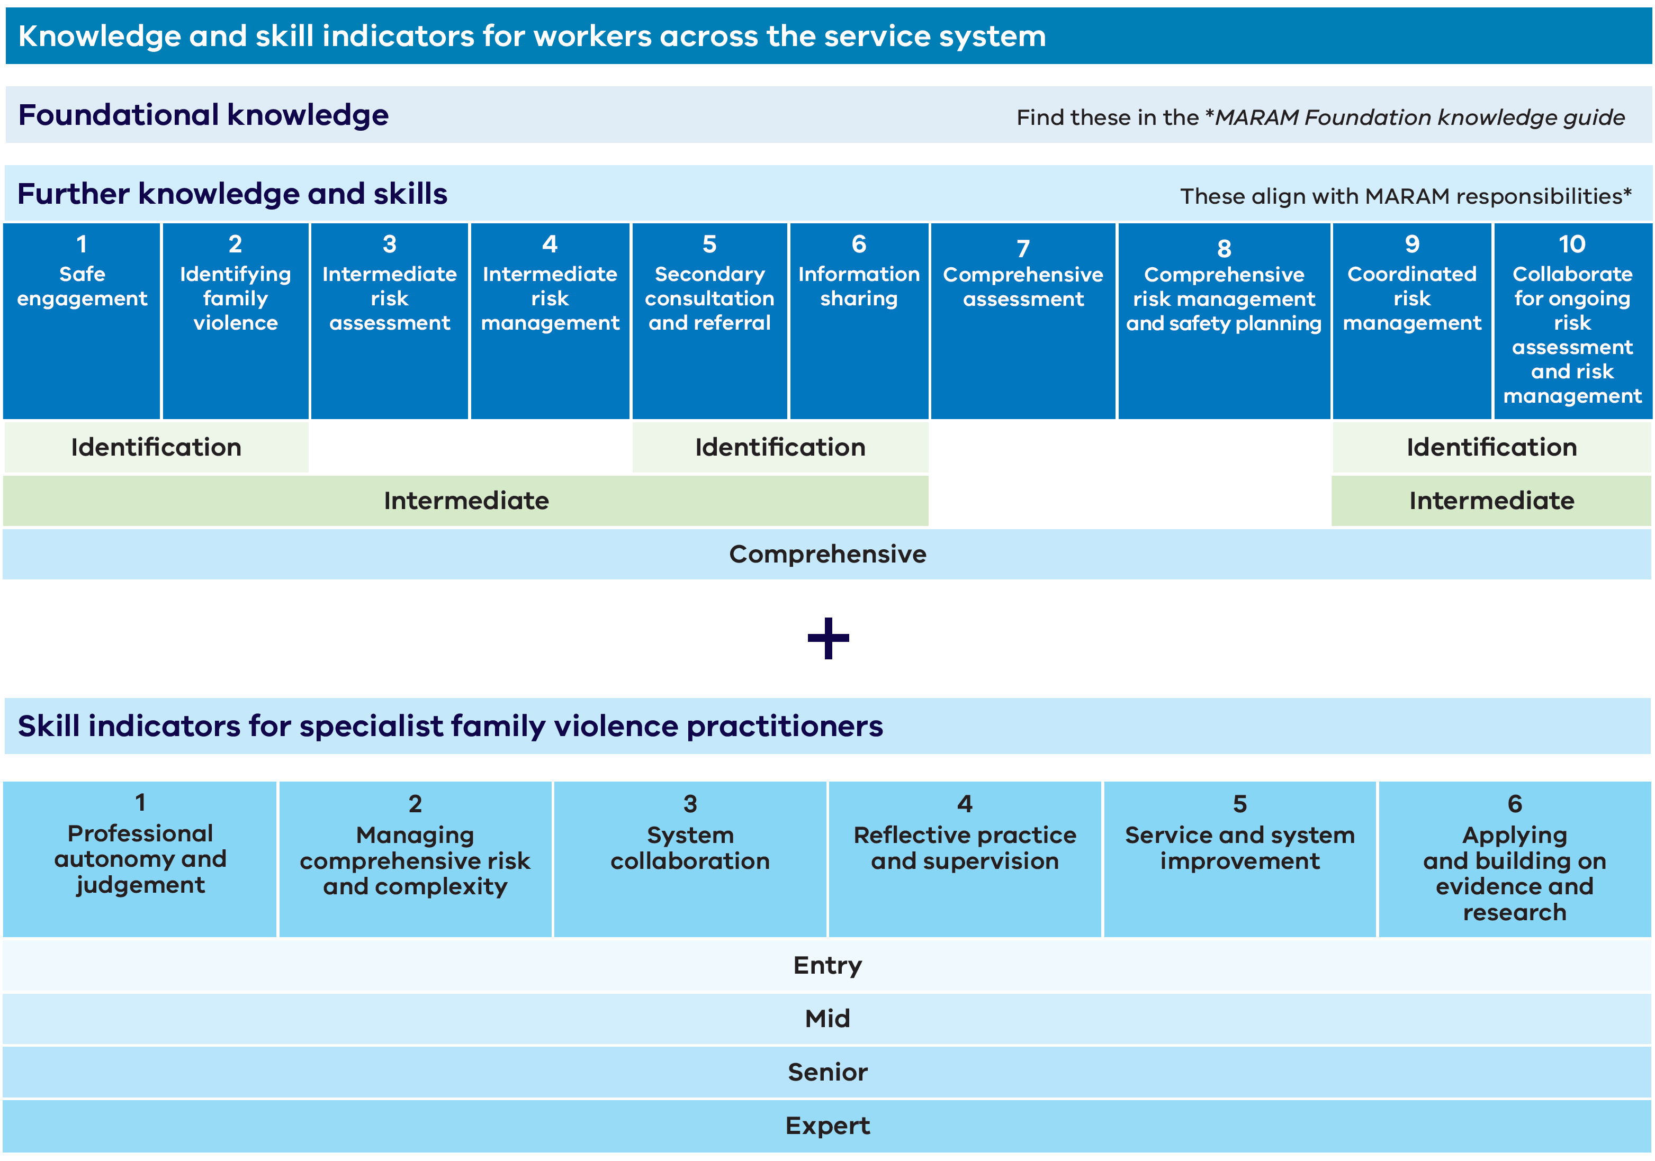
View plain figure text for Figure 1 text: Structure of the Responding to family violence capability framework

Figure 2: Capabilities for all workers across the service system
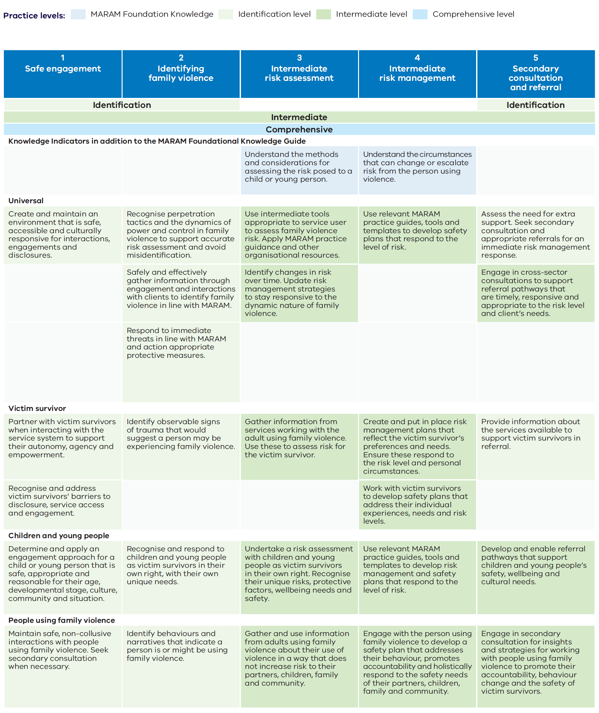

Figure 2: Capabilities for all workers across the service system (continued 2)
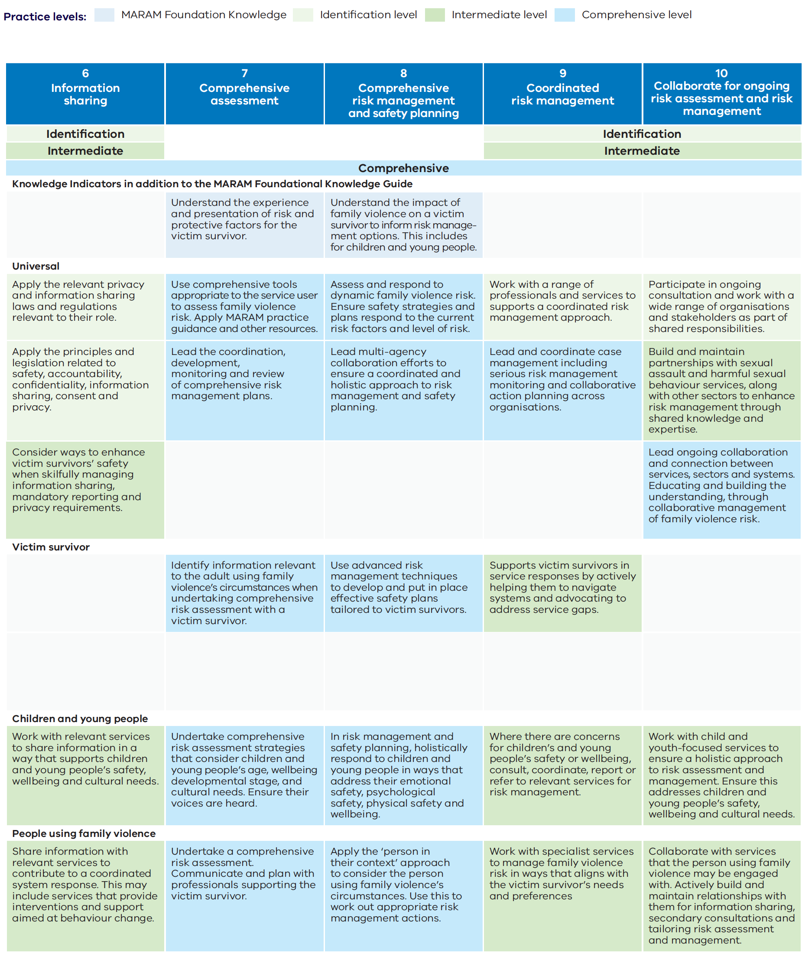

Figure 2: Capabilities for all workers across the service system (continued 3)
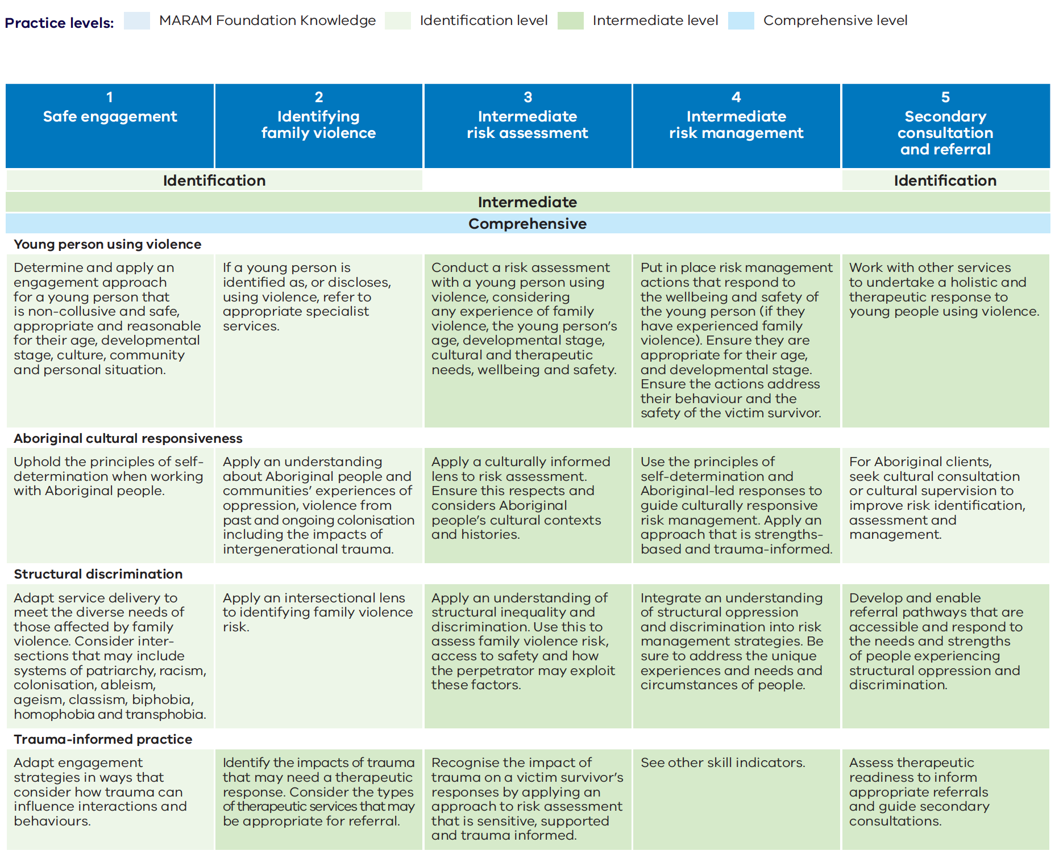

Figure 2: Capabilities for all workers across the service system (continued 3)
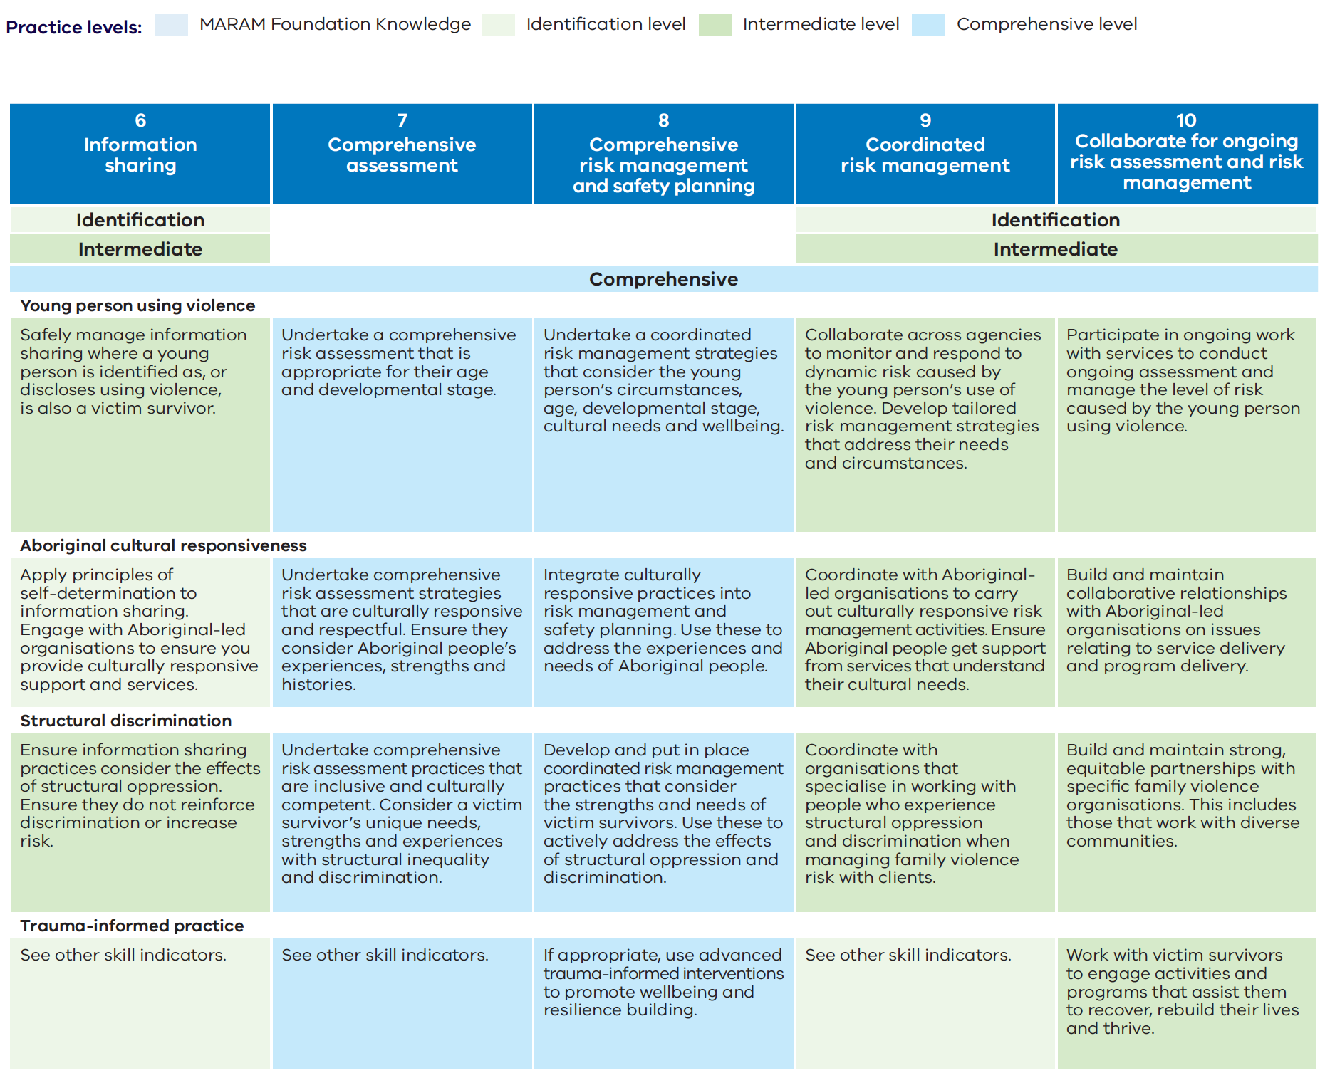
View plain figure text for Figure 2: Capabilities for all workers across the service system

Figure 3: Capabilities for specialist practitioners
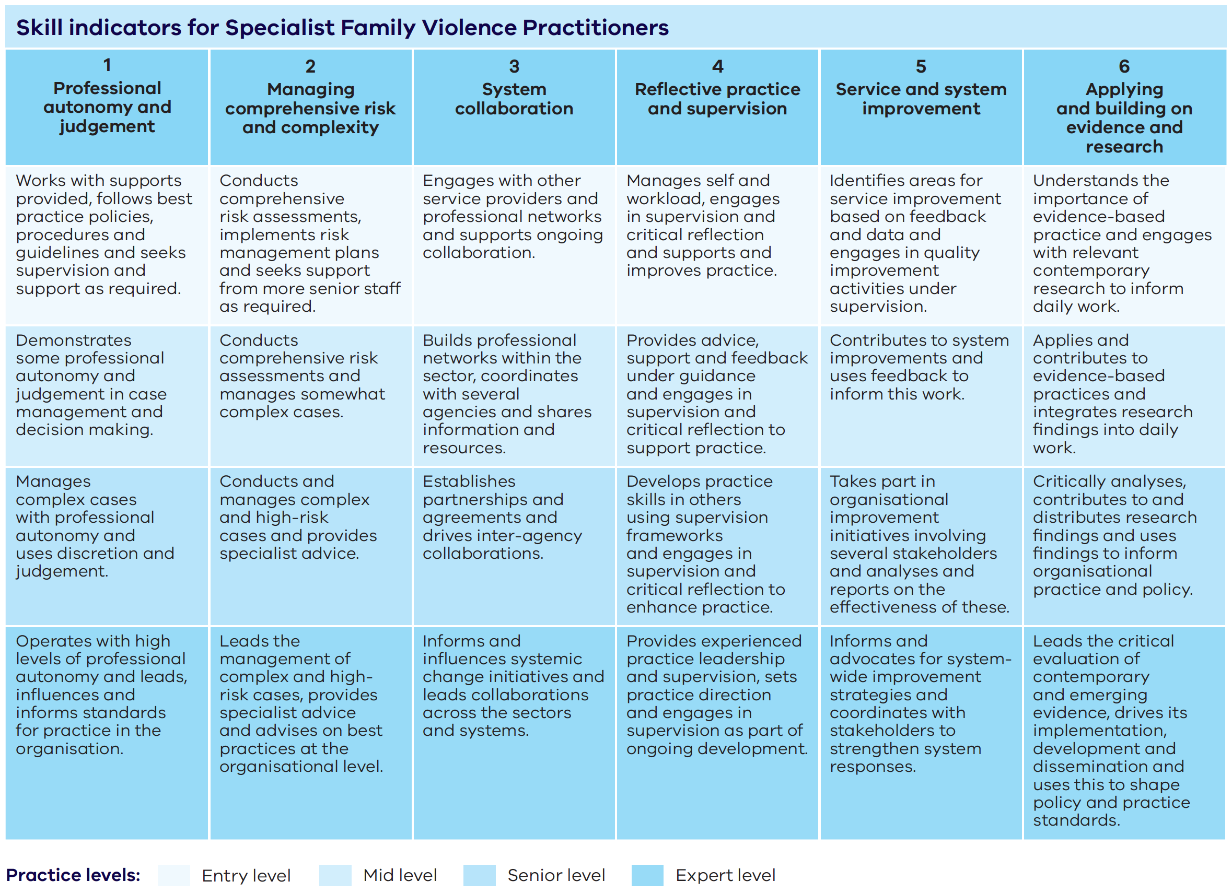

View plain figure text for Figure 3: Capabilities for specialist practitioners

Plain figure text

Figure 1 text: Structure of the Responding to family violence capability framework

Knowledge and skill indicators for all workers across the service system

Foundational knowledge
Find these in the MARAM Foundation knowledge guide.

Further knowledge and skills
These align with MARAM responsibilities.

Identification, intermediate and comprehensive
- Safe engagement
- Identifying family violence

Intermediate and comprehensive
- Intermediate risk assessment
- Intermediate risk management

Identification, intermediate and comprehensive
- Secondary consultations and referral
- Information sharing

Comprehensive
- Comprehensive assessment
- Comprehensive risk management and safety planning

Identification, intermediate and comprehensive
- Coordinated risk management
- Collaborate for ongoing risk assessment and risk management

Skill indicators for specialist family violence practitioners

Four levels of practice: entry mid, senior, expert
- Professional autonomy and judgement
- Managing comprehensive risk and complexity
- System collaboration
- Reflective practice and supervision
- Service and system improvement
- Applying and building on evidence and research.
Return to Figure 1: Structure of the Responding to family violence capability framework

Figure 2 text: Capabilities for all workers across the service system

1. Safe engagement

Corresponding MARAM responsibility levels: identification, intermediate and comprehensive

Skill indicators for safe engagement

Safe engagement – Universal
- Create and maintain an environment that is safe, accessible and culturally responsive for interactions, engagements and disclosures.

Safe engagement – Victim Survivor
- Partner with victim survivors when interacting with the service system to support their autonomy, agency and empowerment.
- Recognise and address victim survivors’ barriers to disclosure, service access and engagement.

Safe engagement – Children and young people
- Determine and apply an engagement approach for a child or young person that is safe, appropriate and reasonable for their age, developmental stage, culture, community and personal situation.

Safe engagement – People using family violence
- Maintain safe, non-collusive interactions with people using family violence. Seek secondary consultation when necessary.

Safe engagement – Young person using violence
- Determine and apply an engagement approach for a young person that is non-collusive and safe, appropriate and reasonable for their age, developmental stage, culture, community and personal situation.

Safe engagement – Aboriginal cultural responsiveness
- Uphold the principles of self-determination when working with Aboriginal people.

Safe engagement – Structural discrimination
- Adapt service delivery to meet the diverse needs of those affected by family violence. Consider intersections that may include systems of patriarchy, colonisation, racism, ableism, ageism, classism, biphobia, homophobia and transphobia.

Safe engagement – Trauma-informed practice
- Adapt engagement strategies in ways that consider how trauma can influence interactions and behaviours.

2. Identifying family violence

Corresponding MARAM responsibility levels: identification, intermediate and comprehensive

Skill indicators for identifying family violence

Identifying family violence – Universal
- Recognise perpetration tactics and the dynamics of power and control in family violence to support accurate risk assessment and avoid misidentification.
- Safely and effectively gather information through engagement and interactions with clients to identify family violence in line with MARAM.
- Respond to immediate threats in line with MARAM and action appropriate protective measures.

Identifying family violence – Victim Survivor
- Identify observable signs of trauma that would suggest a person may be experiencing family violence.

Identifying family violence – Children and young people
- Recognise and respond to children and young people as victim survivors in their own right, with their own unique needs.

Identifying family violence – People using family violence
- Identify behaviours and narratives that indicate a person is or might be using family violence.

Identifying family violence – Young person using violence
- If a young person is identified as, or discloses, using violence, refer to appropriate specialist services.

Identifying family violence – Aboriginal cultural responsiveness
- Apply an understanding about Aboriginal people and communities’ experiences of oppression and violence from past and ongoing colonisation including the impacts of intergenerational trauma.

Identifying family violence – Structural discrimination
- Apply an intersectional lens to identifying family violence risk.

Identifying family violence – Trauma-informed practice
- Identify the impacts of trauma that may need a therapeutic response. Consider the types of therapeutic services that may be appropriate for referral (intermediate and comprehensive only).

3. Intermediate risk assessment

Corresponding MARAM responsibility levels: intermediate and comprehensive

Intermediate risk assessment – Knowledge indicator
- Understand the methods and considerations for assessing the risk posed to a child or young person.

Skill indicators for Intermediate risk assessment

Intermediate risk assessment – Universal
- Use intermediate tools appropriate to the service user to assess family violence risk. Apply MARAM practice guidance and other organisational resources.
- Identify changes in risk over time. Update risk management strategies to stay responsive to the dynamic nature of family violence.

Intermediate risk assessment – Victim Survivor
- Gather information from services working with the adult using family violence. Use these to assess risk for the victim survivor.

Intermediate risk assessment – Children and young people
- Undertake a risk assessment with children and young people as victim survivors in their own right. Recognise their unique risks, protective factors, wellbeing needs and safety.

Intermediate risk assessment – People using family violence
- Gather and use information from adults using family violence about their use of violence in a way that does not increase risk to their partners, children, family and community.

Intermediate risk assessment – Young person using violence
- Conduct a risk assessment with a young person using violence, considering any experience of family violence, the young person’s age, developmental stage, cultural and therapeutic needs, wellbeing and safety.

Intermediate risk assessment – Aboriginal cultural responsiveness
- Apply a culturally informed lens to risk assessment. Ensure this respects and considers Aboriginal people’s cultural contexts and histories.

Intermediate risk assessment – Structural discrimination
- Apply an understanding of structural inequality and discrimination. Use this to assess family violence risk, access to safety and how the perpetrator may exploit these factors.

Intermediate risk assessment – Trauma-informed Practice
- Recognise the impact of trauma on a victim survivor’s responses by applying an approach to risk assessment that is sensitive, supported and trauma informed.

4. Intermediate risk management

Corresponding MARAM responsibility levels: intermediate and comprehensive

Intermediate risk management – Knowledge indicator
- Understand the circumstances that can change or escalate risk from the person using violence.

Skill indicators for intermediate risk management

Intermediate risk management – Universal
- Use relevant MARAM practice guides, tools and templates to develop safety plans that respond to the level of risk.

Intermediate risk management – Victim Survivor
- Create and put in place risk management plans that reflect the victim survivor’s preferences and needs. Ensure these respond to the risk level and personal circumstances.
- Work with victim survivors to develop safety plans that address their individual experiences, needs and risk levels.

Intermediate risk management – Children and young people
- Use relevant MARAM practice guides, tools and templates to develop risk management and safety plans that respond to the level of risk.

Intermediate risk management – People using family violence
- Engage with the person using family violence to develop a safety plan that addresses their behaviour, promotes accountability and holistically respond to the safety needs of their partners, children, family and community.

Intermediate risk management – Young person using violence
- Put in place risk management actions that respond to the wellbeing and safety of the young person (if they have experienced family violence). Ensure they are appropriate for their age, and developmental stage. Ensure the actions address their behaviour and the safety of the victim survivor.

Intermediate risk management – Aboriginal cultural responsiveness
- Use the principles of self-determination and Aboriginal-led responses to guide culturally responsive risk management. Apply an approach that is strengths-based and trauma-informed.

Intermediate risk management – Structural discrimination
- Integrate an understanding of structural oppression and discrimination into risk management strategies. Be sure to address the unique experiences and needs and circumstances of people​.

Intermediate risk management – Trauma-informed practice
- See other skill indicators.

5. Secondary consultation and referral

Corresponding MARAM responsibility levels: identification, intermediate and comprehensive

Skill indicators for secondary consultation and referral

Secondary consultation and referral – Universal
- Assess the need for extra support. Seek secondary consultation and appropriate referrals for an immediate risk management response.
- Engage in cross-sector consultations to support referral pathways that are timely, responsive and appropriate to the risk level and client’s needs (intermediate and comprehensive only).

Secondary consultation and referral – Victim Survivor
- Provide information about the services available to support victim survivors in referral.

Secondary consultation and referral – Children and young people
- Develop and enable referral pathways that support children and young people’s safety, wellbeing and cultural needs (intermediate and comprehensive only).

Secondary consultation and referral – People using family violence
- Engage in secondary consultation for insights and strategies for working with people using family violence to promote their accountability, behaviour change and the safety of victim survivors (intermediate and comprehensive only).

Secondary consultation and referral – Young person using violence
- Work with other services to undertake a holistic and therapeutic response to young people using violence (intermediate and comprehensive only).

Secondary consultation and referral – Aboriginal cultural responsiveness
- For Aboriginal clients, seek cultural consultation or cultural supervision to improve risk identification, assessment and management.

Secondary consultation and referral – Structural discrimination
- Develop and enable referral pathways that are accessible and respond to the needs and strengths of people experiencing structural oppression and discrimination (intermediate and comprehensive only).

Secondary consultation and referral – Trauma-informed practice
- Assess therapeutic readiness to inform appropriate referrals and guide secondary consultations (intermediate and comprehensive only).

6. Information sharing

Corresponding MARAM responsibility levels: identification, intermediate and comprehensive

Skill indicators for information sharing

Information sharing – Universal
- Apply the relevant privacy and information sharing laws and regulations relevant to their role.
- Apply the principles and legislation related to safety, accountability, confidentiality, information sharing, consent and privacy.
- Consider ways to enhance victim survivors’ safety when skilfully managing information sharing, mandatory reporting and privacy requirements (intermediate and comprehensive only).

Information sharing – Children and young people
- Work with relevant services to share information in a way that supports children and young people’s safety, wellbeing and cultural needs (intermediate and comprehensive only).

Information sharing – People using family violence
- Share information with relevant services to contribute to a coordinated system response. This may include services that provide interventions and support aimed at behaviour change (intermediate and comprehensive only).

Information sharing – Young person using violence
- Safely manage information sharing where a young person is identified as, or discloses using violence, is also a victim survivor (intermediate and comprehensive only).

Information sharing – Aboriginal cultural responsiveness
- Apply principles of self-determination to information sharing. Engage with Aboriginal-led organisations to ensure you provide culturally responsive support and services.

Information sharing – Structural discrimination
- Ensure information sharing practices consider the effects of structural oppression. Ensure they do not reinforce discrimination or increase risk (intermediate and comprehensive only).

Information sharing – Trauma-informed practice
- See other skill indicators.

7. Comprehensive assessment

Corresponding MARAM responsibility level: comprehensive

Comprehensive assessment – Knowledge indicator
- Understand the experience and presentation of risk and protective factors for the victim survivor.

Skill indicators for comprehensive assessment

Comprehensive assessment – Universal
- Use comprehensive tools appropriate to the service user to assess family violence risk. Apply MARAM practice guidance and other organisational resources.
- Lead the coordination, development, monitoring and review of comprehensive risk management plans​.

Comprehensive assessment – Victim survivor
- Identify information relevant to the adult using family violence’s circumstances when undertaking comprehensive risk assessment with a victim survivor.

Comprehensive assessment – Children and young people
- Undertake comprehensive risk assessment strategies that consider children and young people’s age, developmental stage, wellbeing and cultural needs. Ensure their voices are heard.

Comprehensive assessment – People using family violence
- Undertake a comprehensive risk assessment. Communicate and plan with professionals supporting the victim survivor.

Comprehensive assessment – Young person using violence
- Undertake a comprehensive risk assessment that is appropriate for their age and developmental stage.

Comprehensive assessment – Aboriginal cultural responsiveness
- Undertake comprehensive risk assessment strategies that are culturally responsive and respectful. Ensure they consider Aboriginal people’s experiences, strengths and histories.

Comprehensive assessment – Structural discrimination
- Undertake comprehensive risk assessment practices that are inclusive and culturally competent. Consider a victim survivor’s unique needs, strengths and experiences with structural inequality and discrimination.

Comprehensive assessment – Trauma-informed practice
- See other skill indicators.

8. Comprehensive risk management and safety planning

Corresponding MARAM responsibility level: comprehensive

Comprehensive risk management and safety planning – Knowledge indicator
- Understand the impact of family violence on a victim survivor to inform risk management options. This includes for children and young people.

Skill indicators for comprehensive risk management and safety planning

Comprehensive risk management and safety planning – Universal
- Assess and respond to dynamic family violence risk. Ensure safety strategies and plans respond to the current risk factors and level of risk.
- Lead multi-agency collaboration efforts to ensure a coordinated and holistic approach to risk management and safety planning.

Comprehensive risk management and safety planning – Victim survivor
- Use advanced risk management techniques to develop and put in place effective safety plans tailored to victim survivors.

Comprehensive risk management and safety planning – Children and young people
- In risk management and safety planning, holistically respond to children and young people in ways that address their emotional safety, psychological safety, physical safety and wellbeing.

Comprehensive risk management and safety planning – People using family violence
- Apply the ‘person in their context’ approach to consider the person using family violence’s circumstances. Use this work out appropriate risk management actions.

Comprehensive risk management and safety planning – Young person using violence
- Undertake a coordinated risk management strategies that consider the young person’s circumstances, age, developmental stage, cultural needs and wellbeing.

Comprehensive risk management and safety planning – Aboriginal cultural responsiveness
- Integrate culturally responsive practices into risk management and safety planning. Use these to address the experiences and needs of Aboriginal people.

Comprehensive risk management and safety planning – Structural discrimination
- Develop and put in place coordinated risk management practices that consider the strengths and needs of victim survivors. Use these to actively address the effects of structural oppression and discrimination.

Comprehensive risk management and safety planning – Trauma-informed practice
- If appropriate, use advanced trauma-informed interventions to promote wellbeing and resilience building.

9. Coordinated risk management

Corresponding MARAM responsibility levels: identification, intermediate and comprehensive

Skill indicators for coordinated risk management

Coordinated risk management – Universal
- Work with a range of professionals and services to supports a coordinated risk management approach.
- Lead and coordinate case management including serious risk management monitoring and collaborative action planning across organisations (comprehensive only).

Coordinated risk management – Victim survivor
- Supports victim survivors in service responses by actively helping them to navigate systems and advocating to address service gaps (intermediate and comprehensive only).

Coordinated risk management – Children and young people
- Where there are concerns for children’s and young people’s safety or wellbeing, consult, coordinate, report or refer to relevant services for risk management (intermediate and comprehensive only).

Coordinated risk management – People using family violence
- Work with specialist services to manage family violence risk in ways that aligns with the victim survivor’s needs and preferences (intermediate and comprehensive only).

Coordinated risk management – Young person using violence
- Collaborate across agencies to monitor and respond to dynamic risk caused by the young person’s use of violence. Develop tailored risk management strategies that address the young person’s needs and circumstances (intermediate and comprehensive only).

Coordinated risk management – Aboriginal cultural responsiveness
- Coordinate with Aboriginal-led organisations to carry out culturally responsive risk management activities. Ensure Aboriginal people get support from services that understand their cultural needs (intermediate and comprehensive only).

Coordinated risk management – Structural discrimination
- Coordinate with organisations that specialise in working with people who experience structural oppression and discrimination when managing family violence risk with clients (intermediate and comprehensive only).

Coordinated risk management – Trauma-informed practice
- See other skill indicators.

10. Collaborating for ongoing risk assessment and risk management

Corresponding MARAM responsibility levels: identification, intermediate and comprehensive

Skill indicators for collaborating for ongoing risk assessment and risk management

Collaborating for ongoing risk assessment and risk management – Universal
- Participate in ongoing consultation and work with a wide range of organisations and stakeholders as part of shared responsibilities.
- Build and maintain partnerships with sexual assault and harmful sexual behaviour services, along with other sectors to enhance risk management through knowledge sharing and shared expertise (intermediate and comprehensive only).
- Lead ongoing collaboration and connection between services, sectors and systems. Educating and building the understanding, through collaborative management of family violence risk (comprehensive only).

Collaborating for ongoing risk assessment and risk management – Children and young people
- Work with child and youth-focused services to ensure a holistic approach to risk assessment and management. Ensure this addresses children and young people’s safety, wellbeing and cultural needs (intermediate and comprehensive only).

Collaborating for ongoing risk assessment and risk management – People using family violence
- Collaborate with services that the person using family violence may be engaged with. Actively build and maintain relationships with them for information sharing, secondary consultations and tailoring risk assessment and management (intermediate and comprehensive only).

Collaborating for ongoing risk assessment and risk management – Young person using violence
- Participate in ongoing work with services to conduct ongoing assessment and manage the level of risk caused by the young person using violence (intermediate and comprehensive only).

Collaborating for ongoing risk assessment and risk management – Aboriginal cultural responsiveness
- Build and maintain collaborative relationships with Aboriginal-led organisations on issues relating to service delivery and program delivery (intermediate and comprehensive only).

Collaborating for ongoing risk assessment and risk management – Structural discrimination
- Build and maintain strong, equitable partnerships with specific family violence organisations. This includes those that work with diverse communities (intermediate and comprehensive only).

Collaborating for ongoing risk assessment and risk management – Trauma-informed practice
- Work with victim survivors to engage activities and programs that assist them to recover, rebuild their lives and thrive (intermediate and comprehensive only).
Return to Figure 2: Capabilities for all workers across the service system

Figure 3 text: Capabilities for specialist practitioners

Capabilities for specialist practitioners

Professional autonomy and judgement

Entry
- Works with supports provided, Follows best practice policies, procedures and guidelines and seeks supervision and support as required.

Mid
- Demonstrates some professional autonomy and judgement in case management and decision making.

Senior
- Manages complex cases with professional autonomy and uses discretion and judgement.

Expert
- Operates with high levels of professional autonomy and leads, influences and informs standards for practice in the organisation.

Managing comprehensive risk and complexity

Entry
- Conducts comprehensive risk assessments, implements risk management plans and seeks support from more senior staff as required.

Mid
- Conducts comprehensive risk assessments and manages somewhat complex cases.

Senior
- Conducts and manages complex and high-risk cases and provides specialist advice.

Expert
- Leads the management of complex and high-risk cases, provides specialist advice and advises on best practices at the organisational level.

System collaboration

Entry
- Engages with other service providers and professional networks and supports ongoing collaboration.

Mid
- Builds professional networks within the sector, coordinates with several agencies and shares information and resources.

Senior
- Establishes partnerships and agreements and drives inter-agency collaborations.

Expert
- Informs and influences systemic change initiatives and leads collaborations across the sectors and systems.

Reflective practice and supervision

Entry
- Manages self and workload, engages in supervision and critical reflection and supports and improves practice.

Mid
- Provides advice, support and feedback under guidance and engages in supervision and critical reflection to support practice.

Senior
- Develops practice skills in others using supervision frameworks and engages in supervision and critical reflection to enhance practice.

Expert
- Provides experienced practice leadership and supervision, sets practice direction and engages in supervision as part of ongoing development.

Service and system improvement

Entry
- Identifies areas for service improvement based on feedback and data and engages in quality improvement activities under supervision.

Mid
- Contributes to system improvements and uses feedback to inform this work.

Senior
- Takes part in organisational improvement initiatives involving several stakeholders and analyses and reports on the effectiveness of these.

Expert
- Informs and advocates for system-wide improvement strategies and coordinates with stakeholders to strengthen system responses.

Applying and building on evidence and research

Entry
- Understands the importance of evidence-based practice and engages with relevant contemporary research to inform daily work.

Mid
- Applies and contributes to evidence-based practices and integrates research findings into daily work.

Senior
- Critically analyses, contributes to and distributes research findings and uses findings to inform organisational practice and policy.

Expert
- Leads the critical evaluation of contemporary and emerging evidence, drives its implementation, development and dissemination and uses this to shape policy and practice standards.
Return to Figure 3: Capabilities for specialist practitioners

Refer to: https://www.vic.gov.au/maram-practice-guides-foundation-knowledge-guide

