Licence Approval Letter
When your child employment licence has been issued, we will generate an approval letter. This document contains important information and resources to help you comply with your obligations as a child employment licence holder.
Step 1) Log in to your Portal account and select ‘My Submissions’ to view your dashboard
Step 2) Click on the ‘Child Employment Licences’ tab to view your active licences
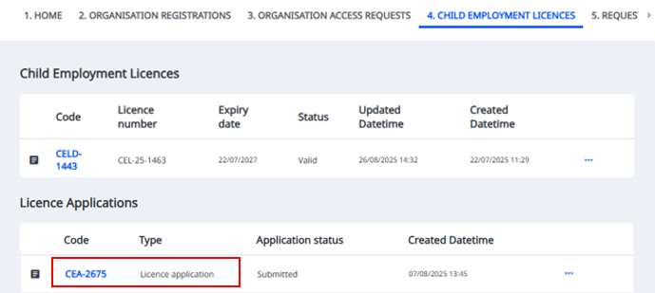
Step 3) Under the ‘Licence Applications’ heading, click on the CEA number

Step 4) Your approval letter can be accessed by opening the document
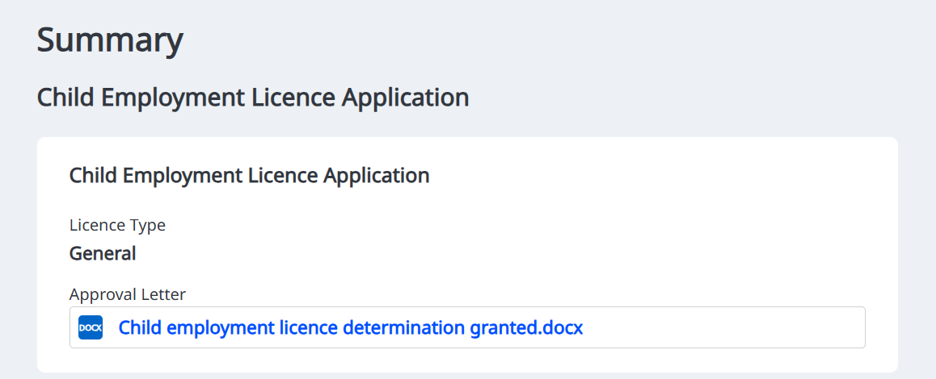
Child Employment Licence
When your child employment licence has been issued, it is available to access and download from the Portal. The licence document contains important information about your licence conditions.
You must keep a copy of the licence at any workplace where children will be employed under the licence, and must make it available on request to:
- any child employed under the licence
- any person employed to supervise those children
- any parent or guardian of those children.
Step 1) Log in to your Portal account and select ‘My Submissions’ to view your dashboard
Step 2) Click on the ‘Child Employment Licences’ tab to view your active licences
Step 3) Under the ‘Child Employment Licences’ heading, click on the CELD number
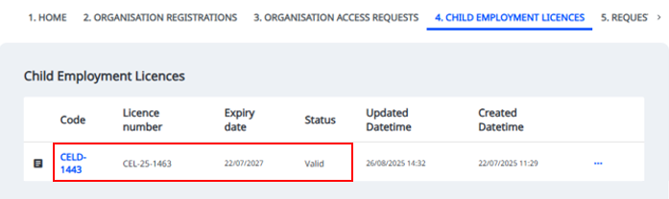

Step 4) Your licence document can be accessed by opening the document
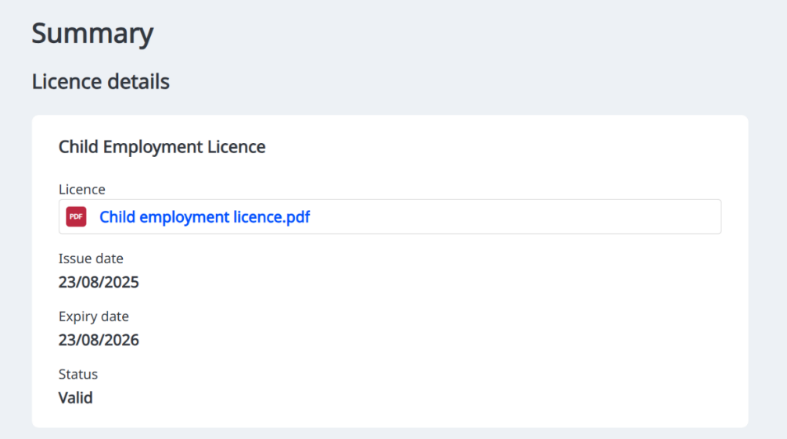

Step 5) Download a copy of your licence document for your records and make sure to review all licence conditions.

