Transport sector emissions reduction pledge 2026–30
Table of Contents
Minister's foreword 2
Overview of transport sector emissions 4
Achievements 7
Emissions reduction pledge 2026–30 8
The Avoid-Shift-Improve framework 9
Emissions reduction actions 2026–30 11
Make freight cleaner 11
Move freight by rail 14
Reduce transport sector emissions through better integrated planning 15
Promote active transport 15
Shift travel to public transport 17
Make public transport free for under 18s and seniors on weekends 17
Continue the ZEV transition 18
Purchase ZEBs for all new public buses 18
Work nationally to progress the uptake of cleaner passenger vehicles 19
Publication information 20
Acknowledgement of Country 20
Copyright 20
Creative Commons 20
Disclaimer 21
Accessibility 21

Minister's foreword
Our journey to net zero in transport delivers on what matters most: while we reduce emissions, we're building a transport network that lowers the cost of living, and supports better housing choices for Victorians.
The Victorian Government is leading the way on climate action to reduce emissions in the transport sector. Our Zero Emission Vehicle (ZEV) Roadmap was released before those in other states, and included several 'first-in-the-nation' measures.
The ZEV transition is now underway with new vehicles coming onto the market and the price gap between the new technology and petrol-powered cars closing. Our transition to zero emission buses (ZEBs) on our public transport network has begun. We’ve also been rolling out a statewide charging network so Victorians can have confidence in purchasing an electric vehicle.
With the bulk of the task to reduce transport sector emissions still ahead of us, significant challenges persist – particularly in reducing emissions from freight and unlocking the full potential of alternatives to private vehicles. Meeting these challenges requires not only sustained commitment but also a strategic evolution of our efforts. The 2026–30 transport sector pledge capitalises on the strengths of the previous pledge, refines our focus and targets ongoing challenges for transport.
The availability of zero emission technology in freight is trailing the passenger vehicle market. So we are working closely with industry to foster investment in reducing emissions in freight as emerging zero emission technology catches up with the passenger vehicle market. And we’ll be making the best use of sustainable modes like public and active transport, as well as moving more freight onto rail.
I’m pleased to present the 2026–30 transport sector pledge. This document continues our commitment to strong climate action while delivering for all Victorians.
Hon. Melissa Horne
Minister for Ports and Freight
Minister for Roads and Road Safety
Minister for Health Infrastructure

Overview of transport sector emissions
The transport sector is Victoria’s second-largest source of emissions, accounting for 26% (22 Mt CO₂-e) of the state’s emissions in 2023. However, as energy sector emissions reduce, transport is projected to become the largest source of emissions nationally by 2030. This shift underscores a critical transition: as progress is made in cleaning up our electricity supply, transport will emerge as the next challenge in the path to net zero. That’s why this pledge increases our focus on reducing emissions from heavy freight, light commercial vehicles and cars.
Transport sector emissions are mainly caused by the burning of fossil fuels such as petrol and diesel in cars, light commercial and heavy vehicles.
Emissions from electricity used to power electric vehicles (including cars, buses, trams and trains) are addressed in the energy sector pledge through our continued decarbonisation of Victoria’s electricity grid and our commitment to power all metropolitan trains and trams by 100% renewable electricity.
Emissions from the transport sector increased by 1.9 Mt CO₂-e (9%) between 2005 and 2023, growing steadily from 2005 to 2015, before plateauing between 2015 and 2019 – with increases driven by Victoria's strong economic and population growth, and plateau resulting from progress in decarbonising some transport sectors.
While disruptions related to the COVID-19 pandemic resulted in a temporary decline in transport activity, transport emissions rebounded in 2023 to just below pre-pandemic levels.
Figure 1: Transport sector emissions in Victoria in 2023
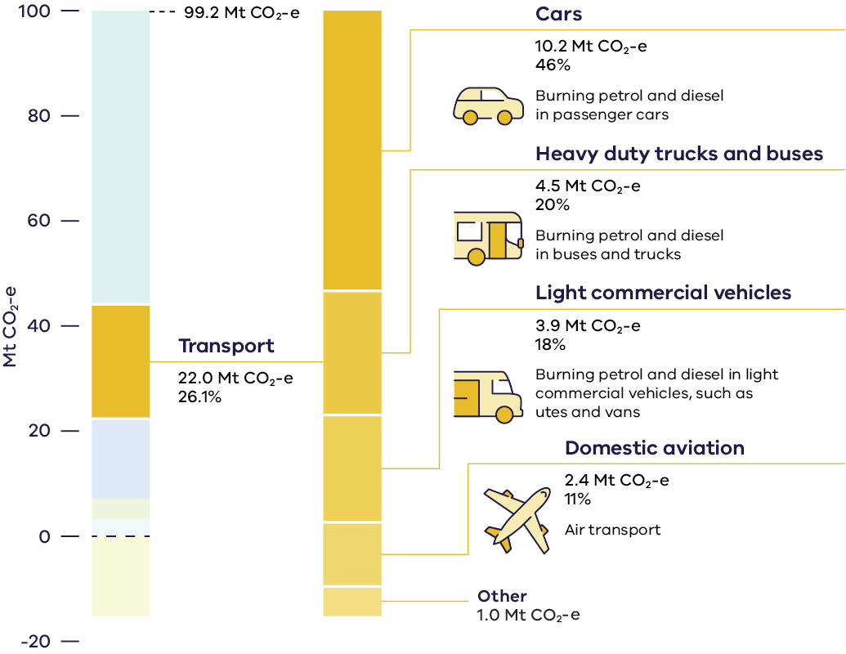
Table 1: Transport sector emissions in Victoria in 2023
Transport sector sub-category | Emissions  (Mt CO₂-e) | % of  total transport sector  emissions | Description of sub-category
Victoria total emissions (all sectors) | 99.2 | – | –
Transport sector (total) | 22.0 | 100% | –
– Cars | 10.2 | 46% | Burning petrol and diesel in passenger cars
– Heavy duty trucks  and buses | 4.5 | 20% | Burning petrol and diesel in buses and trucks
– Light commercial  vehicles | 3.9 | 18% | Burning petrol and diesel in light commercial vehicles, such as utes and vans
– Domestic aviation | 2.4 | 11% | Air transport
– Other | 1.0 | 5% | Other sources
Figures represent latest emissions data from 2023. Numbers may not sum to 100% due to rounding.

Achievements
The actions detailed in this pledge build on Victoria’s long history of investing in programs that have direct benefits for the environment.
- $470 million invested since 2020 in rail freight network upgrades, including $103 million in the 2025–26 State Budget.
- Freight plan released with a range of emissions reduction actions to be delivered between 2025–30.
- ~10,000 EV subsidies helped Victorians to shift into an electric vehicle through Australia's first EV subsidy program.
- 13.6% new vehicle sales were ZEV in September 2025, up from 1.7% in 2021.
- 88 ZEBs currently servicing the network with 252 diesel buses due to be replaced by 2029.
- 100% electric bus depot operational in Ivanhoe (Ventura), with a mixed operations depot in Preston (Kinetic) and others under construction and planning.
- 900+ V/line services have been added to the network since 2014 including on the busiest lines.
- 1,200+ metro train services introduced since 2014.
- Metro Tunnel delivered to enable 500,000 more low-emissions passenger trips per year.
- 24,000 weekly bus services delivered since 2014, with 9,400 extra services since our Bus Plan launched in 2021.
- 410 km walking and riding paths delivered with new and upgraded paths and riding infrastructure to come.

Emissions reduction pledge 2026–30
As the transition to ZEV technology gains pace, the transport sector pledge puts in place measures across the freight and passenger transport system that will deliver significant emissions reduction beyond 2030.
Victoria has led the nation with ZEV targets and incentives through the 2021–25 transport sector pledge and Zero Emissions Vehicle Roadmap. This includes Australia’s first public ZEV subsidy scheme.
Since the first transport sector pledge, ZEV sales have grown from 1.7% of new light vehicle sales in 2021 to over 13.6% in September 2025.
The Australian Government has released a refreshed National Freight and Supply Chain Strategy and 2025–29 National Action Plan. Reducing emissions in freight is one of the plan’s four National Priority Action Areas. We will continue collaborating with government and industry to deliver actions that support our freight industry in moving towards a low-carbon future.
This pledge builds on commitments from the previous pledge, with actions for sustainable transport modes and support for the freight industry as zero emission technology emerges. Pledge actions focus on key areas that complement national actions to drive the uptake of light ZEVs.
Actions within the pledge are expected to contribute to an emissions reduction of 0.2 Mt CO₂-e in 2030.

The Avoid-Shift-Improve framework
The 2026–30 transport sector pledge is guided by the Avoid-Shift-Improve (ASI) framework.
The ASI approach structures policy measures and is inspired by the principles of sustainability, focusing on the mobility needs of people instead of car infrastructure. It seeks to achieve significant emissions reduction, reduced energy consumption and less congestion, with the final objective being to create more liveable cities. It involves avoiding or reducing travel, shifting to more sustainable modes of transport and improving the efficiency of transport systems.
Table 2: The Avoid-Shift-Improve framework
Avoid | Shift | Improve
First, avoid the need for travel through integrated land use planning (e.g. taking steps to build more homes and create more jobs near train and tram lines).  A cleaner transport network | Then, shift the travel to more sustainable modes like active transport, public transport and freight on rail (e.g. switching on the Metro Tunnel and operationalising the Port Rail Shuttle Network).  Cleaner journeys | Finally, improve the efficiency of the vehicles we travel in by transitioning to lower and zero emission vehicles. (e.g. zero emission bus transition and support low and zero emission heavy vehicle uptake).  Cleaner vehicles
The ASI framework delivers emissions reduction while maximising other outcomes
sought through our transport network including:
- support for more housing, and more affordable housing, closer to the activities we need every day
- lowering the cost of living for Victorian families
- better air quality and less noise in local neighbourhoods
- healthier, more active and better connected communities
- increased local job creation and productivity
- better road safety.

Emissions reduction actions 2026–30

Make freight cleaner
Victoria’s freight volumes are growing as our population and its demand for products increases. The Victorian Freight Plan 2025–30 – Victoria Delivers is supporting our freight industry to reduce emissions while protecting local communities and maintaining our competitive advantage. As part of the plan, we’ll:
- Establish an $8 million freight sector innovation fund for small-and-medium-sized transport companies to buy and operate low and zero emission fleets.
- Lead the working group tasked with implementing an action of the National Freight and Supply Chain Strategy to develop government and industry frameworks to collaborate on the transition to net zero.
- Partner with industry and local authorities on new low emission and low impact delivery zones to reduce local transport emissions and traffic congestion.
- Engage with the Australian Government’s Future Made in Australia Program to support the domestic low-carbon liquid fuels industry.
Work with the bus industry on enabling commercial freight vehicle recharging during the day when buses are out on the network.
Support international efforts for lower emissions commercial shipping and improved information exchange, including for low and no carbon fuels.
Case study: The Victorian Freight Plan 2025–30: Victoria Delivers
The Victorian Government’s new freight plan, Victoria Delivers, is our plan to meet the challenge of growing freight volumes – expected to double as our population grows to 10 million by 2050.
Reducing emissions promises economic opportunities. That’s why Victoria Delivers has a strong focus on achievable emissions reduction, with actions to build the foundation for a low-carbon future. Victoria Delivers is our first freight plan where a key pillar is supporting emission reductions in freight. The plan provides a clear and aligned roadmap for investment confidence in low emissions vehicles and technology, and prepares freight transport networks for expansion of zero and low emission operations over the next five years.
The plan sets out how the Victorian Government will work with industry to develop a framework for net zero freight to operate in our towns and cities, and support industry as it invests in cleaner technology. This includes moving more freight by rail due to the benefits it provides in terms of reduced carbon emissions. At the same time, it means encouraging development and uptake of clean technologies through trials, partnerships and innovation co-investments.
Under the plan, the Victorian Government will develop a Freight Charging Framework supporting industry investment in reducing emissions of road freight. To support industry to begin transitioning to low emissions freight vehicles, we are providing $8 million over two years in a co-investment model with small and medium transport operators.
Significantly, the Victorian Government will seek to endorse the Drive to Zero Memorandum of Understanding as a sub-national government, working collaboratively to enable, accelerate, or incentivise the transition to zero emission freight vehicles.
Victoria has already joined the Australia-Singapore Green and Digital Shipping Corridor partnership, giving our ports and industries a leading role in shaping the rules, fuels and technologies that will drive low emission shipping. This creates certainty for industry, supports investment in green bunkering hubs and positions Victorian ports to capture new trade opportunities in a changing global supply chain.

Move freight by rail
The road freight sector is responsible for approximately one third of transport sector emissions, equating to about 9% of Victoria’s overall emissions. There’s significant potential to reduce emissions in freight, however, zero emission heavy vehicle technology is still emerging.
Moving freight to rail in the short-to-medium term can support lower emissions while parallel work supports emerging technology to achieve heavy vehicle emissions reduction in the future. It also reduces the number of trucks on local streets and supports productivity in our regions – a 50-wagon grain train is the equivalent of around 70 B-Double trucks.
To support shifting freight from road to rail, we’re:
- Developing an extended freight rail network that includes a Port Rail Shuttle Network and the Port Rail Transformation Project.
- Rezoning land in the inner-west to encourage the logistics industry to locate closer to existing rail links. The 10 Year Plan for Industrial Land will help protect and unlock industrial land connected to freight rail corridors and creating jobs closer to public transport infrastructure.
- Planning and developing interstate freight terminals including the $12 million Western Intermodal Freight Terminal co-funded with the Australian Government.
- Capital investment in the regional freight network, including $103.1 million in 2025–26 State Budget to deliver major periodic and routine maintenance works on Victorian freight rail corridors to maintain the sustainability of freight rail infrastructure to accommodate longer and heavier trains with faster travel and increased capacity.
- Leasing the Footscray Road Old Melbourne Market site to the Port of Melbourne for container storage and logistics businesses. This will reduce the number of truck trips to and from the port to container park businesses in Melbourne’s inner-west.

Reduce transport sector emissions through better integrated planning
An effective way to reduce transport sector emissions is by avoiding car trips where possible. We’re taking action across land use planning and the transport network to reduce our need for private vehicle travel. These actions reduce emissions, lower the cost of living for Victorians, increase our housing choices and better connect our communities.
The Plan for Victoria and the Suburban Rail Loop will have a significant impact on travel patterns as activity centres are developed. These new activity centres will deliver affordable, well-designed homes nearer to everyday activities and public transport. They’ll increase local active transport trips, make public transport more attractive and reduce the distance to activities when cars are used.

Promote active transport
We’ve set a target for 25% of trips to be made by active transport by 2030. Victoria’s Active Transport Plan provides the framework for:
- improving planning and land use settings
- implementing active transport networks
- adopting a place-based approach to investments and interventions
- enabling behaviour change though a systems approach.
The plan is supported by our ongoing investment in active transport infrastructure – we have delivered 410 kilometres of new and upgraded walking, riding paths and lanes since 2015.
Case study: Launch of Melbourne Zero Emission Bus Franchises
Our bus network is a vital part of our transport system. In the 2021–25 transport sector pledge, the Victorian Government committed to purchasing ZEBs for public transport services from 2025. Following the successful delivery of our low-floor ZEB trials and the release of our Zero Emission Bus Transition Plan, the Metropolitan Zero Emission Bus Franchise went live on 1 July 2025. This is the first of Victoria’s bus franchise packages to begin the full ZEB transition with others to follow as new contracts are awarded.
The new services represent approximately 30% of the metropolitan bus network and over the contract term, we will see around 600 diesel buses transition to ZEBs.
Every year our buses transport over 135 million passengers and over a third of those journeys connect to trams and trains. Each ZEB takes the equivalent of 50 cars off our roads.
As part of our ZEB Transition Plan, we’re prioritising the development and growth of a Victorian ZEB manufacturing industry, actively encouraging investment in a highly-skilled local ZEB workforce and running regional ZEB trials to test the application of high-floor ZEBs in regional areas.

Shift travel to public transport
We’re capitalising on new public transport investments to increase services that connect the state and encourage public transport use. In the 2025–26 Victorian State Budget, we committed to:
- A $98.7 million package to deliver more frequent services on metropolitan and regional lines.
- Switching on the Metro Tunnel with new ‘turn-up-and-go’ services – more frequent services without needing a timetable – for the Cranbourne, Pakenham and Sunbury lines as part of a $727 million package to operationalise the Metro Tunnel. This will also free up more capacity in the City Loop for other lines, further improving the quality and efficiency of the train network.
- An additional $162 million to deliver new and upgraded bus services for Melbourne’s growing communities and realign bus services with future trains to improve bus and ferry services. This package also continues delivering buses and ferries that offer quick and reliable connections so people can go where they need to go faster and with certainty.
- Continuing investment in our public transport network through our major infrastructure program that includes Suburban Rail Loop, Melbourne Airport Rail Link, Sunshine Superhub, level crossing removals, new metro trains and trams, and Victoria’s first dedicated electrified busway.

Make public transport free for under 18s and seniors on weekends
From 1 January 2026, public transport will be free for everyone under 18, everywhere in Victoria. Families will save up to $755 a year per child – the cost of an annual student myki pass. Children under 18 can get a Youth myki to travel on public transport. Free statewide travel for seniors on weekends will also reduce their financial burden and encourage lower use of private vehicles.
This measure further helps to alleviate cost-of-living pressures along with the regional fare cap we introduced in March 2023.

Continue the ZEV transition
As we continue toward our target of 50% of new light vehicle sales being ZEV by 2030, we’re working with industry and the Australian Government to reduce the emissions of the vehicles we travel in.
This includes working with the Commonwealth which, for constitutional and federation funding reasons, has the primary responsibility for policy measures (such as the National Vehicles Emissions Standard) which will be crucial to driving this transition.
It also includes taking action in the energy system to remove barriers to the roll-out of EVs: for example, measures to make it easier to connect EV chargers to the distribution network, measures to ensure that fair tariffs are provided to EV owners, and measures to enable the roll-out of vehicle-to grid – which can allow EV owners to earn income by using their cars as batteries when the grid needs it most. These measures involve a combination of state and federal government responsibility and developments in the National Electricity Market.

Purchase ZEBs for all new public buses
As part of the 2021–25 transport sector pledge, we committed to all new public transport buses purchased from 1 July 2025 being ZEBs.
Victoria’s Zero Emission Bus Transition Plan provides the pathway for making the shift to a cleaner, smarter bus fleet as part of a modern bus network that meets the needs of customers across the state. The plan sets out how we’ll partner with the bus industry to transition approximately 4,500 diesel buses to ZEBs in a balanced, fair and sequenced manner.
The ZEB fleet will join our metro trains and trams which are already powered by 100% renewable energy.

Work nationally to progress the uptake of cleaner passenger vehicles
We’ll continue to work with the Australian Government and other jurisdictions on national action to reduce transport sector emissions by:
- supporting delivery of the National Electric Vehicle Strategy
- advocating for strong fuel efficiency standards
- participating in national forums that support reducing transport sector emissions.

Publication information

Acknowledgement of Country
We acknowledge and respect Victorian Traditional Owners as the original custodians of Victoria’s land and waters, their unique ability to care for Country and deep spiritual connection to it.
We honour Elders past and present whose knowledge and wisdom have ensured the continuation of culture and traditional practices.
We are committed to genuinely partner, and meaningfully engage, with Victoria’s Traditional Owners and Aboriginal communities to support the protection of Country, the maintenance of spiritual and cultural practices and their broader aspirations in the 21st century and beyond.

Copyright
© The State of Victoria Department of Energy, Environment and Climate Action November 2025.

Creative Commons
This work is licensed under a Creative Commons Attribution 4.0 International licence, visit the Creative Commons website (http://creativecommons.org/licenses/by/4.0/).
You are free to re-use the work under that licence, on the condition that you credit the State of Victoria as author. The licence does not apply to any images, photographs or branding, including the Victorian Coat of Arms, and the Victorian Government and Department logos.
ISBN 978-1-76176-634-3 (pdf/online/MS word)

Disclaimer
This publication may be of assistance to you but the State of Victoria and its employees do not guarantee that the publication is without flaw of any kind or is wholly appropriate for your particular purposes and therefore disclaims all liability for any error, loss or other consequence which may arise from you relying on any information in this publication.

Accessibility
To receive this document in an alternative format, phone the Customer Service Centre on 136 186, email customer.service@delwp.vic.gov.au, or contact National Relay Service on 133 677. Available at DEECA website (www.deeca.vic.gov.au).
End of document.

