Self-paced guide
General and late night (general) licence

Introduction

This guide is if for anyone who needs to know about a general or late night (general) licence and its conditions. This may include:
- new licensees, nominees or managers
- existing licensees
- company directors who hold a general or late night (general) licence
- staff at a venue with a general or late night (general) licence.

Once you have completed this guide, you should be able to:
- identify when and where you are allowed to supply alcohol to customers
- identify any special conditions that apply to your licence type
- identify possible general or late night (general) licence breaches.

This guide includes:
- general information – about a general or late night (general) licence (pages 3 to 6)
- licence conditions – explaining in detail (page 7)
- Q & A - to test your understanding (pages 8 to 11).
Please note: Information about the law may have been summarised or expressed in general statements. This information should not be relied upon as a substitute for professional legal advice or reference to the Liquor Control Reform Act 1998 (the Act).
Relevant information about the general licence can be found on our website at vic.gov.au/apply-general-liquor-licence and information about the late night (general) licence at vic.gov.au/late-night-liquor-licences.

General information
Trading hours | A general licence allows you to:  Sell alcohol to drink at your venue:  - Monday to Saturday (except ANZAC Day and Good Friday), 7 am to 1 am the following morning  - Sunday, 10 am to 1 am the following morning  - ANZAC Day and Good Friday, 12 noon to 1 am the following morning  - During any other times only if specified in the licence.  Sell alcohol to drink away from your venue, footpath or kerbside:  - Monday to Saturday (except ANZAC Day and Good Friday), 10 am to 11 pm  - Sunday, 12 noon to 11 pm  - ANZAC Day and Good Friday, 12 noon to 11 pm  - During any other times only if specified in the licence.  A late night (general) licence allows you to:  Sell alcohol to drink at your venue during the following hours, beyond 1 am and at other times as specified in your licence:  - Monday to Saturday (except ANZAC Day and Good Friday), 7 am to 1 am the following morning  - Sunday, 10 am to 1 am the following morning  - ANZAC Day and Good Friday, 12 noon to 1 am the following morning.  Sell alcohol to drink away from your venue, footpath or kerbside:  - Monday to Saturday (except ANZAC Day and Good Friday), 10 am to 11 pm  - Sunday, 12 noon to 11 pm  - ANZAC Day and Good Friday, 12 noon to 11 pm.  - During any other times only if specified in the licence.  If your licence specifies trading hours for specific venue areas, you must comply with those specific trading hours.  You must have planning permission from your local council to trade during the trading hours displayed on your liquor licence.  You have a 30-minute period after closing for customers to finish purchased drinks. During this time, you cannot sell customers any more alcohol.  The trading hours outlined above do not apply to residents if you are a hotel or accommodation provider. This means you can serve residents and their guests alcohol at any time.
Liquor licence and posters | You are required to display:  - a copy of the most recent liquor licence where customers can see it  - the following posters (signage):  - ‘Intoxicated, Drunk, Disorderly?’  - ‘Under 18? Can you enter?’  - ‘Under 18? No supply’.  Posters must be printed in colour on A4 (210 x 297 mm) paper and displayed so customers can see the information.
Red line plan | Your red line plan (the plan) shows where alcohol can be sold, served and consumed at your venue.  The plan is submitted with a licence application. If the licence is transferred to you from an existing licence owner, Liquor Control Victoria (LCV) will have an approved plan.  If Victoria Police or a liquor inspector visits you, they will likely request a copy of your plan to check that you operate within the red line area.
Liquor deliveries | A general or late night (general) licence allows delivery of alcohol via orders taken by an off-premises request (that is, orders taken by internet, phone, mail, fax). You must notify LCV before taking off-premises orders. For more information, see vic.gov.au/off-premises-requests-for-alcohol-delivery.  You must comply with the following conditions set out in section 18C of the Act:  - Display your licence number clearly on your website or ordering platform and in any promotional or advertising materials.  - Display a warning notice where customers place their order (for example, a website or ordering platform) about offence to supply alcohol to a person under 18.  - Instruct delivery drivers that:  - alcohol can only be delivered until 11 pm  - same-day orders must be delivered to the person who ordered the alcohol and cannot be left unattended.  - For first time orders (that are not gifts):  - customers must confirm they are aged 18 or over  - delivery drivers must be instructed that:  - alcohol must be delivered to the customer who made the order and  - they must see an ID document confirming the person is aged 18 or over.  - For subsequent orders by the same customer, you are required to:  - obtain instructions where to leave the order if the customer is not at home  - provide these instructions to the driver and advise that the order must be delivered per the customer’s instructions.  - For gift orders:  - customer must confirm that they and the person receiving the gift are aged 18 or over  - you must obtain the name and address of the gift recipient  - delivery driver must be instructed to only deliver the alcohol to:  - the address provided  - the gift recipient or a person who is aged 18 years or over  - the recipient, who must provide an acceptable form of identification.  A report of failed alcohol deliveries must be provided to LCV by 30 July each year. For further information, see vic.gov.au/off-premises-requests-for-alcohol-delivery.
Underage customers (minors) | Minors are not allowed to be served or drink alcohol at your venue under any circumstances.  A persons under 18 years of age is allowed at your venue, if they are:  - in the company of a ‘responsible adult’ or  - having a meal or  - employed in duties other than the supply of alcohol (for example, preparing food,  taking orders (other than for alcohol)) or  - in an LCV approved hospitality training program or  - otherwise approved by LCV to be there.  A responsible adult is a person who is over the age of 18 years and who is:  - the younger person’s parent, step-parent, guardian or grandparent  - the younger person’s spouse (over the age of 18 years)  - a person acting in place of a parent and supervising the young person (for example, an aunt or uncle).  More information on responsible adult is available at: vic.gov.au/under-18s-at-licensed-venues.
Amenity | Amenity is the impact that your venue and customers may have on the surrounding area.  Your venue should consider the following:  - Parking facilities  Do you have a car park? Do customers park on nearby residential streets?  - Traffic movement and density  Is there a lot of traffic in the surrounding area from customers coming to your venue?  - Noise levels  What measures do you have to minimise noise from your venue (for example, amplified music) or noise from customers queuing or leaving your venue?  - Possibility of nuisance or vandalism  Are your customers likely to cause a nuisance to nearby residents? Is there a potential that they may cause noise, nuisance or damage to property? Are your customers obstructing the footpath, street or road?  - Harmony and coherence of the environment  What general effect does your venue have on the local community and neighbouring businesses/residents?
Tables and chairs on the footpath | Check whether you need a council permit if you have tables and chairs on the footpath outside your venue.  If the council allows you to supply alcohol to the footpath, the following applies:  - purchase must be inside the red line plan (inside the licensed venue, as the footpath is not part of the red line plan in general and late-night general licence) and  - the server can bring the drinks out to the footpath, and they can be consumed there during trading hours and outside trading hours only if specified in the licence.
Personal guests | As a licensee, you can supply alcohol to your personal guests at any time if you:  - live at the venue, and  - serve and drink alcohol in the area that is your private residence.  Note: The licensee’s residence is not in the red line area.
Residents | If your venue provides accommodation, you can supply alcohol to a resident or a resident’s guest for consumption on the licensed premises at any time.  You must keep records of residents staying at your premises as proof if requested by Victoria Police or a liquor inspector.
Responsible Service of Alcohol (RSA) | Licensees must complete RSA training before the licence is granted. Licensees of a late night (general) licence must also complete the Advanced RSA course within 6 months of the licence being granted.  Staff must complete RSA training no more than one month after they begin selling alcohol. Licensees and staff must also complete RSA refresher training every 3 years.  From 1 December 2025, anyone completing their RSA or refresher training will also complete the Sexual Harassment and Assault: Recognise, Prevent and Respond (SHARPR) online module. This module helps licensees and staff recognise some of the key signs of sexual harassment and assault in licensed venues and stores.  The RSA refresher training is free and available at learninghub.liquor.vic.gov.au.  A licensee must provide RSA training information to Victoria Police or liquor inspectors upon request, including:  - the responsible person’s name (for example, the nominee, manager)  - the name of everyone selling and serving alcohol and the date they first sold or served alcohol  - a copy (paper or electronic) of the RSA Certificate of Completion for staff members selling and supplying alcohol.
Sub-letting | You must seek LCV approval to sublet all or part of the licensed premises to another business. To apply, complete the Sublet premises or right to supply liquor form available at vic.gov.au/make-changes-to-liquor-licence.
Allowing other persons to carry on a business of supplying alcohol | You must seek LCV approval if anyone else, except you or your employee, intends to supply alcohol at your venue. To apply, complete the Sublet premises or right to supply liquor form available at vic.gov.au/make-changes-to-liquor-licence.
Other | Relevant information about your licence:  - Annual licence renewal is due on 31 December. A good compliance history can reduce your fees see vic.gov.au/demerit-points-and-star-ratings-for-licensees  - Join the Liquor Portal at liquorportal.vcglr.vic.gov.au/liquorportal/ to access your licence and renewal notice and update your details.  - Apply for a temporary licence at vic.gov.au/apply-temporary-limited-liquor-licence if you wish to extend your trading hours or red line area for a one-off event.  - Change what your licences allows you to do by completing the variation to an existing licence form at vic.gov.au/make-changes-to-liquor-licence.  - Surrender your licence when you no longer need it at vic.gov.au/cancel-liquor-licence.  - Stay compliant with liquor laws and your obligations as a licence holder at vic.gov.au/stay-compliant-for-liquor-licensees.

Licence conditions

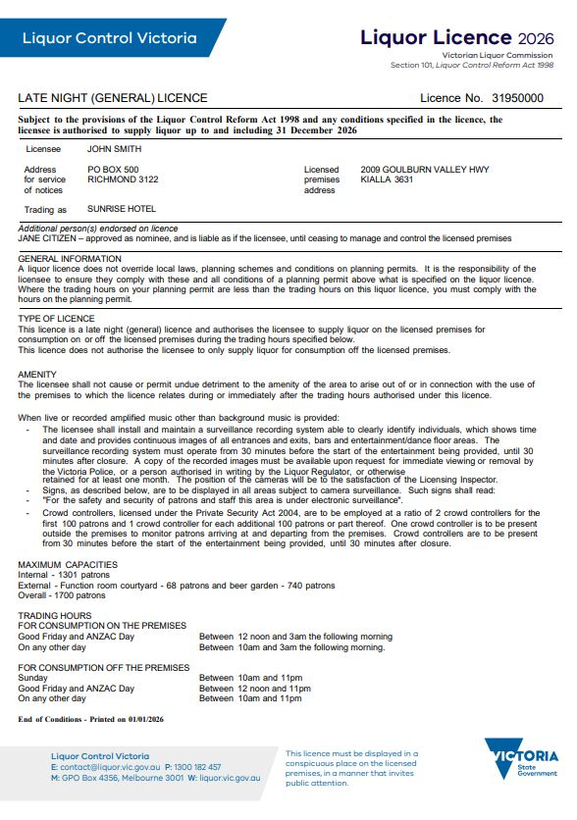
The maximum number of permitted patrons prevents overcrowding and minimises impacts on surroundings, for example due to excessive noise.
If you allow more patrons than stated, you are committing an offence.

For this condition amplified music is any music* or sound played through any electronic device.

Security cameras must:
- clearly identify individuals
- record the time and date.
You must keep your security cameras’ footage for at least one month from the date of recording and provide it if requested by Victoria Police or a liquor inspector.
For this licence, 18 crowd controllers are required when venue is at full capacity of 1700 patrons.

*This may include but is not limited to any music emitted by speakers, sound systems, juke boxes, radios, tape recorders, CD/DVD players, smartphones, iPods, television sets and home entertainment systems.

Questions

It’s time to check your understanding of what has been covered in this guide. Please complete the questions below and check your responses against the answers provided at the back of this guide.

Q.1 Some old friends of the licensee arrive unexpectedly around 10:45 pm when the venue is due to close at 11pm. The licensee serves his friends who sit at the bar. By 11:30 pm, all customers, except the licensee’s friends, have left. The licensee opens a bottle of wine for them to drink.
On what part of the premises may the licensee and his guests drink the wine?
☐ In the main bar
☐ In the office
☐ In the licensee’s private residence.

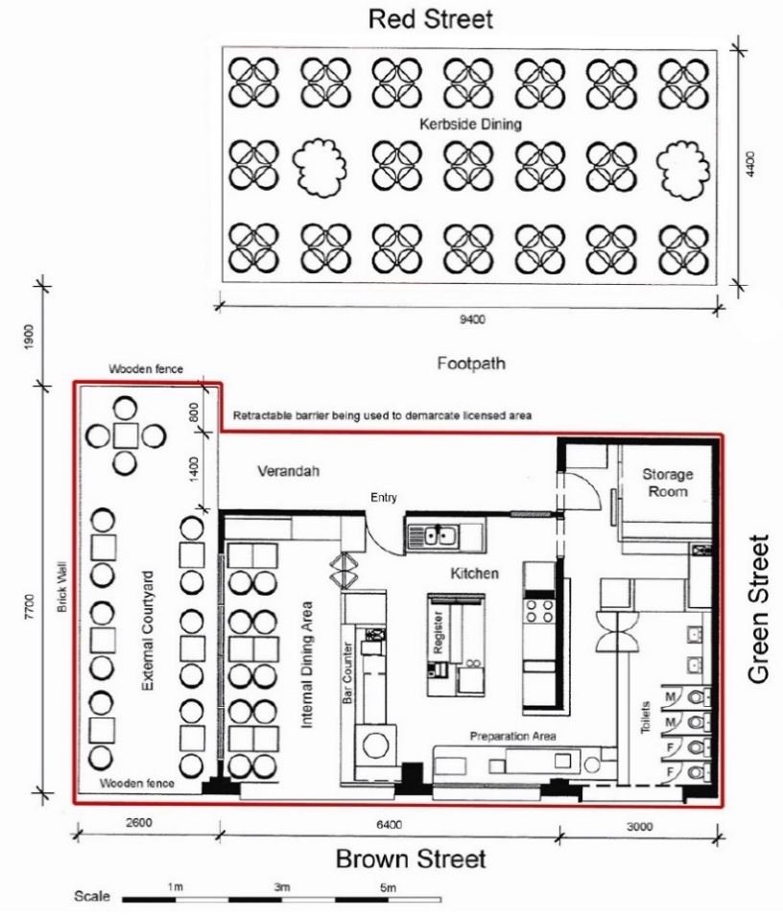
Use the red line plan below for Max Hotel to answer questions 2 and 3:

Q.2 If a customer takes a bottle of wine they’ve purchased in the Max Hotel into the courtyard, is the Max Hotel in breach of its liquor licence?
☐ Yes ☐ No
Explain your answer:
Click or tap here to enter text.

Q.3 If the Max Hotel sets up tables and chairs on the footpath (outside their red line area) for customers to consume alcohol. Is the Max Hotel in breach of its licence?
☐ Yes ☐ No
Explain your answer:
Click or tap here to enter text.

Q.4 A person residing at the Max Hotel (a ‘resident’) rings room service at 4 am on a Sunday and wishes to order alcohol. Is the hotel allowed to serve the person?
☐ Yes ☐ No
Explain your answer:
Click or tap here to enter text.
The Max Hotel trading hours are:
On-premises trading hours
Sunday: 10 am to 11 pm
On any other day: 7 am to 1 am
Off-premises trading hours
Sunday: 10 am to 11 pm
On any other day: 7 am to 11 pm

Q.5 Your best friend is an excellent chef who has won many awards. Your bistro area is not doing well, you have agreed to sublet the kitchen and bistro area to her on a six-month trial, during which she will sell alcohol. Are you in breach of your liquor licence?
☐ Yes ☐ No
Explain your answer:
Click or tap here to enter text.

Q.6 Your licence allows on-premises consumption until 1 am and off-premises until 11 pm each day. You have tables and chairs on the footpath which are not part of your red line plan. A group of customers are outside at 11:30 pm. They come inside to order a bottle of wine and to take it out to the tables on the footpath.

Are you in breach of your licence if you sell them the wine?
☐ Yes ☐ No
Explain your answer:
Click or tap here to enter text.

Q.7 It is a busy night at a hotel with a late-night (general) licence that has amplified music conditions. There is a well-known local band playing and the crowd controllers are not letting any more patrons in; there is a long queue of people out the front of the venue.
The maximum patron capacity is 451 patrons, and on this night there are four crowd controllers on duty.
How many crowd controllers is the venue required to have at its maximum patron capacity?
Click or tap here to enter text.

Q.8 A local resident lives 200 metres from your venue and complains that the noise coming from your venue late at night is affecting their sleep. What licence condition might you be breaching?
Click or tap here to enter text.

Q.9 If a late night (general) licence has a condition regarding a surveillance recording system when must it be in operation?
☐ 60 minutes before the start of the entertainment and 60 minutes after closing
☐ 30 minutes before the start of the entertainment and 30 minutes after closing
☐ 30 minutes after the entertainment starts and as soon as the entertainment finishes.

Q.10 What are the RSA training requirements for staff of general and late night (general) licences?
Click or tap here to enter text.

Answers

Q.1 In the licensee’s private residence.

Q.2 No. The courtyard is within the Max Hotel’s red line area.

Q.3 No. Customers may take their drinks onto the footpath area during the hours authorised for off-premises consumption.
Max Hotel would need to check that it has the relevant council planning permission to set up tables and chairs on the footpath.

Q.4 Yes. They are a resident of the hotel and can be supplied alcohol at any time. You should consider responsible service of alcohol and refuse to supply if person is intoxicated or drunk.

Q.5 Yes, a licensee must not let or sublet any part of the licensed premises or assign the right to supply liquor without the consent of LCV.

Q.6 Yes, your off-premises trading hours finished at 11 pm.

Q.7 Six crowd controllers, that is two for the first 100 patrons, and another for four for the remaining 351 patrons.

Q.8 The amenity condition.

Q.9 30 minutes before the start of the entertainment and 30 minutes after closing.

Q.10 Staff selling, offering or serving liquor for a general or late night (general) licence, will need to undertake RSA training no more than one month after they begin selling, offering or serving alcohol on the licensed premises. Staff must also undertake RSA refresher training every 3 years.

This document was updated on 27 January 2026
Minor changes made: Ensure content aligned with style guide and updated URL links.
Major changes made: Updated liquor deliveries section regarding display of licence number, display of warning notice and same day deliveries. Updated RSA section to include information on SHARPR training.

