Self-paced guide
On-premises and late night (on-premises) licence

Introduction
This guide is if for anyone who needs to know about an on-premises or late night (on-premises) licence and its conditions. This may include:
- new licensees, nominees or managers
- existing licensees
- company directors who hold a on-premises or late night (on-premises) licence
- staff at a venue with an on-premises or late night (on-premises) licence.

Once you have completed this guide, you should be able to:
- identify when and where you are allowed to supply alcohol to customers
- identify any special conditions that apply to your licence type
- identify possible breaches of an on-premises or late night (on-premises) licence.

This guide includes:
- general information – about an on-premises or late night (on-premises) licence (page 3 to 5)
- licence conditions – explaining in detail parts of your licence (page 6)
- Q&A – to test your understanding of the licence (page 7 to 9).
Please note: Information about the law may have been summarised or expressed in general statements. This information should not be relied upon as a substitute for professional legal advice or reference to the Liquor Control Reform Act 1998 (the Act).

Relevant information about the on-premises licence can be found at vic.gov.au/apply-on-premises-liquor-licence or information about a late night (on-premises) licence can be found at vic.gov.au/late-night-liquor-licences.

General information
Trading hours | An on-premises licence allows you to trade:  - Monday to Saturday (except ANZAC Day and Good Friday), 7 am to 1 am the following morning  - Sunday, 10 am to 1 am the following morning  - ANZAC Day and Good Friday, 12 noon to 1 am the following morning.  - During any other times only if specified in the licence.  A late night (on-premises) licence allows you to trade during the following hours, beyond 1am and at other times as specified in your licence:  - Monday to Saturday (except ANZAC Day and Good Friday), 7 am to 1 am the following morning  - Sunday, 10 am to 1 am the following morning  - ANZAC Day and Good Friday, 12 noon to 1 am the following morning.  If your licence specifies trading hours for specific areas of the venue you will need to comply with those specific trading hours.  You must have planning permission from your local council to trade during the trading hours displayed on your liquor licence.  You have a 30-minute period after closing time for customers to finish purchased drinks. During this time, you cannot sell them any more alcohol.
Liquor licence and posters | You are required to display:  - a copy of the most recent liquor licence where customers can see it  - the following posters (signage):  - ‘Intoxicated, Drunk Disorderly?’  - ‘Under 18? Can you enter?’  - ‘Under 18? No supply’.  Posters must be printed in colour on A4 (210 x 297 mm) paper and displayed so customers can see the information.
Red line plan | Your red line plan (the plan) shows where alcohol can be sold, served and consumed on the licensed premises.  The plan is submitted with a licence application. If the licence is transferred to you from an existing licence owner, Liquor Control Victoria (LCV) will have an approved plan.  If Victoria Police or a liquor inspector visits you, they will likely request a copy of your plan to check you are operating within the red line area.
Underage customers (minors) | Minors are not allowed to be served or drink alcohol at your venue under any circumstances.  A person under 18 years of age is allowed at your venue, if they are:  - in the company of a ‘responsible adult’, or  - having a meal, or  - employed in duties other than the supply of alcohol (for example preparing food, taking orders (other than for alcohol)), or  - in an LCV approved hospitality training program, or  - otherwise approved by LCV to be there.  A responsible adult is a person who is over the age of 18 years and who is:  - the younger person’s parent, step-parent, guardian or grandparent  - the younger person’s spouse (over the age of 18 years)  - a person acting in place of a parent and who is supervising the young person (for example, an aunt or uncle).  More information on responsible adult is available at: vic.gov.au/under-18s-at-licensed-venues.
Amenity | Amenity is the impact that your venue and customers may have on the surrounding area. Your venue should consider the following:  - Parking facilities  Do you have a car park? Do customers park in nearby residential streets?  - Traffic movement and density  Is there a high volume of customer traffic in the surrounding area from customers coming to your venue?  - Noise levels  What measures do you have to minimise noise from your venue (for example, amplified music) or noise from customers queuing or leaving your venue?  - Possibility of nuisance or vandalism  Are your customers likely to cause a nuisance to nearby residents? Is there a potential that they may cause noise, nuisance or damage to property? Are your customers obstructing the footpath, street or road?  - Harmony and coherence of the environment  What general effect does your venue have on the local community and neighbouring businesses/residents?
Tables and chairs on the footpath | You may have tables and chairs on the footpath outside your venue. To serve alcohol in this area, you must include it in the red line plan when applying for a licence.  You need council approval to use the footpath before LCV can approve the licence.  This area on your red line plan is your Authorised Area (AA).
Personal guests | You can supply alcohol to your personal guests at any time if you:  - live at the venue, and  - serve and drink alcohol in the area that is your private residence.  Note: The licensee’s residence is not in the red line area.
Residents | If your venue provides accommodation, you can supply alcohol to a resident or a resident’s guest for consumption on the licensed premises at any time.  You must keep records of residents staying at your premises as proof if requested by Victoria Police or a liquor inspector.
Responsible Service of Alcohol (RSA) | Licensees must complete RSA training before a licence is granted.  Licensees of a late night (on-premises) licence must also complete the Advanced RSA course within 6 months of the licence being granted.  Staff must complete RSA training no more than one month after they begin selling alcohol. Licensees and staff must also complete RSA refresher training every 3 years.  From 1 December 2025, anyone completing their RSA or refresher training will also complete the Sexual Harassment and Assault: Recognise, Prevent and Respond (SHARPR) online module. This module helps licensees and staff recognise some of the key signs of sexual harassment and assault in licensed venues and stores.  The RSA refresher training is free and available at learninghub.liquor.vic.gov.au.  A licensee must provide RSA training information to Victoria Police and liquor inspectors upon request, including:  - the responsible person’s name (for example the nominee, manager)  - the name of everyone selling and serving alcohol and the date they first sold or served alcohol  - a copy (paper or electronic) of the RSA Certificate of Completion for staff members selling and supplying alcohol.
Sub-letting | You must seek LCV approval to sublet all or part of the licensed premises to another business. To apply, complete the Sublet premises or right to supply liquor form available at vic.gov.au/make-changes-to-liquor-licence.
Allowing other persons to carry on a business of supplying alcohol | You must seek approval of LCV if anyone else, except you or your employee, is to supply alcohol at your store. To apply complete the Sublet premises or right to supply alcohol form available at vic.gov.au/make-changes-to-liquor-licence.
Other | Relevant information about your licence:  - Annual licence renewal is due on 31 December. A good compliance history can reduce your fees see vic.gov.au/demerit-points-and-star-ratings-for-licensees.  - Join the Liquor Portal at liquorportal.vcglr.vic.gov.au/liquorportal/ to access your licence, renewal notice and update your details.  - Apply for a temporary licence at vic.gov.au/apply-temporary-limited-liquor-licence if you wish to extend your trading hours or red line area for a one-off event.  - Change what your licences allows you to do by completing the variation to an existing licence form at vic.gov.au/make-changes-to-liquor-licence.  - Surrender your licence when you no longer need it at vic.gov.au/cancel-liquor-licence  - Stay compliant with liquor laws and your obligations as a licence holder at vic.gov.au/stay-compliant-for-liquor-licensees.

Licence conditions

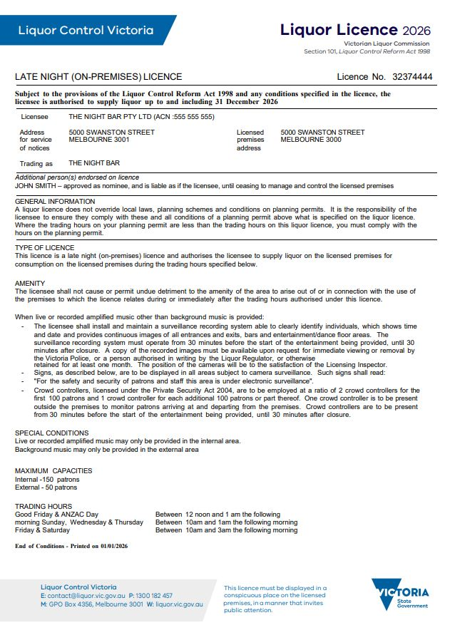
For this condition amplified music is any music* or sound played through any electronic device.

Security cameras must:
- clearly identify individuals
- record the time and date.
You must keep your security cameras’ footage for at least one month from date of recording and provide it if requested by Victoria Police or a liquor inspector
You must comply with special conditions on your licence. If not, you are committing an offence.

The maximum number of permitted customers (patrons) prevents overcrowding and minimises impacts on surroundings for example noise.
If you allow more people than stated you are committing an offence.

*This may include but is not limited to any music emitted by speakers, sound systems, juke boxes, radios, tape recorders, CD/DVD players, smartphones, iPods, television sets and home entertainment systems.

Questions

It’s time to check your understanding of what has been covered in this guide. Please complete the questions below and check your responses against the answers provided at the back of this guide.

Q.1 It is a busy, warm evening in a small suburban bar. All the tables and chairs are occupied on the footpath outside. As there are no vacant tables, a group of women take their drinks and sit on a low wall a few metres down the street. Is this breaching the liquor licence?
☐ Yes ☐ No
Explain your answer
Click or tap here to enter text.

Q.2 Can smokers go outside the licensed premises with their drink if it is outside the red line area?
☐ Yes ☐ No
Explain your answer
Click or tap here to enter text.

Q.3 If business demand grows, you can add tables and chairs to the outside footpath area as long as the neighbouring shops agree.
☐ Yes ☐ No
Explain your answer
Click or tap here to enter text.

Q.4 Your best friend is an excellent chef who has won many awards. Your food sales are not doing well, you have agreed to sublet the kitchen to her on a six-month trial. Are you in breach of your liquor licence?
☐ Yes ☐ No
Explain your answer:
Click or tap here to enter text.

Q.5 Some friends come into your bar at around 11 pm for a drink. You look at the clock and it is 11:20 pm. Can you serve them without breaching your licence?
Click or tap here to enter text.

Q.6 Saturday nights are always busy in your bar. What are some of the amenity issues you need to consider?
Click or tap here to enter text.

Q.7 Your liquor licence has a condition stating that the maximum number of patrons is 451. How many crowd controllers are you required to have when your venue is at full capacity?
Click or tap here to enter text.

Q.8 The surveillance recording system must operate at least:
☐ 60 minutes before the start of the entertainment and 60 minutes after closing
☐ 30 minutes before the start of the entertainment and 30 minutes after closing
☐ 30 minutes after the entertainment starts and as soon as the entertainment finishes.

Q.9 Most of the bar staff have been working for over six months and have completed their RSA course. Two of the bar staff called in sick and the licensee has asked their 18-year-old son to help. Can the licensee’s son serve alcohol behind the bar?
☐ Yes ☐ No
If yes, are there any requirements that have to be met?
Explain your answer:
Click or tap here to enter text.

Q.10 What are the RSA training requirements for staff of on-premises and late night (on-premises) licences?
Click or tap here to enter text.

Answers
Q.1 Yes, it is unlikely the red line area would extend past neighbouring shops.
If a customer is consuming alcohol, not within a red line area, that would be a breach.

Q.2 No, they are not permitted to take their drinks outside the red line area.

Q.3 No. You can only trade within the red line area.
You can apply to LCV for approval to trade on the footpath, but you must have local council approval first.

Q.4 Yes, a licensee must not let or sublet any part of the licensed premises or assign the right to supply liquor without the consent of LCV.

Q.5 Yes, as extended trading hours allow you to supply until 1am on premises as long as your council planning
permit also allows you to trade until 1 am. If your council permit doesn’t allow you to trade until 1am, trading hours apply, and you would be in breach.

Q.6 Answers may include any of the following:
- noise from patrons when they are leaving your premises
- parking outside residences in nearby streets
- traffic noise
- damage to cars or property.

Q.7 Six crowd controllers, two for the first 100 patrons and another four for the remaining 351 patrons.

Q.8 30 minutes before the start of the entertainment and 30 minutes after closing.

Q.9 Yes, the licensee’s son can serve behind the bar and will need to undertake RSA training within one month of
serving alcohol.
Q.10 Staff selling, offering or serving liquor for an on-premises or late night (on-premises) licence will need to complete RSA training no more than one month after they begin selling, offering or serving alcohol on the licensed premises. Staff must also complete RSA refresher training every 3 years.

This document was updated on 27 January 2026
Minor changes made: Ensure content aligned with style guide and updated URL links.
Major changes made: Updated RSA section to include information on SHARPR training.

