Self-paced guide
Packaged liquor and late night
(packaged liquor) licence

Introduction
This guide is for anyone who needs to know about a packaged liquor licence or late night (packaged liquor) licence and its conditions. This may include:
- new licensees and nominees
- existing licensees
- company directors
- staff who work at a store with packaged liquor or late night (packaged liquor) licence.
Once you have completed this guide you should be able to:
- identify when and where you are allowed to supply alcohol to customers
- identify any special conditions on your licence
- identify possible breaches of a packaged liquor or late night (packaged liquor) licence.
This guide includes:
- general information – about a packaged liquor or late night (packaged liquor) licence (pages 3 to 6)
- licence conditions – explaining in detail parts of your licence (page 7)
- Q&A – to test your understanding of the licence (pages 8 to 10).
Please note: Information about the law may have been summarised or expressed in general statements. This information should not be relied upon as a substitute for professional legal advice or reference to the Liquor Control Reform Act 1998 (the Act).
Relevant information about the packaged liquor licence can be found at vic.gov.au/apply-packaged-liquor-licence and information about a late night (packaged) liquor licence at vic.gov.au/late-night-liquor-licences.

General information
Trading hours | A packaged liquor licence allows you to trade:  - Monday to Saturday, 9 am to 11 pm  - Sunday, 10 am to 11 pm  - ANZAC Day, 12 noon to 11 pm  - No trading on Good Friday and Christmas Day, unless your licence states otherwise  - During any other times only if specified in the licence.  A late night (packaged liquor) licence you to trade:  - Monday to Saturday, 9 am to 11 pm  - Sunday, 10 am to 11 pm  - ANZAC Day, 12 noon to 11 pm  - No trading on Good Friday and Christmas Day, unless your licence states otherwise.  - Beyond 1am as specified on the licence.  - During any other times only if specified in the licence.
Liquor licence and posters | You are required to display:  - a copy of the current liquor licence where customers can see it  - the following posters (signage):  - ‘Intoxicated, Drunk, Disorderly?’  - ‘Under 18? No supply’  - ‘Do not attempt to buy liquor for under 18s’.  Posters must be printed in colour on A4 (210 x 297 mm) paper and displayed so customers can see the information.
Red line plan | Your red line plan (the plan) shows where alcohol can be sold on the licensed premises.  The plan is submitted with a licence application. If the licence is transferred to you from an existing licence owner, Liquor Control Victoria (LCV) will have an approved plan.  If you have a mixed business retail store (for example, supermarket or grocery store), you will most likely have a designated area, separate from the grocery area, where alcohol can be supplied.  Some licensed supermarkets may have a remote checkout approval, allowing the sale to occur via a checkout/register outside the red line area. The approval is only granted where the licensee is also the landlord of the supermarket. To apply for a remote checkout approval, you must complete the Packaged Liquor Licence Remote Checkout Authority form, which can be requested by emailing contact@liquor.vic.gov.au.  If Victoria Police or a liquor inspector visits you, they will likely request a copy of your plan to check you are operating within the red line area.
Liquor deliveries | A packaged liquor or late night (packaged liquor) licence allows alcohol delivery via orders taken by an off-premises request (that is, orders taken by internet, phone, mail, fax). You must notify LCV before taking off-premises orders. You must notify LCV before taking off-premises orders. For more information, see vic.gov.au/off-premises-requests-for-alcohol-delivery.  You must comply with the following conditions set out in section 18C of the Act:  - Display your licence number clearly on your website or ordering platform and in any promotional or advertising materials.  - Display a warning notice where customers place their order (for example, a website or ordering platform) about offence to supply alcohol to a person under 18.  - Instruct delivery drivers to:  - alcohol can only be delivered until 11pm  - same-day orders must be delivered to the person who ordered the alcohol and cannot be left unattended.  - For first time orders (that are not gifts):  - customers must confirm they are aged 18 or over  - delivery drivers must be instructed that:  - alcohol must be delivered to the customer who made the order and  - they must see an ID document confirming the person is aged 18 or over.  - For subsequent orders by the same customer, you are required to:  - obtain instructions where to leave the order if the customer is not at home  - provide these instructions to the driver and advise that the order must be delivered in accordance with the customer’s instructions.  - For gift orders:  - customer must confirm that they and the person receiving the gift are aged 18 or over  - you must obtain the name and address of the gift recipient  - delivery driver must be instructed to only deliver the alcohol to:  - the address provided  - the gift recipient or a person who is aged 18 years or over  - the recipient, who must provide an acceptable form of identification.  A report of failed alcohol deliveries must be provided to LCV by 30 July each year. For further information, see vic.gov.au/off-premises-requests-for-alcohol-delivery.
Tastings | You can offer free ‘tastings’ in your store, for example, wine tastings.
Underage persons (minors) in your store | You may allow under 18-year-olds in your store if they are:  - employed in duties other than the supply of alcohol or  - in the company of a responsible adult.  A responsible adult is a person who is over the age of 18 years and who is:  - the younger person’s parent, step-parent, guardian or grandparent, or  - the younger person’s spouse (over the age of 18 years), or  - a person acting instead of a parent and supervising the young person (for example, an aunt or uncle).  More information on responsible adult is available at: vic.gov.au/under-18s-at-licensed-venues.  Note: Employees under 18 years are allowed to take packaged alcohol to a customer’s vehicle but are not allowed to take orders or receive payment for alcohol. In this case, they do not require a Responsible Service of Alcohol (RSA) certificate.
Amenity | Amenity is how your store or customer’s behaviour influences the experience of the surrounding area.  Your store should consider the following:  - Parking facilities  Do you have a car park? Do customers park on nearby residential streets?  - Traffic movement and density  Is there a lot of traffic in the surrounding area from customers coming to your store?  - Noise levels  What measures are in place to minimise noise from customers leaving your store?  - Possibility of nuisance or vandalism  Are your customers likely to cause a nuisance to nearby residents? Could they cause noise, nuisance or damage to property or cars?  - Harmony and coherence of the environment  What effect does your store have on the local community and neighbouring businesses/residents?
No advertising within 150 metres of the permitter of a school | It is an offence under the Act for anyone to display (or cause to be displayed) static alcohol advertising (for example banners, billboards, signs) within 150 metres of the perimeter of a school for any direct or indirect financial benefit.
Responsible Service of Alcohol (RSA) training | Licensees must complete RSA training before a licence is granted.  Staff must complete RSA training no more than one month after they begin selling alcohol. Licensees and staff must also complete RSA refresher training every three years.  From 1 December 2025, anyone completing their RSA or refresher training will also complete the Sexual Harassment and Assault: Recognise, Prevent and Respond (SHARPR) online module. This module helps licensees and staff recognise some of the key signs of sexual harassment and assault in licensed venues and stores.  The RSA refresher course is free and available at learninghub.liquor.vic.gov.au/.  A licensee must provide RSA training information to Victoria Police or a liquor inspector upon request, including:  - the responsible person’s name (for example, the nominee, manager)  - the name of each person who is engaged in the sale and service of liquor and the date on which each person first sold or served alcohol on the premises  - a copy (paper or electronic) of the RSA Certificate of Completion for staff members selling and supplying alcohol.
Sub-letting | You must seek LCV approval to sub-let any part of your store or selling your licence to a third party. To apply complete the Sublet premises or right to supply alcohol form available at vic.gov.au/make-changes-to-liquor-licence.
Allowing other persons to carry on a business of supplying alcohol | You must seek LCV’s approval if anyone else, except you or your employee, is to supply alcohol at your store. To apply, complete the Sublet premises or right to supply alcohol form available at vic.gov.au/make-changes-to-liquor-licence.
Other | Relevant information about your licence:  - Annual licence renewal is due on 31 December. A good compliance history can reduce your fees, see vic.gov.au/demerit-points-and-star-ratings-for-licensees.  - Join the Liquor Portal at liquorportal.vcglr.vic.gov.au/liquorportal/ to access your licence, renewal notice or update your details.  - Apply for a temporary licence at vic.gov.au/apply-temporary-limited-liquor-licence if you wish to extend your trading hours or red line area for a one-off event.  - Vary your licence by completing the variation to an existing licence form at https://www.vic.gov.au/make-changes-to-liquor-licence.  - Surrender your licence when you no longer need it at vic.gov.au/cancel-liquor-licence.  - Stay compliant with liquor laws and your obligations as a licence holder at vic.gov.au/stay-compliant-for-liquor-licensees.

Licence conditions

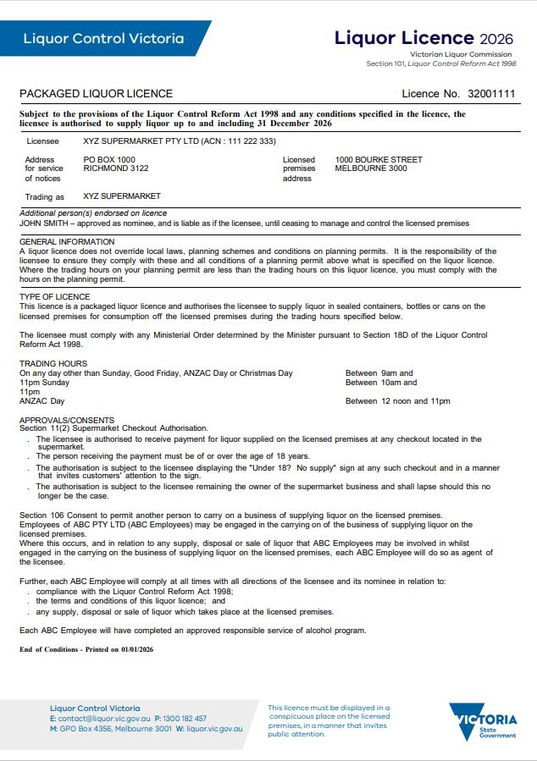
This consent allows another person to carry on a business of supplying alcohol at your store.
If you have this approval, any checkout can be used to receive payments for alcohol.
The person on the checkout must be over 18 years old.
The ‘Under 18? No supply’ sign must be clearly displayed at checkouts in the supermarket.
This only applies where the licensee is also the landlord of the supermarket.
Ministerial orders that may apply to this condition can be found on LCV’s website at: vic.gov.au/ministerial-liquor-orders-guidelines

This consent allows a person (other than the licensee) to carry on a business of supplying alcohol.

Quiz
It’s time to check your understanding of what has been covered in this guide. Please complete the questions below and check your responses against the answers provided at the back of this guide.

Q.1 A woman purchases a bottle of wine in your store. She explains that she is on her way to a picnic and doesn’t have a corkscrew and asks you to open the bottle for her. Will you be in breach of your licence if you open the bottle for her?
☐ Yes ☐ No
Explain your answer:
Click or tap here to enter text.

Q.2 At 11 am on Saturday morning you walk into David’s Supermarket, they hold a packaged liquor licence. You walk past a table set up with wine tasting. A staff member asks if you would like to taste one of the wines. Is David’s Supermarket in breach of their licence?
☐ Yes ☐ No
Explain your answer:
Click or tap here to enter text.

Q.3 You are the licensee and also the landlord of a supermarket with a packaged liquor licence. Can a customer pay for alcohol at a register located outside the bottle shop area if there is no remote checkout approval in place?
☐ Yes ☐ No

Q.4 Is it an offence to hold a wine tasting in the grocery area of a supermarket?
☐ Yes ☐ No
Explain your answer:
Click or tap here to enter text.

Q.5 The cashiers on the registers in the bottle shop must be over 18 years old?
☐ Yes ☐ No
Explain your answer:
Click or tap here to enter text.

Q.6 Is it an offence for supermarket customers under 18 years old to go into a bottle shop without a responsible adult?
☐ Yes ☐ No
Explain your answer:
Click or tap here to enter text.

Q.7 Can a delivery of packaged alcohol be left with a person under 18 years old?
☐ Yes ☐ No
Explain your answer:
Click or tap here to enter text.

Q.8 The RSA course must be completed by the licensee:
☐ within 6 months of being granted a licence
☐ within one month of being granted a licence
☐ prior to being granted a licence.

Q.9 How often must a licensee and staff do the RSA refresher course?
☐ Every 12 months
☐ Every 3 years
☐ Twice a year.

Answers
Q.1 Yes, as a packaged liquor store, you may only sell liquor in sealed containers. Opening the wine would constitute an open container.

Q.2 There is no offence.
Packaged liquor licensees can provide ‘tastings’ under Section 20 of the Act.

Q.3 No.

Q.4 Yes, it must be held within the red line area shown on the plan approved by LCV.

Q.5 Yes, only people over 18 years of age are allowed to supply liquor.

Q.6 Yes, minors are only allowed in packaged liquor or late night (packaged liquor) licence if they are employed in duties other than the supply of liquor or if they are in the company of a parent or a responsible adult acting in place of a parent.

Q.7 No, packaged alcohol cannot be left with a person under 18-years old.
The licensee must ensure that delivery arrangements include requiring evidence of age where appropriate.

Q.8 Prior to being granted a licence.

Q.9 Every 3 years.

This document was updated on 27 January 2026
Minor changes made: Ensure content aligned with style guide and updated URL links.
Major changes made: Update red line plan section on where to get Packaged Liquor Licence Remote Checkout Authority form. Updated liquor deliveries section regarding display of licence number, display of warning notice and same day deliveries. Updated RSA section to include information on SHARPR training.

