Self-paced guide
Producer’s licence

Introduction
This guide is for anyone who needs to know about a producer’s licence and its conditions. This may include:
- new licensees and nominees
- existing licensees
- company directors
- staff who work at a venue with a producer’s licence.
Once you have completed this guide, you should be able to:
- identify when and where you are allowed to supply alcohol to customers
- identify any special conditions on your licence
- identify possible breaches of a producer’s licence.
This guide includes:
- general information – about a producer’s licence (pages 3 to 5)
- licence conditions – explaining in detail parts of your licence (page 6)
- Q&A – to test your understanding of the licence (pages 7 and 8).
Please note: Information about the law may have been summarised or expressed in general statements. This information should not be relied upon as a substitute for professional legal advice or reference to the Liquor Control Reform Act 1998 (the Act).
Relevant information about the producer’s licence can be found at vic.gov.au/apply-producers-liquor-licence.

General information
Trading hours | A producer’s licence allows you to sell:  - your product (wholesale) to any other licensees (wholesale) at any time.  - sell alcohol for customers to drink at your venue or takeaway:  - Monday to Saturday (except for Good Friday and ANZAC Day), 7 am to 11 pm  - Sunday, Good Friday and ANZAC Day, 10 am to 11 pm  - During any other times only if specified in the licence.  You must have planning permission from your local council to trade during the trading hours displayed on your liquor licence.  You have a 30-minute period after closing time for customers to finish purchased drinks. During this time, you cannot sell customers any more alcohol.
Liquor licence and posters | You are required to display:  - a copy of the current liquor licence where customers can see it  - the following posters (signage):  - ‘Intoxicated, Drunk, Disorderly?’  - ‘Under 18? No supply’.  Posters must be printed in colour on A4 (210 x 297 mm) paper and displayed so the public can see the information.
Red line plan | Your red line plan (the plan) shows where alcohol can be sold and consumed at your venue. The plan is submitted with the application for a licence. If the licence is transferred to you from an existing licence owner, Liquor Control Victoria (LCV) will have an approved plan.  If Victoria Police or an LCV inspector visits you, they will likely request a copy of your plan to check you are operating within the red line area.
Liquor deliveries | A producer’s licence allows alcohol delivery via orders taken by an off-premises request (that is, orders taken by internet, phone, mail, fax). You must notify LCV before taking off-premises orders. For more information, see vic.gov.au/off-premises-requests-for-alcohol-delivery.  You must comply with the following conditions set out in section 18C of the Act:  - Display your licence number clearly on your website or ordering platform and in any promotional or advertising materials.  - Display a warning notice where customers place their order (for example, a website or ordering platform) about offence to supply alcohol to a person under 18  - Instruct delivery drivers that:  - alcohol can only be delivered until 11 pm  - same-day orders must be delivered to the person who ordered the alcohol and cannot be left unattended.  - For first time orders (that are not gifts):  - customers must confirm they are aged 18 or over  - instruct delivery drivers that:  - alcohol must be delivered to the customer who made the order and  - they must see an ID document confirming the person is aged 18 or over.  - For subsequent orders by the same customer, you are required to:  - obtain instructions where to leave the order if the customer is not at home  - provide these instructions to the driver and advise that the order must be delivered in accordance with the customer’s instructions.  - For gift orders:  - customers must confirm that they and the person receiving the gift are aged 18 or over  - you must obtain the name and address of the gift recipient  - delivery driver must be instructed to only deliver the alcohol to:  - the address provided  - the gift recipient or a person who is aged 18 years or over  - the recipient who must provide an acceptable form of identification.  A report of failed alcohol deliveries must be provided to LCV by 30 July each year. For further information see vic.gov.au/off-premises-requests-for-alcohol-delivery.
Underage customers (minors) | Minors are not allowed to be served or drink alcohol at your venue under any circumstances.  A person under 18 years of age is allowed at your venue if they are:  - in the company of a ‘responsible adult’, or  - having a meal, or  - employed in duties other than the supply of alcohol (for example, preparing food, taking orders (other than for alcohol)), or  - in an LCV approved hospitality training program, or  - otherwise approved by LCV to be there.  A responsible adult is a person who is over the age of 18 years and who is:  - the younger person’s parent, step-parent, guardian or grandparent  - the younger person’s spouse (over the age of 18 years)  - a person acting in place of a parent and supervising the young person (for example an aunt or uncle).  More information on responsible adult is available at: vic.gov.au/under-18s-at-licensed-venues.
Amenity | Amenity is the impact that your venue and customers may have on the surrounding area.  Your venue should consider the following amenity impacts:  - Parking facilities  Do you have a car park? Do customers park on nearby residential streets?  - Traffic movement and density  Is there a high volume of customer traffic from customers coming to your venue?  - Noise levels  What measures do you have in place to minimise noise from your venue (if you have amplified music) or from customers leaving your venue?  - Possibility of nuisance or vandalism  Are your customers likely to cause a nuisance to nearby residents? Could they cause noise, nuisance or damage to property?  - Harmony and coherence of the environment  What general effect does your venue have on the local community and neighbouring businesses/residents?
0BPromotional  1Bevent  authorisation | You can apply to sell your own alcoholic product at farmers markets, craft markets, festivals and other promotional events. This is called a promotional event authorisation.  This approval does not include selling alcohol at major events or horse racing events.  You must pay a promotional event authorisation fee and annual licence renewal fee.
Retail premises | You may specify in your application an area where you will be selling alcohol to the public. This is considered as a retail premises.  The location of the retail premises must be in the same geographical region as the primary premises on the licence. The licence can include the retail premises address, as well as the primary address.  You can only sell your product for take away at the retail premises.
Responsible Service of Alcohol (RSA) | The licensee must complete RSA training before the licence is granted. Licensees must also complete RSA refresher training every 3years.  The RSA refresher course is free and available at learninghub.liquor.vic.gov.au.  Victoria Police or a liquor inspector may request a copy of the most recent RSA Certificate of Completion during inspections.
Other | Relevant information about your licence:  - Annual licence renewal is due on 31 December. A good compliance history can reduce your fees see vic.gov.au/demerit-points-and-star-ratings-for-licensees.  - Join the Liquor Portal at liquorportal.vcglr.vic.gov.au/liquorportal/ to access your licence, renewal notice or update your details.  - Apply for a temporary licence at vic.gov.au/apply-temporary-limited-liquor-licence if you wish to extend your trading hours or red line area for a one-off event.  - Vary your licence by completing the variation to an existing licence form at vic.gov.au/make-changes-to-liquor-licence.  - Surrender your licence when you no longer need it at vic.gov.au/cancel-liquor-licence.  - Stay compliant with liquor laws and your obligations as a licence holder at vic.gov.au/stay-compliant-for-liquor-licensees.

Licence conditions

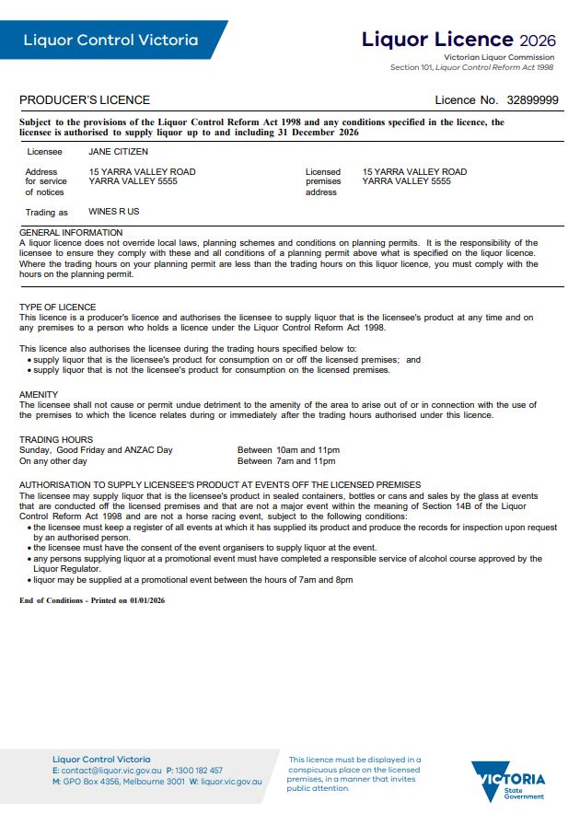
You must keep records of promotional events at which you have supplied your product.
The register could be in the form of a diary, electronic spreadsheet, or a dedicated notebook.
The register needs to be easily accessible and must be produced on request to Victoria Police or a liquor inspector.

You are responsible for your customers when they are at your venue and as they are leaving (this includes immediate footpath area).

Quiz
It’s time to check your understanding of what has been covered in this guide. Please complete the questions below and check your responses against the answers provided at the back of this guide.

Q.1 A customer only drinks one glass out of a bottle of wine they’ve purchased with their lunch in your winery restaurant. Can they take the bottle of wine home with them?
☐ Yes ☐ No
Explain your answer:
Click or tap here to enter text.

Q.2 During what hours are you allowed to supply your own product to other licence holders (wholesale)?
Click or tap here to enter text.

Q.3 What does a promotional event authorisation allow a producer’s licensee to do?
Click or tap here to enter text.

Q.4 What time do trading hours finish?
☐ 10 pm
☐ 11 pm
☐ midnight.

Q.5 Simone sells your wine in her restaurant. She calls to arrange to collect her next order at 8 am on Sunday morning. Is it a breach of your licence to sell Simone wine at that time on a Sunday?
☐ Yes ☐ No
Explain your answer:
Click or tap here to enter text.

Q.6 You own a winery, a customer advises they don’t like wine and ask if they can order a vodka and orange with their meal. Are you allowed to supply the customer vodka?
Click or tap here to enter text.
Q.7 You have your own delivery driver who delivers cases of your wine to residents. Jane Smith is ordering a case of wine from you for the first time. Is your delivery driver required to only deliver to Jane and site her ID to confirm she is over 18?
Click or tap here to enter text.

Q.8 You have a winery in the Yarra Valley Region, you want to set up a shop in Mornington Peninsula to sell your wine to the public. Can you do this under your existing licence?
Click or tap here to enter text.

Q.9 What posters are you required to display at your venue?
Click or tap here to enter text.

Q.10 When is the annual licence renewal fee due?
Click or tap here to enter text.

Answers

Q.1 Yes, they may take it home providing it is within the off-premises trading hours listed on your licence and is the licensee’s own product.

Q.2 At any time.

Q.3 A promotional event authorisation allows a producer’s licensee to sell their product at as many farmers markets, craft markets, festivals, and promotional events as they wish.

Q.4 11 pm.

Q.5 No, it is not a breach of your licence. She has a liquor licence too, so you can sell her your wine at any time on any day.

Q.6 Yes, the licence allows the sale of any alcohol to a customer to consume at the venue, including alcohol that is
not the licensee’s own product.
Q.7 Yes, for first time orders, alcohol must only be delivered and received by the customer who placed the order, and the delivery driver must verify their age by sighting an evidence-of-age document. It is your job as a licensee to instruct your delivery driver to do so.
Q.8 No, you cannot set up a shop in Mornington Peninsula to sell your own wine using your existing licence, as the retail premises needs to be in the same geographical region as your winery. In this instance, you would need a separate licence for a shop in Mornington Peninsula.
Q.9 ‘Intoxicated, Drunk Disorderly?’ and ‘Under 18? No supply’.
Q.10 31 December.

This document was updated on 27 January 2026
Minor changes made: Ensure content aligned with style guide and updated URL links.
Major changes made: Updated liquor deliveries section regarding display of licence number, display of warning notice and same day deliveries.

