Self-paced guide
Restaurant and cafe licence

Introduction

This guide is for anyone who needs to know about a restaurant and cafe licence and its conditions. This may include:
- new licensees, nominees or managers
- existing licensees
- company directors who hold a restaurant and cafe licence
- staff at a restaurant or cafe.

Once you have completed this guide, you should be able to:
- identify when and where you are permitted to supply alcohol to customers
- identify any special conditions that may apply to a restaurant and cafe licence
- identify possible breaches of a restaurant and cafe licence.

This guide includes:
- general information – about a restaurant and cafe licence (pages 3 to 6)
- licence conditions – explaining in detail parts of your licence (page 7)
- Q&A – to test your understanding of the licence (pages 8 to 11).
Please note: Information about the law may have been summarised or expressed in general statements. This information should not be relied upon as a substitute for professional legal advice or reference to the Liquor Control Reform Act 1998 (the Act).
Relevant information about the restaurant and cafe licence can be found at vic.gov.au/apply-restaurant-and-cafe-liquor-licence.

General information
Trading hours | A restaurant and cafe licence allows you to trade from:  - Monday to Saturday (except ANZAC day and Good Friday), 7 am to 1 am the following morning  - Sunday, 10 am to 1 am the following morning  - ANZAC Day and Good Friday, 12 noon to 1 am the following morning  - Between 1 am and 3 am on 1 January  - Sell a limited amount of packaged alcohol with takeaway or home-delivered meals until 11 pm  - During any other times only if specified in the licence.  If your licence includes trading hours for specific areas (for example, courtyard area) you will need to comply with those specific trading hours.  You must have planning permission from your local council to trade during the trading hours displayed on your liquor licence.  You have a 30-minute period after closing time for customers to finish purchased drinks. During this time, you cannot sell them any more alcohol.
Main activity | A restaurant and cafe licence requires that the main activity of the restaurant or cafe is the preparation and serving of meals consumed on premises.  Additionally, the following must be met:  - There must be tables and chairs so that at least 75% of the customers attending the restaurant and cafe at any one time can be seated (for example, if you have 50 customers, you must have at least 38 chairs on the floor, not stacked ready for people to sit).  - The meals are substantial and not just snacks.  - Most customers are there to eat or have eaten a meal.  - Live music performance or the playing of recorded music at a higher than background level outside trading hours is not permitted unless played at a private function*  *Private functions must be in a separate pre-booked area and are attended by the organiser and their guests only (no public access). Victoria Police or a liquor inspector may ask for evidence that a private function has been pre-booked.  Note: You cannot operate as a restaurant or cafe during the day and become a bar at night. A different licence is required to operate as a bar at night.
Liquor licence and posters | You are required to display:  - a copy of the current liquor licence where customers can see it  - the following posters (signage):  - ‘Intoxicated, Drunk, Disorderly?’  - ‘Under 18? No supply’.  Posters must be printed in colour on A4 (210 x 297 mm) paper and displayed so customers can see the information.
Red line plan | Your red line plan (the plan) shows where alcohol can be sold, served and consumed on the licensed premises.  The plan is submitted with the licence application. If the licence is transferred to you from an existing licence owner, LCV will have an approved plan.  If Victoria Police or a liquor inspector visits you, they will likely request a copy of your plan to check you are operating within the red line area.
Footpath  trading | You may have tables and chairs on the footpath outside your venue. To serve alcohol in this area, you must include it in the red line plan when applying for a licence.  You need council approval to use the footpath before LCV can approve the licence. This area on your red line plan is your Authorised Area (AA).
Takeaway and home deliveries | This licence allows supply of alcohol for consumption away from your restaurant or cafe, through take-away or delivery (that is, consumption off your premises). Alcohol must be provided to customers in sealed containers, such as stubbies, bottles or cans.  These rules must be followed when selling takeaway or delivering alcohol:  - it must be supplied with a meal, prepared at the restaurant and cafe, for an adult customer, and  - it must not be more than:  - 750 millilitres bottle of wine; or  - six containers of not more than 375 millilitres each, of beer, cider or pre-mixed spirits; and  - it can’t be provided past 11 pm.  You must notify LCV before supplying packaged alcohol with takeaway or home delivered meals. For more information, see vic.gov.au/off-premises-requests-for-alcohol-delivery.  You must comply with the following conditions set out in section 18C of the Act:  - Display your licence number clearly on your website or ordering platform and in any promotional or advertising materials.  - Display a warning notice where customers place their order (for example, a website or ordering platform) about offence to supply alcohol to a person under  - Instruct delivery drivers that:  - alcohol can only be delivered until 11 pm  - same-day orders must be delivered to the person who ordered the alcohol and cannot be left unattended.  - For first time orders (that are not gifts):  - customers must confirm they are aged 18 or over  - delivery drivers must be instructed that:  - alcohol must be delivered to the customer who made the order and  - they must see an ID document confirming the person is aged 18 or over.  - For subsequent orders by the same customer, you are required to:  - obtain instructions where to leave the order if the customer is not at home  - provide these instructions to the driver and advise that the order must be delivered per the customer’s instructions.  - For gift orders:  - customer must confirm that they and the person receiving the gift are aged 18 or over  - you must obtain the name and address of the gift recipient  - delivery driver must be instructed to only deliver the alcohol to:  - the address provided  - the gift recipient or a person who is aged 18 years or over  - the recipient, who must provide an acceptable form of identification.  A report of failed alcohol deliveries must be provided to LCV by 30 July each year. For further information see vic.gov.au/off-premises-requests-for-alcohol-delivery.
Takeaway of unconsumed alcohol | You may allow a person over the age of 18 to take-away unconsumed alcohol supplied during a meal, provided that:  - the alcohol is in the same resealable container it was supplied and  - no more than one resealable container of unconsumed alcohol per person is taken away.
Underage customers (minors) | Minors are not allowed to be served or drink alcohol at your restaurant or café under any circumstances.  You may allow under 18-year-olds at your restaurant or café to eat or drink a non-alcoholic beverage until 11pm.  If you are licensed to trade late, a person under 18 years of age is allowed after 11pm on your premises, if they are:  - in the company of a ‘responsible adult’  - having a meal  - employed in duties other than the supply of alcohol (for example, preparing food, taking orders (other than for alcohol))  - in an LCV approved hospitality training program, or  - otherwise approved by LCV to be there.  A responsible adult is a person who is over the age of 18 years and who is:  - the younger person’s parent, step-parent, guardian or grandparent  - the younger person’s spouse (over the age of 18 years)  - a person acting in place of a parent and supervising the young person (for example an aunt or uncle).  More information on responsible adult is available at: vic.gov.au/under-18s-at-licensed-venues.
Amenity | Amenity is how your venue or customers' behaviour influences the experience of the surrounding area.  Your venue should consider the following:  - Parking facilities  Do you have a car park? Do customers park on nearby residential streets?  - Traffic movement and density  Is there high customer traffic in the surrounding area from patrons coming from and going to your restaurant/cafe?  - Noise levels  What measures are in place to minimise noise from your restaurant or cafe (if you have amplified music) or customers leaving your venue?  - Possibility of nuisance or vandalism  Are your customers likely to cause a nuisance to nearby residents? Could they cause noise, nuisance or damage to property?  - Harmony and coherence of the environment  What general effect does your restaurant or cafe have on the local community and neighbouring businesses or residents?
Other | Relevant information about your licence:  - Annual licence renewal is due on 31 December. A good compliance history can reduce your fees, see vic.gov.au/demerit-points-and-star-ratings-for-licensees.  - Join the Liquor Portal at liquorportal.vcglr.vic.gov.au/liquorportal/ to access your licence and renewal notice and update your details.  - Apply for a temporary licence at vic.gov.au/apply-temporary-limited-liquor-licence if you wish to extend your trading hours or red line area for a one-off event.  - Vary your licence by completing the variation to an existing licence form at vic.gov.au/make-changes-to-liquor-licence.  - Surrender your licence when you no longer need it at vic.gov.au/cancel-liquor-licence  - Stay compliant with liquor laws and your obligations as a licence holder at vic.gov.au/stay-compliant-for-liquor-licensees.

Licence conditions

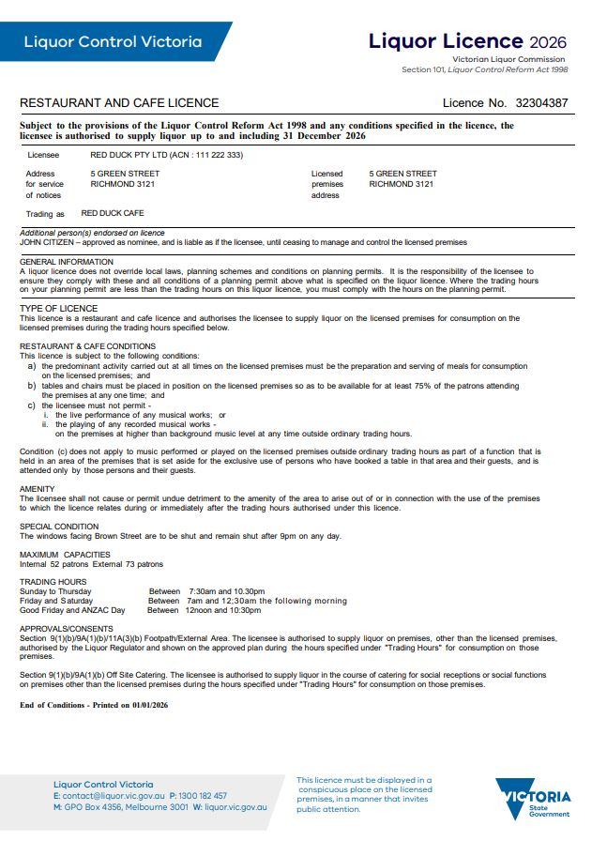
This approval allows supply of liquor during catering for social receptions or functions at another location other than the licensed premises (offsite).

If you have approval to supply alcohol in a footpath dining area it will be listed here.
You are responsible for your customers when they are at your venue and as they leave (this includes immediate footpath area).
The maximum number of permitted customers (patrons) prevents overcrowding and minimises impacts on surroundings for example noise.
If you allow more people than stated, you are committing an offence.

If you have special conditions listed on your licence, you must comply with them, or you will be committing an offence.

Quiz
It’s time to check your understanding of what has been covered in this guide. Please complete the questions below and check your responses against the answers provided at the back of this guide.

Q.1 A customer drinks one glass out of a bottle of wine purchased with their lunch in a cafe. Can they take the bottle of wine home?
☐ Yes ☐ No
Explain your answer:
Click or tap here to enter text.

Q.2 Customers in your restaurant have been drinking an imported wine. They ask if they can buy a dozen bottles for their wine cellar. Is it a breach of your restaurant and cafe licence to sell the wine to this customer?
☐ Yes ☐ No
Explain your answer:
Click or tap here to enter text.

Q.3 A group of four customers order drinks while they look at the menu. The waiter returns to take their orders, only three of them order a meal. Is this a breach of a restaurant and cafe licence?
☐ Yes ☐ No
Explain your answer:
Click or tap here to enter text.

Q.4 What time do trading hours finish?
☐ 1am the following day
☐ 11pm
☐ 12 midnight

Q.5 Three people enter your cafe at 3 pm on a Saturday. They are obviously under 18 years of age but just want to order coffees. Can you allow this?
☐ Yes ☐ No
Click or tap here to enter text.

Q.6 The Spicy Prawn Café is a popular venue for the 18- to 35-year-olds, serving breakfast, lunch and dinner Wednesday to Sunday (see below for trading hours). On Friday and Saturday nights they are open until 1am and the kitchen closes at 10 pm. Many customers coming after 8pm do not eat a meal. Does The Spicy Prawn Cafe meet the main activity requirement for a restaurant and cafe licence?
☐ Yes ☐ No

Explain your answer:
Click or tap here to enter text.

Q.7 It is Friday night at The Spicy Prawn Café, the restaurant is full, and the small function room is booked for a 40th birthday party. There is a live band playing music above background level in the function from 9 pm until midnight. At 12:30 am, the party is still going. Is there a breach of the restaurant and cafe licence conditions?
☐ Yes ☐ No
Explain your answer:
Click or tap here to enter text.

Q.8 From 4 pm to 10 pm each Saturday, The Spicy Prawn Café has live music. From midday to 4pm they have tables and chairs for their maximum capacity of 100 people. At 4pm, they reduce tables and chairs to accommodate 50 people and to make room for salsa dancing. By 10 pm, they have reached their maximum capacity of 100 customers. Is there a breach of the restaurant and cafe licence conditions?
☐ Yes ☐ No
Explain your answer:
Click or tap here to enter text.

Q.9 The Spicy Prawn Café is playing music until 12:30 am on Saturday and Sunday morning (Friday and Saturday nights), not in the pre-booked function space. Neighbours have complained they can hear the music in their homes and have made several requests to the licensee to turn the music down.
- Is there a breach of the restaurant and cafe licence?
☐ Yes ☐ No
Click or tap here to enter text.
- If so, what time must the music be turned down to background level?
☐ 11 pm
☐ 12:30 am
☐ 1 am
☐ the premises should not be playing music.

Q.10 Yolanda is having a drink with friends in The Spicy Prawn Café when she receives a call from Sara. Sara hasn’t been there before, and Yolanda says she will wait on the footpath for Sara. Yolanda takes her glass of wine onto the footpath to wait for Sara. Is there a breach of The Spicy Prawn Café restaurant and cafe licence?
☐ Yes ☐ No
Explain your answer:
Click or tap here to enter text.
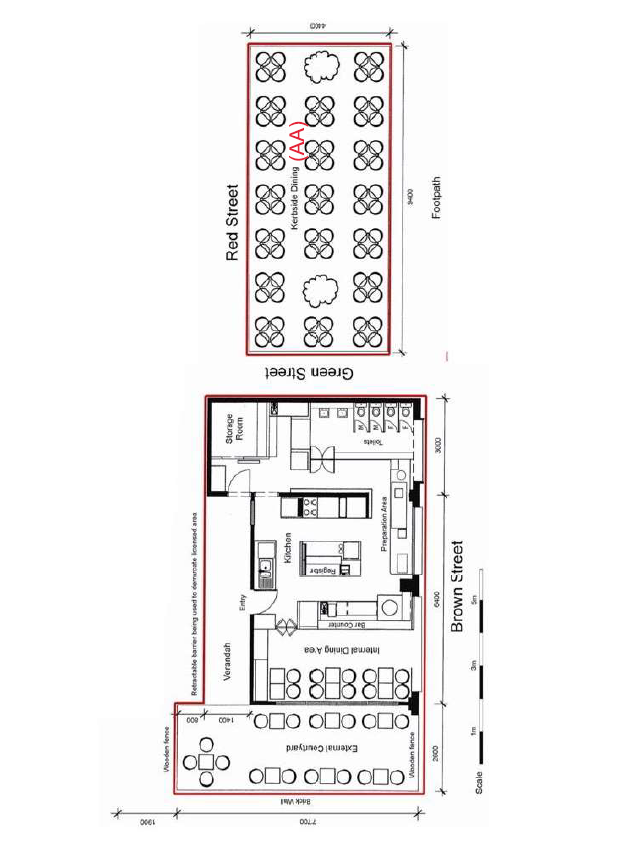

Answers

Q.1 Yes, as unconsumed alcohol supplied during a meal can be taken away provided that:
- the unconsumed alcohol is taken away in the same resealable container in which it was supplied and
- no more than one resealable container of unconsumed alcohol per person is taken away.

Q.2 Yes. Under a restaurant and cafe licence you cannot supply alcohol for off-premises consumption other than with an adult meal and only 1 x 750 ml bottle of wine.

Q3 No, it is not a breach. The majority of customers in your venue must be there to eat or have eaten a meal and the meals you offer are substantial and not just snacks.

Q.4 11pm.

Q.5 Yes. Minors are allowed on the premises of a restaurant and cafe licence unaccompanied during ordinary trading hours (up until 11pm) as long as they do not consume alcohol.

Q.6 No. The main activity for a restaurant and cafe licence is the preparation and serving of meals. If The Spicy Prawn Cafe would like to trade as a bar, an on-premises licence may be a better option for the venue.
Contact LCV for further information to ensure you apply for the right type of licence for your business model.

Q.7 No, the function is permitted to have music above background music.

Q.8 Yes, they must retain 75% of their tables and chairs at any time. By reducing the tables and chairs to accommodate 50 people, they only have 50%.
Q.9 a) Yes, because it is past 11 pm (ordinary trading hours) and the music is having an impact on the amenity of the area, that is, the residential neighbours.
b) 11 pm.

Q.10 Yes, the footpath is not within the red line area.

This document was updated on 27 January 2026
Minor changes made: Ensure content aligned with style guide and updated URL links.
Major changes made: Updated liquor deliveries section regarding display of licence number, display of warning notice and same day deliveries.

