Self-paced guide
Restricted club licence
Introduction

This guide is for anyone who needs to know about a restricted club licence and its conditions. This may include:
- new club committee members, nominees or managers
- existing committee members
- staff at a club with a restricted club licence.

Once you have completed this guide, you should be able to:
- identify when and where you are allowed to supply alcohol to members and their guests
- identify any special conditions that apply to your licence type
- identify possible breaches of a restricted club licence.

This guide includes:
- general information – about a restricted club licence (pages 3 to 5)
- licence conditions – explaining in detail parts of your licence (page 6)
- Q&A – to test your understanding of the licence (pages 7 to 9).
Please note: Information about the law may have been summarised or expressed in general statements. This information should not be relied upon as a substitute for professional legal advice or reference to the Liquor Control Reform Act 1998 (the Act).

Relevant information about the restricted club licence can be found at vic.gov.au/apply-club-liquor-licence.

General information
Trading hours | A restricted club licence allows you to supply liquor to members, members’ guests and the general public (during club events and functions) during the times and days specified in the licence.  Your licence may specify trading hours for:  - specific days and times of the week (for example, Thursday and Saturday, 5 pm to 9:30 pm)  - specific areas of the club  - specific periods of the year (for example, April to September).  Note: You have a 30-minute period after closing time for customers to finish purchased drinks. During this time, you cannot sell them any more alcohol.
Liquor licence and posters | You are required to display:  - a copy of the current liquor licence, where the public can see it  - the following posters (signage):  - ‘Intoxicated, Drunk, Disorderly?’  - ‘Under 18? No supply’.  Posters must be printed in colour on A4 (210 x 297 mm) paper and displayed so the public can see the information.
Red line plan | The red line plan (the plan) shows where alcohol can be sold and consumed at your club.  The plan is submitted with the licence application. If the licence is transferred to you from an existing licence owner, Liquor Control Victoria (LCV) will have an approved plan.  If Victoria Police or a liquor inspector visits you, they will likely request a copy of your plan to check you are operating within the red line area.
Amenity | Amenity is the impact your club, members, or visitors may have on the surrounding area.  Your club should consider the following amenity impacts:  - Parking facilities  Do you have a car park? Do members or visitors park on nearby residential streets?  - Traffic movement and density  Is there a lot of traffic in the surrounding area from members or visitors coming to your club?  - Noise levels  What measures do you have in place to minimise noise from your club (if you have amplified music) or from members or visitors leaving your club?  - Possibility of nuisance or vandalism  Are your members or visitors likely to cause a nuisance to nearby residents? Could they cause noise, nuisance or damage to property or cars?  - Harmony and coherence of the environment  What general effect does your club have on the local community and neighbouring businesses/residents?
Non-member functions | Your restricted club licence does not permit you to hold non-member functions where the function organiser supplies their own alcohol.  In this situation, the organiser requires their own temporary limited licence.  You should ask the function organiser for a copy of their temporary limited licence for your records.
Members’ and guests’ registers | A members’ register must be kept, which contains the following details:  - name  - residential address  - last membership payment details.  Note: Members are not required to sign in each time they use the club.  A register of members’ guests and visitors to the club must be kept, which contains the following details.  - guest/visitor’s name  - guest/visitor’s residential or email address  - name of the member of whom they are a guest (if applicable)  - date they visited the club.  Note: Guests and visitors must sign in each time they visit the club.  The club secretary ensures registers are kept on the club premises. The registers must be available for inspection by Victoria Police or a liquor inspector.
Underage members and visitors (minors) | Minors are not allowed to be served or drink alcohol at your club under any circumstances.  Many sporting clubs have junior teams that train and play sporting games at the club. Clubs must apply to LCV requesting permission to allow anyone under 18 years of age to participate in club activities. To apply, complete the Permanent underage authority for clubs form at vic.gov.au/make-changes-to-liquor-licence.  Where permission is granted, the licence will include the terms and conditions. This usually includes a time by which minors must leave the club premises.  Persons under 18 years of age may be in your club if they are:  - in the company of a ‘responsible adult’, or  - having a meal, or  - employed in duties other than the supply of alcohol (for example, preparing food,  taking orders (other than for alcohol)), or  - in an LCV approved hospitality training program, or  - otherwise approved by LCV to be there.  A responsible adult is a person who is over the age of 18 years and who is:  - the younger person’s parent, step-parent, guardian or grandparent  - the younger person’s spouse (over the age of 18 years)  - a person acting in place of a parent and who is supervising the young person (for example, an aunt or uncle).  More information on responsible adult is available at: vic.gov.au/under-18s-at-licensed-venues.
Sub-letting | You must not let or sublet any part of the licensed premises (whether the sublet allows the supply of alcohol or not) or assign the right to supply alcohol to a third party without the consent of LCV. To apply, complete the Sublet premises or right to supply liquor form available at vic.gov.au/make-changes-to-liquor-licence.
Allowing other persons to carry on a business of supplying alcohol | You must seek LCV’s approval if anyone else, except you or your employee, is to supply alcohol at your club. To apply, complete the Sublet premises or right to supply alcohol form available at vic.gov.au/make-changes-to-liquor-licence.
Other | Relevant information about your licence:  - Annual licence renewal is due on 31 December. A good compliance history can reduce your fees, see vic.gov.au/demerit-points-and-star-ratings-for-licensees.  - Join the Liquor Portal at liquorportal.vcglr.vic.gov.au/liquorportal/ to access your licence and renewal notice and update your details.  - Apply for a temporary licence at vic.gov.au/apply-temporary-limited-liquor-licence if you wish to extend your trading hours or red line area for a one-off event.  - Change what your licences allows you to do by completing the variation to an existing licence form at vic.gov.au/make-changes-to-liquor-licence.  - Surrender your licence when you no longer need it at vic.gov.au/cancel-liquor-licence.  - Stay compliant with liquor laws and your obligations as a licence holder at vic.gov.au/stay-compliant-for-liquor-licensees.

Licence conditions

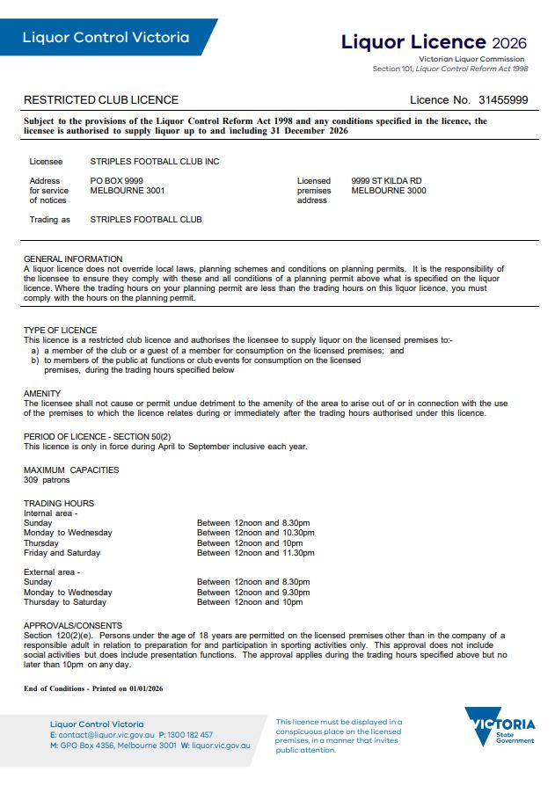
Persons under 18 years may be at the club unaccompanied for:
- sporting activities and presentation functions only
- training (preparation) or participating in sporting events during the specified trading hours.

The licence must only be used during the months listed here or when a limited licence has been issued.
You are responsible for your customers when they are at your club and as they leave.
Quiz

It’s time to check your understanding of what has been covered in this guide. Please complete the questions below and check your responses against the answers provided at the back of this guide.

Q.1 A member drinks one glass out of a bottle of wine they have purchased with dinner in the clubroom. Can they take the bottle of wine home with them?
☐ Yes ☐ No
Explain your answer:
Click or tap here to enter text.

Q.2 Which posters are you required to display at your club?
Click or tap here to enter text.

Q.3 What are some possible amenity impacts you should consider?
Click or tap here to enter text.

Q.4 Name four pieces of information that the guests’ register must contain.
1. Click or tap here to enter text.
2. Click or tap here to enter text.
3. Click or tap here to enter text.
4. Click or tap here to enter text.

Q.5 Your club rooms are to be renovated and will now have a functions room. Does your restricted club licence allow you to hold non-member functions?
☐ Yes ☐ No
Why? Click or tap here to enter text.

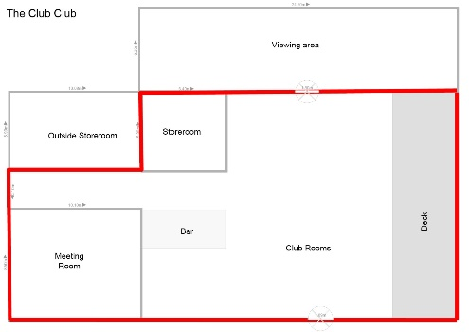
Q.6 Look at the red line plan below. Can a member take alcohol into the viewing area to watch a sports match?
☐ Yes ☐ No

Q.7 It is 1pm on Saturday afternoon at the local football club. The trading hours are Thursday and Saturday from 12 noon to 1 am. A member orders some beer for himself and two guests, which he intends to take outside the red line area to the grandstands to watch the game. Is there a breach of the licence?
☐ Yes ☐ No
Why?
Click or tap here to enter text.

Q.8 The local sporting club has the standard amenity condition on the licence with no approvals or consents. Jan and Stan attend a member function on a Saturday evening and bring Joey their 17-year-old son and Margie their 19-year-old daughter. Is the sporting club in breach of its licence?
☐ Yes ☐ No
Explain your answer:
Click or tap here to enter text.

Q.9 Some members, including the Club Secretary and President, are doing an all-day Saturday working bee at the football club in late March. They finish working around 5:30 pm and have a BBQ. Some members have brought along beer and wine. The licence operates on Tuesdays and Saturdays from 5 pm to 11 pm from April to September.
- Can they drink beer and wine without breaching the club licence conditions?
☐ Yes ☐ No
Explain your answer:
Click or tap here to enter text.
- Can a member open the bar for those involved in the working bee?
☐ Yes ☐ No
Explain your answer:
Click or tap here to enter text.

Q.10 The tennis club wishes to have a special competition on a Friday night for a month, during which alcohol will be supplied. What must the tennis club do to supply alcohol?
☐ Ask members to BYO alcohol.
☐ Apply for a limited licence.
☐ Tell members that alcohol cannot be sold for the Friday night competition.
☐ Nothing.
The tennis club licence states that trading hours are:
Tuesday and Thursday between 6 pm and 11 pm
Saturday between 1 pm and 10 pm

Answers
Q.1 No, the club is licensed for on-premises consumption only—no takeaway.

Q.2 ‘Intoxicated, Drunk, Disorderly?’ and ‘Under 18? No supply’.

Q.3 Amenity impacts you should consider include:
- is there enough parking for member and visitors to the club
- traffic movement and density
- noise from amplified music coming from the club or from members
- members causing a nuisance of damaging property or cars.

Q.4 Name, residential or email address, name of the member of whom they are a guest, date of visit.

Q.5 Yes. The club can supply alcohol to non-members at a non-member event or function held on the licensed premises. However, if the club is hiring out the venue and the event organiser is supplying alcohol, then the event organiser will need to apply for a limited licence.

Q.6 No. The viewing area is outside the red line on the plan.

Q.7 Yes. A restricted club licence only permits alcohol consumption on the licensed premises and within the red line area.

Q.8 No. Joey is with his parents (who fit within the definition of a responsible adult), and so long as Jan or Stan are club members and sign in their guests, there is no breach.

Q.9 The answers are:
- Yes. Providing it is not within the club’s red line area.
- No. It is outside the club’s licensed trading hours; it is March, and the licence is effective from April to September only.

Q.10 Apply for a limited licence.

This document was updated on 27 January 2026
Minor changes made: Ensure content aligned with style guide and updated URL links.

